Vilnius University

Faculty of Mathematics and Informatics

Institute of Computer Science

Vytautas Čyras

ARTIFICIAL INTELLIGENCE

<https://www.mif.vu.lt/~cyras/AI/ai-cyras.pdf>

Vilnius

2019

Table of Contents

[1. Introduction 5](#_Toc3642524)

[1.1. The subject matter of artificial intelligence 5](#_Toc3642525)

[1.2. The Towers of Hanoi 7](#_Toc3642526)

[1.3. Dynamic nature of artificial intelligence 10](#_Toc3642527)

[1.4. Methods of problem solving 11](#_Toc3642528)

[2. Artificial intelligence system as a production system 12](#_Toc3642529)

[2.1. Testing 16](#_Toc3642530)

[3. Control with backtracking and procedure BACKTRACK 17](#_Toc3642531)

[3.1. An example of the DEADEND predicate 18](#_Toc3642532)

[4. The 8-queens puzzle 19](#_Toc3642533)

[5. Heuristic 22](#_Toc3642534)

[5.1. Heuristic search in N-queens problem 22](#_Toc3642535)

[5.2. Knight’s move heuristic in the N-queens problem 25](#_Toc3642536)

[6. BACKTRACK1 – a cycle-avoiding algorithm 31](#_Toc3642537)

[7. Depth-first search in a labyrinth 32](#_Toc3642538)

[7.1. Testing depth-first search in a labyrinth 35](#_Toc3642539)

[8. Breadth-first search in a labyrinth 37](#_Toc3642540)

[8.1. Testing breadth-first search in a labyrinth 41](#_Toc3642541)

[9. Breadth-first search in a graph 43](#_Toc3642542)

[10. Shortest path problem in a graph with edge weights 46](#_Toc3642543)

[11. Depth-first search in a graph with no weights 49](#_Toc3642544)

[12. The prefix, infix and postfix order of tree traversal 51](#_Toc3642545)

[13. GRAPHSEARCH algorithm 56](#_Toc3642546)

[14. Differences between BACKTRACK1 and GRAPHSEARCH-DEPTH-FIRST 57](#_Toc3642547)

[14.1. Searching in a graph 57](#_Toc3642548)

[14.2. Multiple cycles in a labyrinth 58](#_Toc3642549)

[14.3. A counterexample of better performance with BACKTRACK1 60](#_Toc3642550)

[15. Hill-climbing strategy 62](#_Toc3642551)

[16. Manhattan distance 65](#_Toc3642552)

[17. A\* search algorithm 67](#_Toc3642553)

[17.1. Manhattan distance in the tile world 67](#_Toc3642554)

[17.2. An example from Russell & Norvig 2003 70](#_Toc3642555)

[18. Forward chaining and backward chaining 73](#_Toc3642556)

[18.1. Forward chaining 73](#_Toc3642557)

[18.2. Backward chaining 74](#_Toc3642558)

[18.3. Program synthesis 75](#_Toc3642559)

[18.4. Superfluous rules in forward chaining 77](#_Toc3642560)

[18.5. Superfluous rules in backward chaining 78](#_Toc3642561)

[18.6. Complexity of forward chaining 78](#_Toc3642562)

[18.7. Testing forward chaining 78](#_Toc3642563)

[18.8. Testing backward chaining 80](#_Toc3642564)

[19. Resolution 83](#_Toc3642565)

[19.1. Inference example 85](#_Toc3642566)

[19.2. Example with three rules 87](#_Toc3642567)

[19.3. Using resolution to prove theorem 90](#_Toc3642568)

[20. Expert systems 91](#_Toc3642569)

[21. Internet shopping 94](#_Toc3642570)

[22. The Turing test 100](#_Toc3642571)

[23. Intension, extension and ontology 101](#_Toc3642572)

[23.1. Signs 102](#_Toc3642573)

[23.2. What is a conceptualization? 103](#_Toc3642574)

[23.3. What is a proper formal, explicit specification? 107](#_Toc3642575)

[23.4. Distinct models of a specification 112](#_Toc3642576)

[24. Examination questions 115](#_Toc3642577)

[25. References 116](#_Toc3642578)

Preface

This course-book views artificial intelligence (AI) from the standpoint of programming. Fundamental concepts of classical AI are presented: problem solving by search, solver, planner, etc. A purpose is to understanding the spirit of a discipline of artificial intelligence.

The course-book is available at <https://www.mif.vu.lt/~cyras/AI/ai-cyras.pdf> and presents primarily figures and text excerpts which are comprised in the broader Lithuanian edition[[1]](#footnote-1).

The following themes are presented:

* History of artificial intelligence
* Philosophical questions
* The Turing test
* A system of artificial intelligence according to Nils Nilsson: 1) a global data base, 2) a set of production rules, and 3) a control system
* Examples: the 8 queens puzzle, the knight’s tour, path search in a labyrinth
* Problem spaces
* Backtracking
* Depth-first search and breadth-first search, Dijkstra’s algorithm, A\*
* The role of heuristics
* Forward chaining and backward chaining
* Knowledge-based reasoning, deduction, resolution technique
* Hill climbing
* Elements of expert systems architecture: facts, rules, and an inference engine
* Knowledge representation
* Structured representation, frames and objects
* Semantic networks
* Artificial intelligence and law
* Extensional relational structure and what is an ontology

**Acknowledgements**. Sincere thanks to students who contributed to this course-book. Edgaras Abromaitis’ work was essential in shaping the text and producing the figures.

# Introduction

American scientist Marvin Minsky defined AI as “the science of making machines do things that would require intelligence if done by men.”[[2]](#footnote-2) A similar definition is “the science of designing computer systems to perform tasks that would normally require human intelligence” (Sowa 2000, p. XI). The term “artificial intelligence” was coined at the Dartmouth conference (1956), USA and is attributed to John McCarthy.

The term “artificial intelligence” is used to describe machines that mimic “cognitive” functions that humans associate with other human minds, such as “learning” and “problem solving”, see (Russell, Norvig 2010, p. 2).

## The subject matter of artificial intelligence

The subject matter of AI also shows the place of AI within the discipline of computer science. Following is a classification of *computing* according to the ACM Computing Classification System in US; see <https://www.acm.org/publications/class-2012> by the Association for Computer Machinery.

General Literature

Hardware

Computer systems organization

Networks

Software

Data

Theory of computation

Mathematics of computing

Information systems

Security and privacy

Human-centered computing

**Computing methodologies**

Computer applications

Social and professional topics

Artificial intelligence is comprised by the branch Computing methodologies above which is classified further:

Symbolic and algebraic manipulation

Parallel computing methodologies

**Artificial intelligence**

Machine learning

Modeling and simulation

Computer graphics

Distributed computing methodologies

Concurrent computing methodologies

Artificial intelligence is classified further:

* Natural language processing
  + Information extraction; Machine translation; Discourse, dialogue and pragmatics; Natural language generation; Speech recognition; Lexical semantics; Phonology / morphology; Language resources
* **Knowledge representation and reasoning**
  + Description logics; Semantic networks; Nonmonotonic, default reasoning and belief revision; Probabilistic reasoning; Vagueness and fuzzy logic; Causal reasoning and diagnostics; Temporal reasoning; Cognitive robotics; Ontology engineering; Logic programming and answer set programming; Spatial and physical reasoning; Reasoning about belief and knowledge
* Planning and scheduling
  + Planning for deterministic actions; Planning under uncertainty; Multi-agent planning; Planning with abstraction and generalization; Robotic planning
* Search methodologies
  + Heuristic function construction; Discrete space search; Continuous space search; Randomized search; Game tree search; Abstraction and micro-operators; Search with partial observations
* Control methods
  + Robotic planning; Computational control theory; Motion path planning
* Philosophical/theoretical foundations of artificial intelligence
  + Cognitive science; Theory of mind
* Distributed artificial intelligence
  + Multi-agent systems; Intelligent agents; Mobile agents; Cooperation and coordination
* Computer vision
  + Computer vision tasks
    - Biometrics; Scene understanding; Activity recognition and understanding; Video summarization; Visual content-based indexing and retrieval; Visual inspection; Vision for robotics; Scene anomaly detection
  + Image and video acquisition
    - Camera calibration; Epipolar geometry; Computational photography; Hyperspectral imaging; Motion capture; 3D imaging; Active vision
  + Computer vision representations
    - Image representations; Shape representations; Appearance and texture representations; Hierarchical representations
  + Computer vision problems
    - Interest point and salient region detections; Image segmentation; Video segmentation; Shape inference; Object detection/recog­nition/identification; Tracking; Reconstruction; Matching

What means “artificially intelligent”? Intelligent entities have the abilities to perceive, understand, predict, and manipulate. AI is related with logic. Logic (from the Ancient Greek logikḗ, “the word” or “what is spoken” (but coming to mean “thought” or “reason”), is generally held to consist of the systematic study of the form of arguments. Also related to logos, “word, thought, idea, argument, account, reason, or principle” (<https://en.wikipedia.org/wiki/Logic>).

## The Towers of Hanoi

See <https://en.wikipedia.org/wiki/Towers_of_Hanoi>.

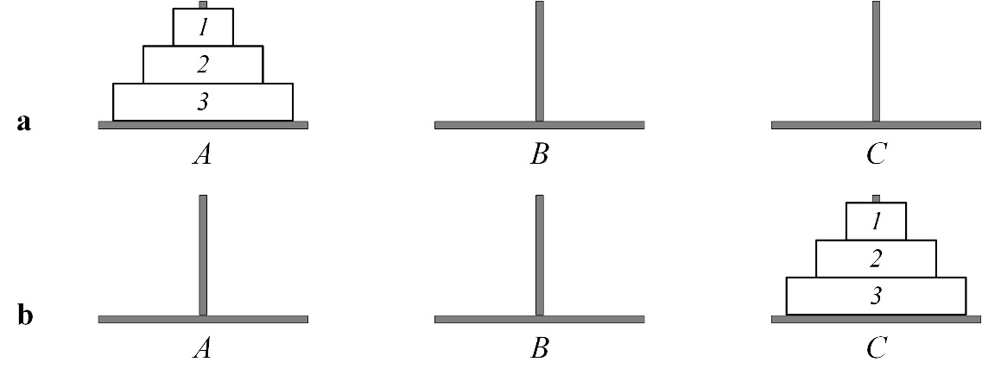

Fig. 1.1. a) Initial state A=(3,2,1), B=(), C=(). b) Terminal state A=(), B=(), C=(3,2,1)

Finding a sequence of moves is an intelligent task. Intelligence is hidden in the recursive algorithm below:

Part 1. Move n–1 disks from A to B;

Part 2. Move disk n from A to C;

Part 3. Move n–1 disks from B to C.

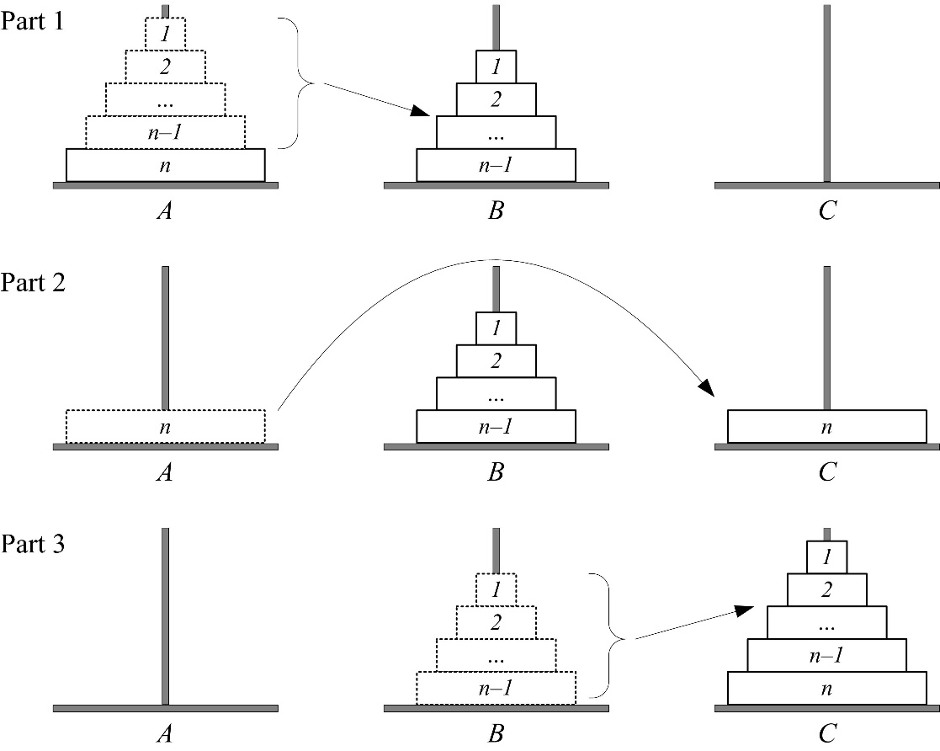

Fig. 1.2. Three parts of the recursive algorithm

The sequence of moves for n=3:

Initial state A=(3,2,1), B=(), C=()

1. Move disk 1 from A to C. A=(3,2), B=(), C=(1)

2. Move disk 2 from A to B. A=(3), B=(2), C=(1)

3. Move disk 1 from C to B. A=(3), B=(2,1), C=()

4. Move disk 3 from A to C. A=(), B=(2,1), C=(3)

5. Move disk 1 from B to A*.* A=(1), B=(2), C=(3)

6. Move disk 2 from B to C. A=(1), B=(), C=(3,2)

7. Move disk 1 from A to C*.* A=(), B=(), C=(3,2,1)

Following is the recursive procedure:

**procedure** ht(x, y, z: char; n: integer);  
*{x, y, z – rod names; n – number of disks.}  
{x – from, y – intermediary, z – onto.}*  
**begin** **if** n > 0 **then** **begin** ht(x, z, y, n-1); {1. Move n-1 disks onto intermediary.}  
 writeln(' Move disk ', n, ' from ', x,' to ', z); {2.}  
 ht(y, x, z, n-1); {3. Move n-1 disks onto target. }  
 **end  
end**

Invoking the above procedure with *n=3*:

ht('A', 'B', 'C', 3)

The number of moves is exponential: *2n – 1*.

Further we discuss state transition in state transition graphs. Fig. 1.3 shows GRAPHSEARCH\_DEPTH\_FIRST search tree for the Hanoi tower problem n=3.

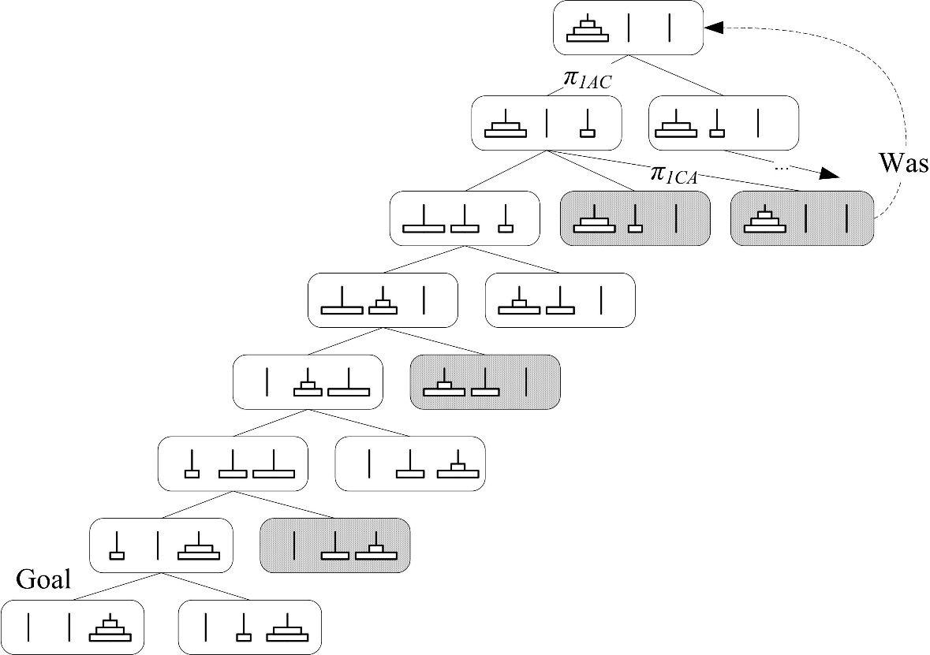

Fig. 1.3. A search tree of the algorithm GRAPHSEARCH\_ DEPTH\_FIRST for the Hanoi tower problem n=3. The grey nodes appear in the list OPEN or CLOSED

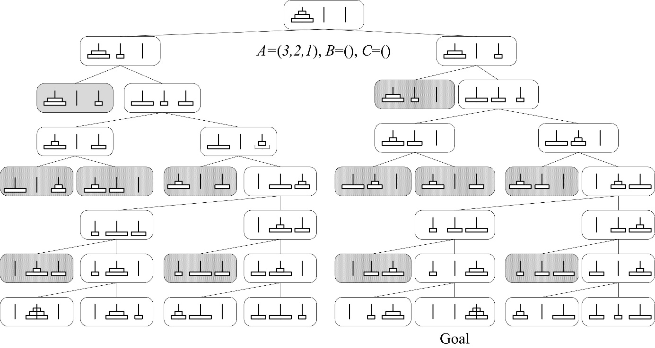

Fig. 1.4 . A search tree of the GRAPHSEARCH\_BREADTH\_FIRST algorithm for the Hanoi tower problem. The grey nodes appear in the list OPEN or CLOSED

**Exercise 1. The iterative Hanoi tower solution.** The iterative algorithm for the Hanoi tower problem is less well-known as the recursive one. First, we arrange the pegs in a circle, so that clockwise we have *A*, *B*, *C*, and then *A* again. Following this, assuming we never move the same disk twice in a row, there will always only be one disk that can be legally moved, and we transfer it to the first peg it can occupy, moving in a clockwise direction, if *n* is even (2, 4, 6,…), and counterclockwise, in *n* is odd (1, 3, 5,…). (See Brachman & Levesque (2004), *“Knowledge representation and reasoning”*, p. 133–134, Exercise 2). Write a program.

**Exercise 2. On the complexity of the Hanoi tower problem.** Suppose one move takes 1 second. How many years will it take to solve the Hanoi tower problem for *n*=64?

**Exercise 3. Monkey and banana problem.** A monkey is in a room. Suspended from the ceiling is a bunch of bananas, beyond the monkey’s reach. However, in the room there are also a chair and a stick. The ceiling is just the right height so that a monkey standing on a chair could knock the bananas down with the stick. The monkey knows how to move around, carry other things around, reach for the bananas, and wave a stick in the air. What is the best sequence of actions for the monkey? (<https://en.wikipedia.org/wiki/Monkey_and_banana_problem>)

## Dynamic nature of artificial intelligence

Research is at the forefront of AI. “Intelligence is whatever machines haven’t done yet” (<http://www.nomodes.com/Larry_Tesler_Consulting/Adages_and_Coinages.html>). Program­mers may do tasks not knowing that they are assigned to AI.

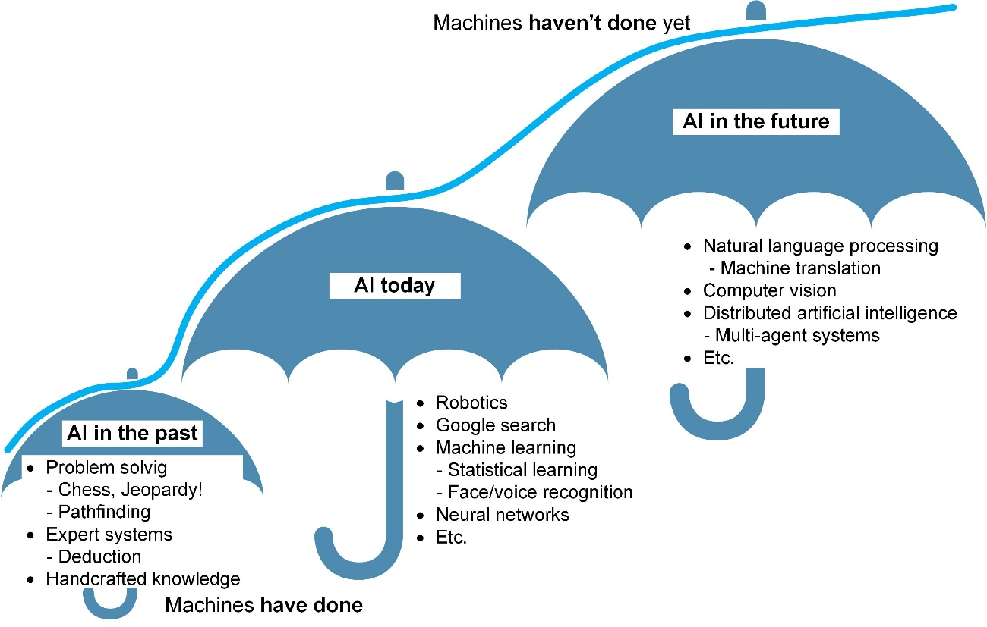

Fig. 1.5. As machines become increasingly capable, tasks considered to require “intelligence” are often removed from the definition of AI, a phenomenon known as the AI effect.

## Methods of problem solving

Following are two classifications in artificial intelligence:

|  |  |
| --- | --- |
| **Tasks in artificial intelligence** | **Problem solving methods** |
| 1. interpret (analysis)  1.1. identify (recognise)  1.1.1. monitor (audit, check)  1.1.2. diagnose (debug)  1.2. predict (simulate)  1.3. control  2. construct (synthesis)  2.1. specify (constrain)  2.2. design  2.2.1. plan (process)  2.2.2. configure (structure)  2.2. assemble (manufacture)  2.3.1. modify (repair) | 1. classification)  1.1. certain classification  1.1.1. decision trees  1.1.2. decision tables  1.2. heuristic classification  1.3. model-based classification  1.3.1. set covering classification  1.3.2. functional classification  1.4. statistical classification  1.5. case-based classification  2. construction  2.1. heuristic construction  2.1.1. skeletal construction  2.1.2. propose-and-revise strategy  2.1.3. propose-and-exchange strategy  2.1.4. least-commitment strategy  2.2. model-based construction  2.3. case-based construction  3. simulation  3.1. one-step simulation  3.2. multiple-step simulation  3.2.1. numerical multiple-step simulation  3.2.2. qualitative multiple-step simulation |

What differentiates a method and a principle? A method is applied in a clear situation but a principle – in a situation that needs not to be clear. A principle is applied in the case a method is not known in a given situation. This is similar to a difference between a legal norm and a principle. Following are short descriptions by Albertas Čaplinskas, a scholar and practitioner in software engineering:

Method = schema + procedures

Methodology = method + recommendations

There are other characterisations of the term “method” such as “Method = notation + process model”. An example is UML + RUP, i.e. Rational’s Unified Modeling Language + Process (Hesse, Verrijn-Stuart 2001, p. 1).

# Artificial intelligence system as a production system

This section follows (Nilsson 1982, Section 1.1)

DEFINITION 2.1. A *production system* is a triple:

1. A global database (GDB);
2. A production (rule) set {π1, π2,..., πm};
3. A control system.

The basic production system algorithm for solving a problem such as the 8-puzzle, the knight’s tour, the 8 queens puzzle, etc. can be written in nondeterministic form as follows:

**procedure** PRODUCTION

*{1}* DATA := initial GDB;

*{2}* **until** DATA will satisfy the termination condition, **do**

*{3}* **begin**

*{4}* **select** some rule, *π*, in the set of rules

that can be applied to DATA

*{5}* DATA := *π*(DATA) *{Result of applying π to DATA}*

*{6}* **end**

The output is a sequence of productions 〈πi1, πi2,...,πin〉. This is a non-determinate procedure. PRODUCTION performs depth-first search. The procedure is treated as a *paradigm* of a control system. A meaning of the word “paradigm” can be found, for instance, in Oxford English Dictionary, <http://www.oed.com/>: “A pattern or model, an exemplar; (also) a typical instance of something, an example.”

The Knight’s Tour problem (<https://en.wikipedia.org/wiki/Knight%27s_tour>) is examined to demonstrate problem solving with the PRODUCTION procedure. A knight’s tour is a sequence of moves of a knight on a chessboard such that the knight visits every square only once. Suppose the knight starts from the square [1,1] (Fig. 2.1 a). Eight productions {π1,…, π8} are shown in Fig. 2.1 b. Variations involve chessboards *N*×*N*. The simplest case is *N*=5.

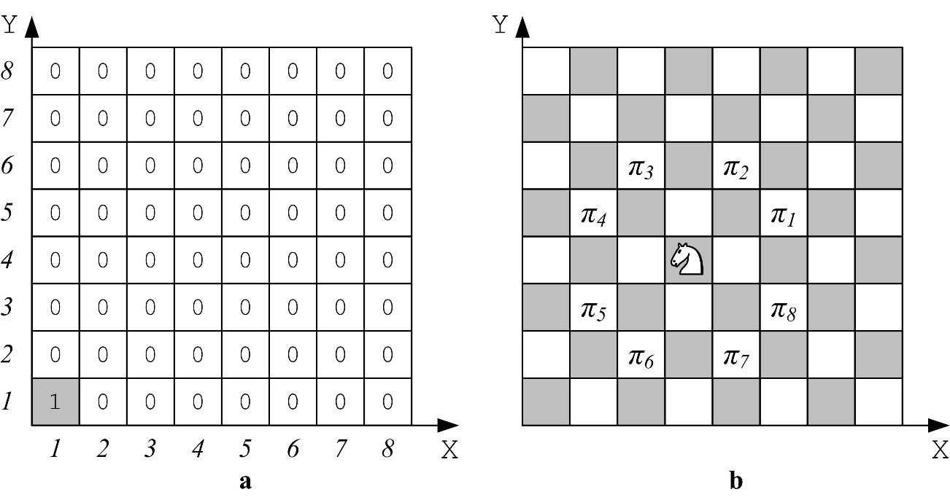

Fig. 2.1. The knight starts from the square [1,1] on a 8×8 chessboard

**program** KNIGHTS\_TOUR;

**const** N = 5; *{Length of the board}*

NN = 25; *{Number of squares 5\*5}*

**type** INDEX = 1..N;

**var**

BOARD : **array**[INDEX, INDEX] **of** integer; *{Global data base}*

CX, CY : **array**[1..8] **of** integer; *{8 production rules}*

I, J : integer; YES: boolean;

**procedure** INITIALISE;

**var** I, J : integer

**begin**

*{1) Production set is formed}*

CX[1] := 2; CY[1] := 1;

CX[2] := 1; CY[2] := 2;

CX[3] := -1; CY[3] := 2;

CX[4] := -2; CY[4] := 1;

CX[5] := -2; CY[5] := -1;

CX[6] := -1; CY[6] := -2;

CX[7] := 1; CY[7] := -2;

CX[8] := 2; CY[8] := -1;

*{2) Initialise the global data base}*

**for** I := 1 to N **do**

**for** J := 1 to N **do**

BOARD[I, J] := 0;

**end**; *{INITIALISE}*

**procedure** TRY (L : integer; X, Y : INDEX; **var** YES : boolean);

*{Input parameters: L – move number; X, Y – knight's last position.}*

*{Output parameter (i.e. the result): YES.}*

**var**

K : integer; *{Production number.}*

U, V : integer; *{New knight's position.}*

**begin**

K := 0;

**repeat** *{Select each of 8 productions.}*

K := K + 1;

U := X + CX[K]; V := Y + CY[K];

*{Check if the condition of the production is satisfied.}*

**if** (U >= 1) **and** (U <= N) **and** (V >= 1) **and** (V <= N)

**then** *{Within the board.}*

*{Check if the square is empty.}*

**if** BOARD[U, V] = 0

**then**

**begin**

*{New position.}*

BOARD[U, V] := L;

*{Check if all squares are visited.}*

**if** L < NN

**then**

**begin** *{If not all are visited.}*

TRY(L+1, U, V, YES);

*{If no success,}*

*{then backtrack and free the position.}*

**if** **not** YES **then** BOARD[U, V] := 0;

**end**

**else** YES := **true**; *{When L=NN.}*

**end**;

**until** YES **or** (K = 8); *{Either success or all productions were tried.}*

**end**; *{TRY}*

**begin** *{Main program)}*

*{1. Initialise.}*

INITIALISE; YES := **false**;

*{2. Initial position [1,1].}*

BOARD [1, 1] := 1;

*{3. Make move no.2 from X=1 and Y=1 and obtain the answer YES.}*

TRY(2, 1, 1, YES);

*{4. If a solution found then print it.}*

**if** YES **then**

**for** I := N **downto** 1 **do**

**begin**

**for** J := 1 to N **do**

write(BOARD[I,J]);

writeln;

**end**;

**else** writeln('Path does not exist.');

**end**.

The first solution is shown in Fig. 2.1 a. There are several solutions. The first deadend is reached on square 21; see Fig. 2.1 b. The search tree is shown in Fig. 2.3.

|  |  |
| --- | --- |
| a) A solution on a 5×5 chessboard. b) Grey coloured are seven foremost moves that lead to success. Move 8 fails |  |

What do the variables represent?

1. BOARD, X and Y – the global data base;
2. CX and CY – the production set;
3. Procedure TRY – the control system.

A solution is a sequence of 24 moves 〈*πi1, πi2, πi3,..., πi24*〉, where *πij*{*π1, π2, π3, π4, π5, π6, π7, π8*}, i.e. *ij*{1, 2, ..., 8}.

Two elements are distinguished in knowledge-based system architecture:

1. reasoning. This stands for a control system. The inference engine does not depend on a domain and can be purchased.
2. knowledge base. It is comprised of a global data base and a production set. It depends on the domain and can hardly be purchased. “God is in the detail”.

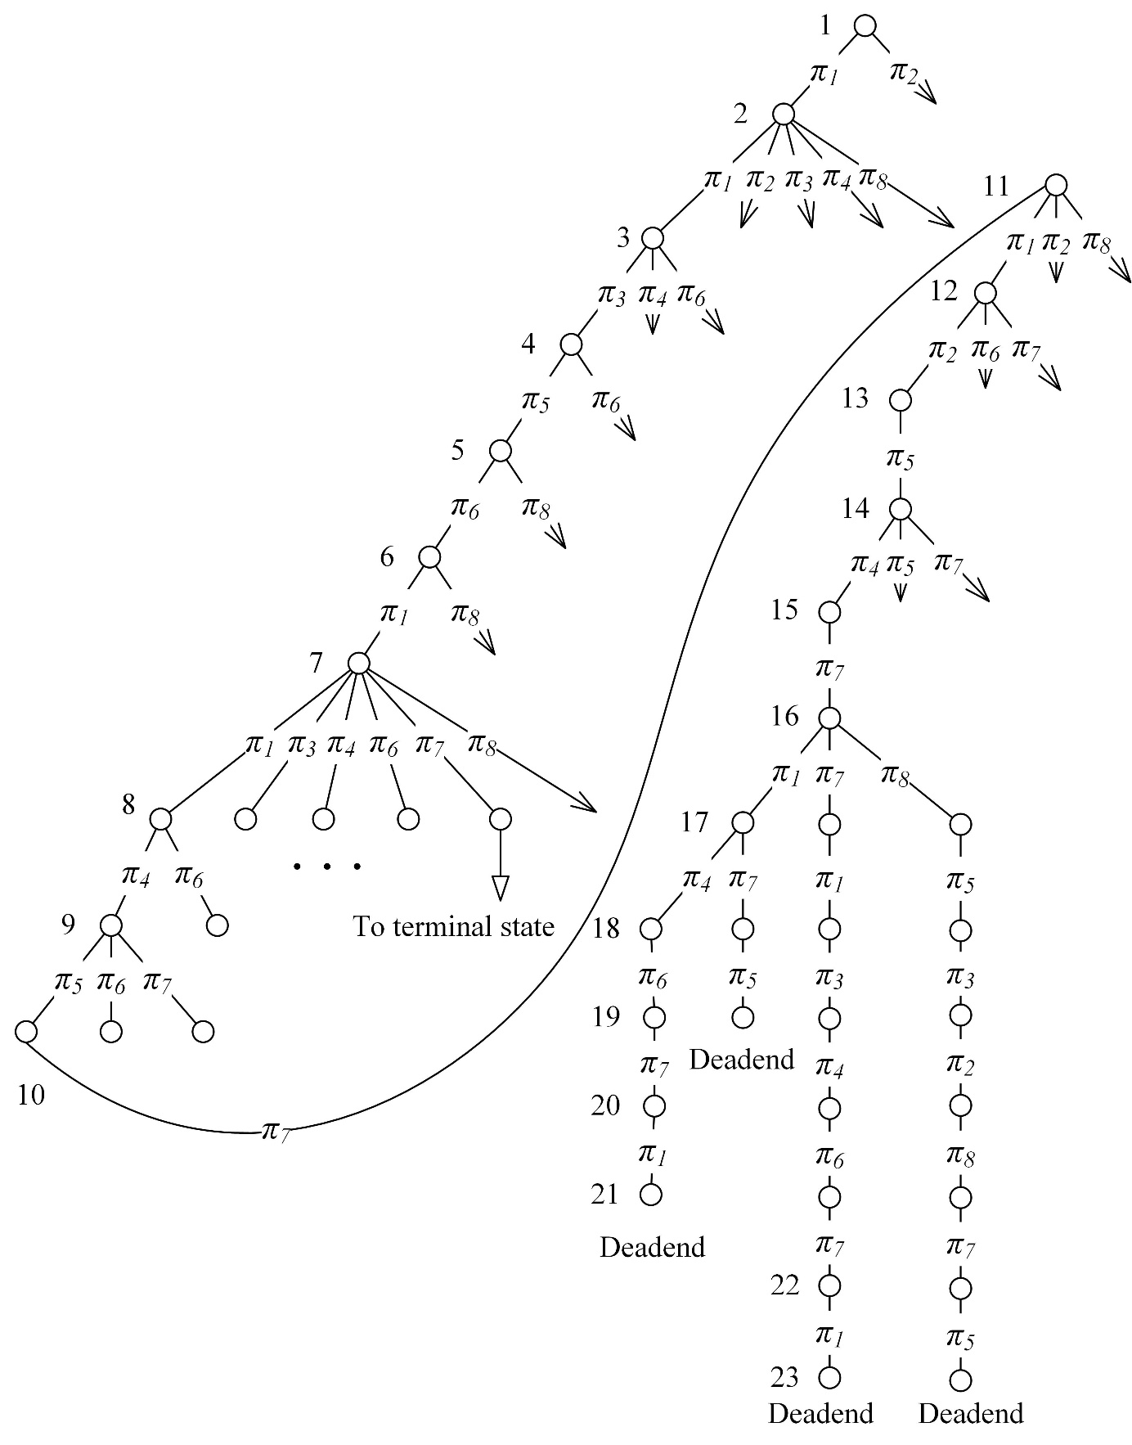

Fig. 2.3. Search tree which leads to the first deadend on a 5×5 board. The state is shown in Fig. 2.2 b.

## Testing

Modify your Knight’s Tour solver to print the trace below.

PART 1. Data

1) Board 5x5.

2) Initial position X=1, Y=1. L=1.

PART 2. Trace

1) R1. U=3, V=2. L=2. Free. BOARD[3,2]:=2.

2) -R1. U=5, V=3. L=3. Free. BOARD[5,3]:=3.

3) --R1. U=7, V=4. L=4. Out.

4) --R2. U=6, V=5. L=4. Out.

5) --R3. U=4, V=5. L=4. Free. BOARD[4,5]:=4.

6) ---R1. U=6, V=6. L=5. Out.

7) ---R2. U=5, V=7. L=5. Out.

8) ---R3. U=3, V=7. L=5. Out.

9) ---R4. U=2, V=6. L=5. Out.

10) ---R5. U=2, V=4. L=5. Free. BOARD[2,4]:=5.

11) ----R1. U=4, V=5. L=6. Thread.

And so on until the deadend at L=21. Then backtrack one level, i.e. pop one hyphen.

...) -------------------R1. U=4, V=2. L=21. Free. BOARD[4,2]:=21.

...) --------------------R1. U=6, V=3. L=22. Out.

...) --------------------R2. U=5, V=4. L=22. Thread.

...) --------------------R3. U=3, V=4. L=22. Thread.

...) --------------------R4. U=2, V=3. L=22. Thread.

...) --------------------R5. U=2, V=1. L=22. Thread.

...) --------------------R6. U=3, V=0. L=22. Out.

...) --------------------R7. U=5, V=0. L=22. Out.

...) --------------------R8. U=6, V=1. L=22. Out. Backtrack.

...) -------------------R2. U=3, V=3. L=21. Thread.

...) -------------------R3. U=1, V=3. L=21. Thread.

...) -------------------R4. U=0, V=2. L=21. Out.

...) -------------------R5. U=0, V=0. L=21. Out.

...) -------------------R6. U=1, V=-1. L=21. Out.

...) -------------------R7. U=3, V=-1. L=21. Out.

...) -------------------R8. U=4, V=0. L=21. Out. Backtrack.

...) ------------------R8. U=3, V=2. L=20. Thread. Backtrack

...) -----------------R7. U=3, V=3. L=19. Thread.

...) -----------------R8. U=4, V=4. L=19. Thread. Backtrack.

...) ----------------R5. U=2, V=3. L=18. Thread.

...) ----------------R6. U=3, V=2. L=18. Thread.

...) ----------------R7. U=5, V=2. L=18. Free. BOARD[5,2]:=18.

...) -----------------R1. U=7, V=3. L=19. Out.

And so on.

70611) ---------------------R1. U=5, V=5. L=23. Free. BOARD[5,5]:=23.

70612) ----------------------R1. U=7, V=6. L=24. Out.

70613) ----------------------R2. U=6, V=7. L=24. Out.

70614) ----------------------R3. U=4, V=7. L=24. Out.

70615) ----------------------R4. U=3, V=6. L=24. Out.

70616) ----------------------R5. U=3, V=4. L=24. Thread.

70617) ----------------------R6. U=4, V=3. L=24. Free. BOARD[4,3]:=24.

70618) -----------------------R1. U=6, V=4. L=25. Out.

70619) -----------------------R2. U=5, V=5. L=25. Thread.

70620) -----------------------R3. U=3, V=5. L=25. Thread.

70621) -----------------------R4. U=2, V=4. L=25. Thread.

70622) -----------------------R5. U=2, V=2. L=25. Thread.

70623) -----------------------R6. U=3, V=1. L=25. Thread.

70624) -----------------------R7. U=5, V=1. L=25. Free. BOARD[5,1]:=25.

|  |  |
| --- | --- |
| PART 3. Results  1) Path is found. Trials=70624.  2) Path graphically  Y, V ^  5 | 21 16 11 4 23  4 | 10 5 22 17 12  3 | 15 20 7 24 3  2 | 6 9 2 13 18  1 | 1 14 19 8 25  -----------------------> X, U  1 2 3 4 5 | Seven tests: 1) N=5, X=1, Y=1. Trials=70 624. 2) N=5, X=5, Y=1. Trials=236. 3) N=5, X=1, Y=5. Trials= 111 981. 4) N=5, X=2, Y=1. No path. Trials=14 635 368. 5) N=6, X=1, Y=1. Trials=1 985 212. 6) N=7, X=1, Y=1. Trials=57 209 233. 7) N=4, X=1, Y=1. No path. Trials=17 784.  Print the trace as follows: a) PART 1 and PART 3 – to console and the file myoutput1.txt, and b) all three parts – to the file myoutput2.txt. |

# Control with backtracking and procedure BACKTRACK

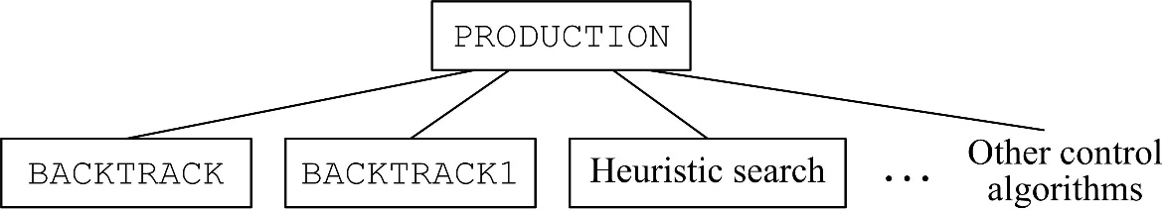

Fig. 3.1. BACKTRACK in the context of other control algorithms

BACKTRACK is used to solve the 8-queens problem:

1. Global data base – a chess board.
2. A set of 64 productions {*πi,j*, *i,j* = 1, 2, ..., 8}, where *πi,j* denotes placing a queen into position [*i,j*]. We reduce this set to 8 productions {*πk*, *k* = 1, 2, ..., 8}. Each queen i is placed in row *i* one by one, *i*=1, 2 and so on until 8. *πk* denotes placing a queen into column *k*. The first queen is placed in row 1 and column *k2*, the second – in row 2 and column *k2* and so on.
3. Control system – procedure BACKTRACK.

An empty board stands for the initial state. A solution is 〈*πk1, πk2, …, πk8*〉, where *k1*, *k2*,…, *k8* ∈ {1, 2,…, 8}.

Below we adapt from (Nilsson 1982, Section 2.1). A general description of the backtracking control strategy was presented earlier as procedure PRODUCTION. Compared with graph-search control regimes, backtracking strategies are typically simpler to implement and require less storage.

A simple recursive procedure captures the essence of the operation of a production system under backtracking control. This procedure, which we call BACKTRACK, takes a single argument, Data, initially set equal to the global database of the production system. Upon successful termination, the procedure returns a list of rules, that, if applied in sequence to the initial database, produces a database satisfying the termination condition. If the procedure halts without finding such a list of rules, it returns FAIL. The BACKTRACK procedure is defined as follows:

**recursive** **procedure** BACKTRACK(DATA) {return list of rules}  
*{DATA – a current state of the GDB. Returns a list of rules.}* *{ 1}* **if** TERM(DATA) **then** **return** NIL; *{TERM is a  
 predicate true for arguments that satisfy  
 the termination condition of the production  
 system. Upon successful termination, NIL,  
 the empty list is returned.}*  
 *{ 2}* **if** DEADEND(DATA) **then** **return** FAIL; *{DEADEND is a  
 predicate true for arguments that are known  
 not to be on a path to a solution. In this  
 case, the symbol FAIL is returned.}*  
 *{ 3}* RULES := APPRULES(DATA); *{APPRULES is a function  
 that computes the rules applicable to its  
 argument and orders them (either arbitrari-  
 ly or according to heuristic merit).}*  
 *{ 4}* LOOP: **if** NULL(RULES) **then** **return** FAIL;  
 *{If there is no (more) rules to apply,  
 the procedure fails.}*  
 *{ 5}* R := FIRST(RULES); *{The best of the  
 applicable rules is selected.}*  
 *{ 6}* RULES := TAIL(RULES); *{The list of  
 applicable rules is diminished by  
 removing the one just selected.}*  
 *{ 7}* RDATA := R(DATA); *{Rule R is applied to  
 produce a new database.}*  
 *{ 8}* PATH := BACKTRACK(RDATA); *{Recursive call  
 on the new database.}*  
 *{ 9}* **if** PATH = FAIL **then** goto LOOP; *{If the re-  
 cursive call fails, try another rule.}*  
 *{10}* **return** CONS(R, PATH); *{Otherwise, pass the  
 successful list of rules up, by adding  
 R to the front of the list.}*  
**end**

## An example of the DEADEND predicate

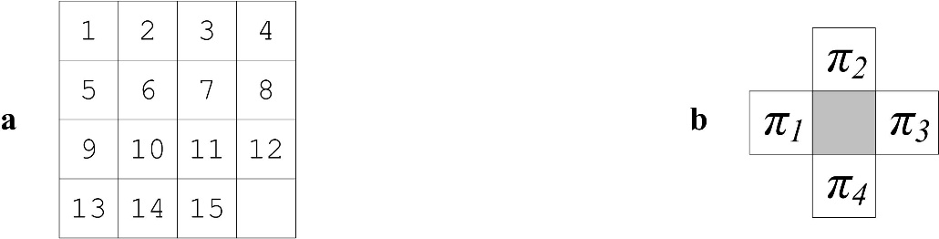

Fig. 3.2. a) The terminal state in the 15-puzzle. b) Four moves

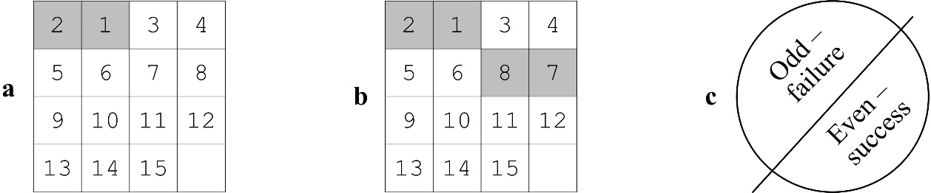

Fig. 3.3. a) A sample initial state in the 15-puzzle with one permutation, an odd number. This is a failure state. b) The number of permutations is 2, an even number. Success can be reached from this state

# The 8-queens puzzle

Below we follow (Nilsson 1982, Section 2.1). Suppose the problem of placing 4 queens on a 4×4 chessboard so that none can capture any other. For our global database, we use a 4×4 array with marked cells corresponding to squares occupied by queens. The terminal condition, expressed by the predicate TERM, is satisfied for a database if and only if it has precisely 4 queen marks and the marks correspond to queens located so that they cannot capture each other.

There are many alternative formulations possible for the production rules. A useful one for our purposes involves the following rule schema, for 1 ≤ i, j≤ 4:

Rij Precondition:

*i* = 1: There are no marks in the array.

1 < *i*≤ 4: There is a queen mark in row *i*– 1 of the array.

Effect: Puts a queen mark in row i, column j of the array.

Thus, the first queen mark added to the array must be in row 1, the second must be in row 2, etc.

To use the BACKRACK procedure to solve the 4-queens problem, we have still to specify both the predicate DEADEND and an ordering relation for applicable rules. Suppose we arbitrarily say that Rij is ahead of Rik in the ordering only when j < k. The predicate DEADEND might be defined so that it is satisfied for databases where it is obvious that no solution is possible; for example, certainly no solution is possible for any database containing a pair of queen marks in mutually capturing positions. Altogether, the algorithm backtracks 22 times before finding a solution; even the very first rule applied must ultimately be taken back (Nilsson 1982, p. 57–58). A search tree with 26 edges is shown in see Fig. 5.5.

To see an example of this multilevel backtracking phenomenon, consider using BACKTRACK to solve the 8-queens problem. In this problem, we must place 8 queens on an 8×8 board so that none of them can capture any others. (Nilsson 1982, p. 60)

Placing queens is encoded in the array X, where X[I]=K denotes placing a queen in row I, column K. A solution is shown in Fig. 4.1: X[1]=1, X[2]=5, X[3]=8, X[4]=6, X[5]=3, X[6]=7, X[7]=2, X[8]=4.

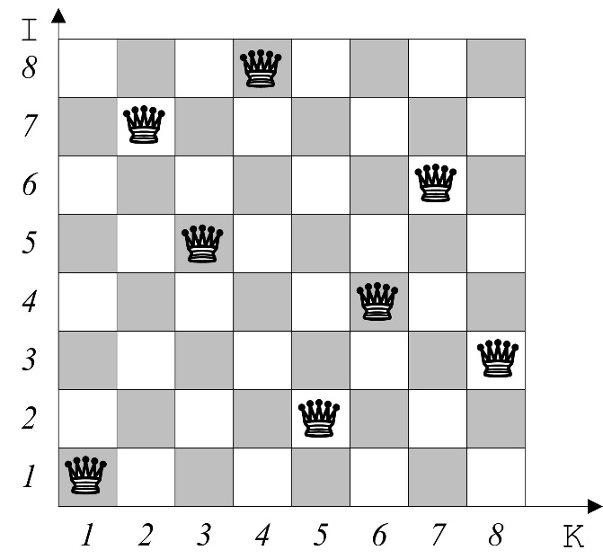

Fig. 4.1. A solution of the 8-queens puzzle

A *brute force* algorithm searches among 8! = 8*⋅*7*⋅*6*⋅*…*⋅*2*⋅*1 = 40320 permutations. A solution is as follows:

PATH=〈π1, π5, π8, π6, π3, π7, π2, π4〉

Here the I-th element is *π*X[I] , i.e. PATH[I] = *π*X[I], where I = 1, 2, …, 8. There are N! permutations in the case of an N×N board. As *N* grows, the factorial *N*! increases faster than all polynomials and exponential functions, i.e. N! = 2α*⋅*N, where α is a real number that depends on N.

The program below follows (Dagienė, Grigas, Augutis, 1986); see also <https://en.wikipedia.org/wiki/Eight_queens_puzzle>.

In the case I=2, K=3, the column is K=3, moving up diagonal is K−I = 3−2 = 1, and moving down diagonal is I+K−1 = 2+3−1 = 4.

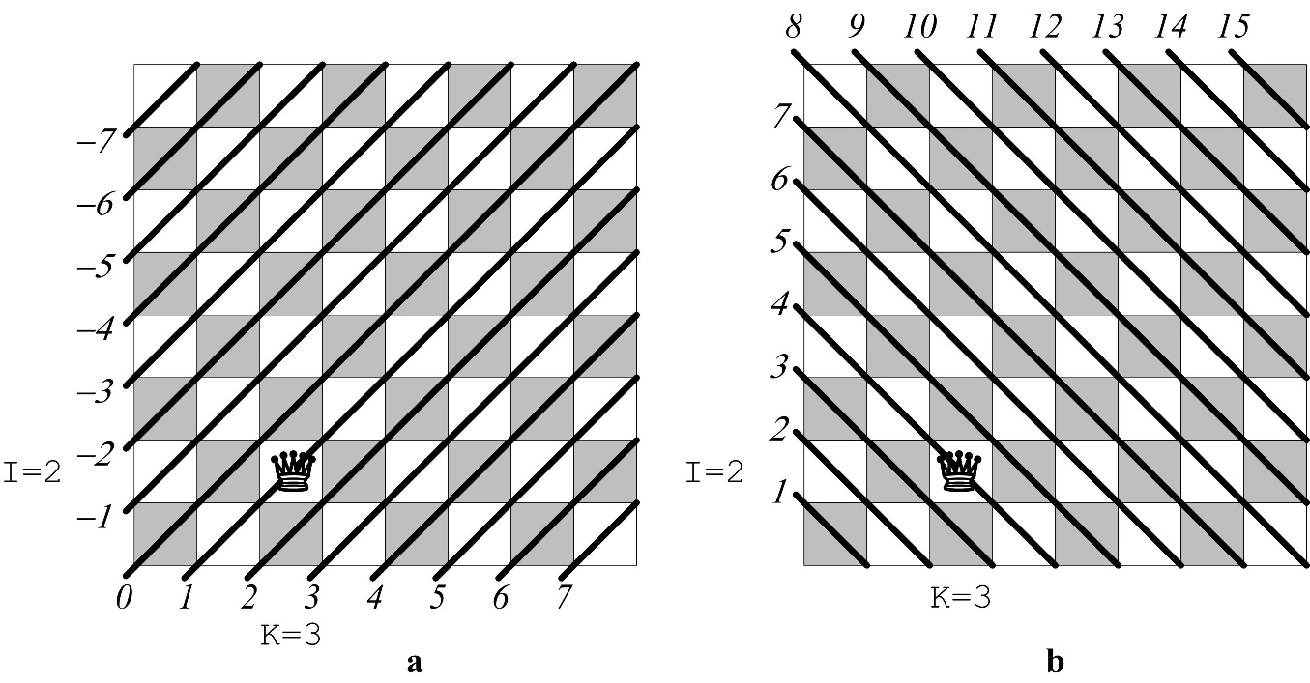

Fig. 4.2. a) Moving up diagonals are numbered from −7 to7.  
b) Moving down diagonals are numbered from 1 to15

**program** QUEENS;  
**const** N = 8;  
 NM1 = 7; *{N-1}*  
 N2M1 = 15; *{2\*N-1}*  
**var** X : **array** [1 .. N] **of** integer;  
 VERT : **array** [1 .. N] **of** boolean; *{Columns.}*  
 UP : **array** [-NM1 .. NM1] **of** boolean; *{Moving up diagonals.}*  
 DOWN : **array** [1..N2M1] **of** boolean; *{Moving down diagonals.}*  
 YES : boolean;  
 I, J : integer;

TRIALS : longint;  
  
**procedure** TRY (I : integer; **var** YES : boolean);   
*{Input I – trial‘s number. Output YES – succeed or no.}* **var** K : integer;  
**begin** K := 0;  
 **repeat** K := K + 1; TRIALS := TRIALS + 1;  
 **if** VERT[K] **and** UP[K - I] **and** DOWN[I + K - 1]  
 **then** *{The column, the up diagonal and the down diagonal are free.}*  
 **begin** X[I] := K;  
 VERT[K] := **false**; UP[K - I] := **false**; DOWN[I + K - 1] := **false**;  
 **if** I < N **then** *{Continue.}* **begin** TRY(I + 1, YES);  
 **if** **not** YES  
 **then** *{Path further is not found.}*  
 **begin** VERT[K] := true; UP[K - I] := **true**;  
 DOWN[I + K - 1] := **true**; *{Free the position.}*  
 **end**;  
 **end** **else** YES := **true**; *{The last row I = N.}*  
 **end**;  
 **until** YES **or** (K = N);  
**end**; *{TRY}*  
  
**begin** *{Main program.}*  
 *{1. Initialise.}*  
 **for** J := 1 **to** N **do** VERT[J] := **true**;  
 **for** J := -NM1 **to** NM1 **do** UP[J] := **true**;  
 **for** J := 1 **to** N2M1 **do** DOWN[J] := **true**;  
 YES := **false**; TRIALS := 0;  
 *{2. Invoke the procedure.}*  
 TRY(1, YES);

*{3. Print the board.}*  
 **if** YES **then**  
 **begin** **for** I := N **downto** 1 **do** **begin** **for** J := 1 **to** N **do** **if** X[I] = J **then** write(1 : 3) **else** write(0 : 3);  
 writeln; *{Write either number 1 or 0 in 3 positions.}*  
 **end**;  
 writeln('The number of trials: ', TRIALS);

**end** **else** writeln('No solution.');  
**end**.

# Heuristic

A heuristic is a rule of thumb; see (Russell, Norvig, 2003, p. 94). The term “heuristic” see Oxford English Dictionary, <http://www.oed.com/>:

**adjective**

a. Serving to find out or discover…

c. Under an ‘heuristic’ programming procedure the computer searches through a number of possible solutions at each stage of the programme, it evaluates a ‘good’ solution for this stage and then proceeds to the next stage. Essentially heuristic programming is similar to the problem solving techniques by trial and error methods which we use in everyday life. (1964 T. W. McRae)

**noun**

b. A process that may solve a given problem, but offers no guarantees of doing so, is called a heuristic for that problem. *Ibid.* For conciseness, we will use ‘heuristic’ as a noun synonymous with ‘heuristic process’. (1957 A. Newell et al.)

## Heuristic search in N-queens problem

As an example, we examine the heuristic which is proposed in (Nilsson 1982, Section 2.1, p. 58) to solve the 4-queens problem. A solution exists; see Fig. 5.1. The problem can be generalised to N*-*queens on an *N*×*N* board. The previous section was devoted to obtaining a solution with the BACKTRACK procedure and involved no heuristics.

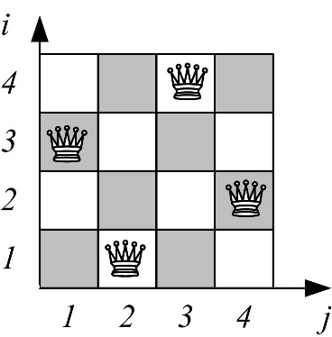

Fig. 5.1. A solution on a 4×4 board

A more efficient algorithm (with less backtracking) can be obtained if we use a more informed rule ordering. One simple, but useful ordering for this problem involves using the function diag(i,j), defined to be the length of the longest diagonal passing through cell (i,j). Let π*ij* be ahead of π*mn* in the ordering if diag(i,j) < diag(m,n). (For equal values of diag, use the same orders as before.) Below we verify that this ordering scheme solves the 4-queens problem with only 2 backtracks. (Nilsson 1998, p. 58)

A corresponding search tree consists of 6 edges and is shown in Fig. 5.4. Let us examine the heuristics in more details. Hence, the heuristic is formalised

πi,j < π i,k, if diag(i,j) < diag(i,k),

where diag(i,j) = max( up(i,j), down(i,j) ). First,

diag(1,1)=max(4,1)=4

Similarly, other row 1 diagonals diag(1,j), j=1,…,4 are calculated:

diag(1,1)=4; diag(1,2)=max(3,2)=3; diag(1,3)=max(2,3)=3; diag(1,4)=max(1,4)=4

Hence

diag(1,2) ≤ diag(1,3) ≤ diag(1,1) ≤ diag(1,4)

Row 1 productions are ordered:

π1,2 < π1,3 < π1,1 < π1,4

Row 2 diagonals, t. y. diag(2,j), j=1,…,4:

diag(2,1)=max(3,1)=3; diag(2,2)=max(4,3)=4; diag(2,3)=max(3,4)=4; diag(2,4)=max(2,3)=3

Row 2 productions are ordered:

π2,1 < π2,4 < π2,2 < π2,3

Row 3 diagonals diag(3,j), j=1,…,4:

diag(3,1)=max(2,3)=3; diag(3,2)=max(3,4)=4; diag(3,3)=max(4,3)=4; diag(3,4)=max(3,2)=3

Row 3 productions are ordered:

π3,1 < π3,4 < π3,2 < π3,3

Row 4 diagonals diag(4,j), j=1,…,4:

diag(4,1)=max(1,4)=4; diag(4,2)=max(2,3)=3; diag(4,3)=max(3,2)=3; diag(4,4)=max(4,1)=4

Row 4 productions are ordered:

π4,2 < π4,3 < π4,1 < π4,4

To sum up, diag(i,j) values are shown in Fig. 5.2.

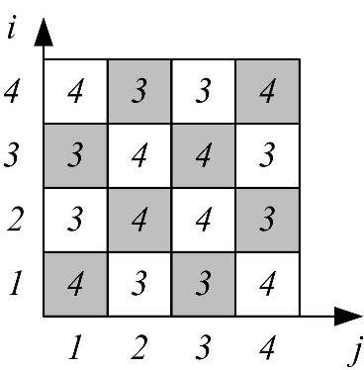

Fig. 5.2. diag(i,j) on a 4×4 board

Hence, the ordering of production rules is as follows:

|  |  |
| --- | --- |
| *π1,2 < π1,3 < π1,1 < π1,4*  *π2,1 < π2,4 < π2,2 < π2,3*  *π3,1 < π3,4 < π3,2 < π3,3*  *π4,2 < π4,3 < π4,1 < π4,4* | – row 1  – row 2  – row 3  – row 4 |

Table 5.3 . Ordering productions on a 4×4 board

A search tree is shown in Fig. 5.4.

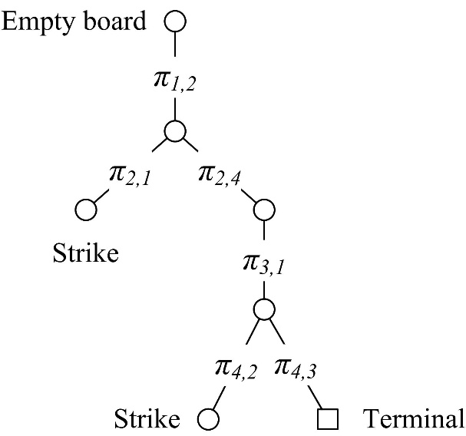

Fig. 5.4. Heuristic search produces a tree of 6 edges. Hence, only 2 backtracks

A search with no heuristic produces a tree shown in Fig. 5.5 (*πi,1 < πi,2 < πi,3 < πi,4*).

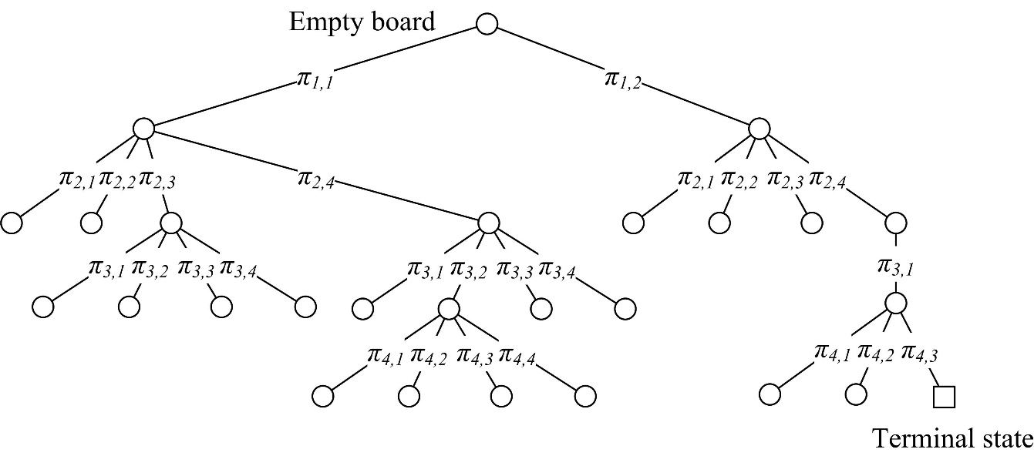

Fig. 5.5. Non-heuristic search on a 4×4 board. 26 edges is significantly more than 6 edges in the case of heuristic search

Heuristic search on an 8×8 board consists of 204 states. First 6 moves are shown in Fig. 5.6. Further moves require backtrack.

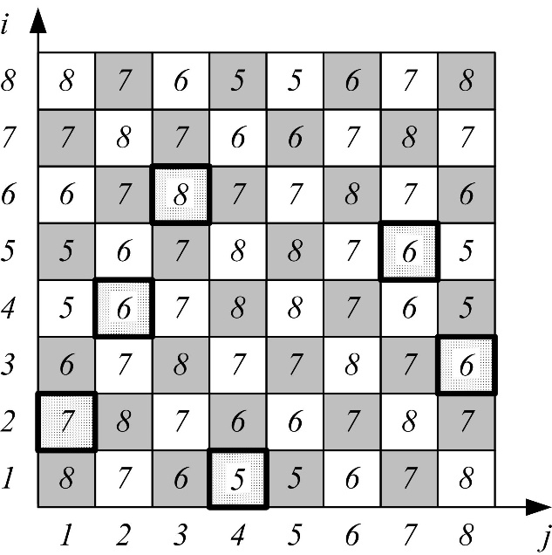

Fig. 5.6. Ordering productions on an 8×8 board

## Knight’s move heuristic in the N-queens problem

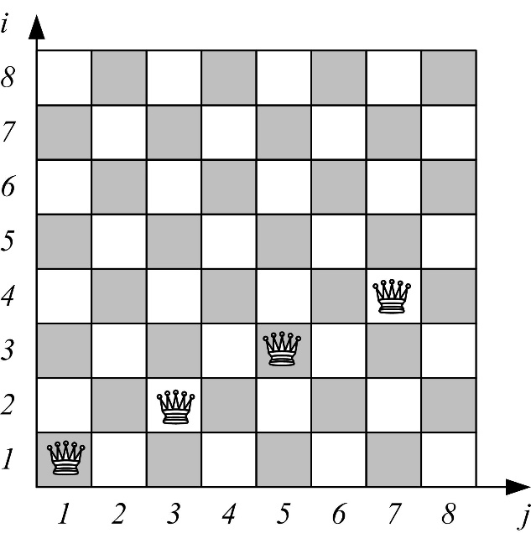

Fig. 5.7. Knight’s move

|  |  |  |
| --- | --- | --- |
| *π* **1** = | { | * [i=1,j=2] if N ≠ 6n+3 * [i=1,j=4] if N = 6n+3 |

|  |  |  |
| --- | --- | --- |
| *πž* = | { | * [i+1,j+2], if within the board. Here [i,j] is the last queen in the previous row * [i+1,j=1], if [i+1,j+2] is out of the board |

|  |  |  |
| --- | --- | --- |
| *πk* = |  | [i,j+1] in a cycle, i.e. [i,j=1] if j+1 > N (out of the board);  In other words, [i,(j mod N) + 1], where [i,j] is the last attempt in this row. |

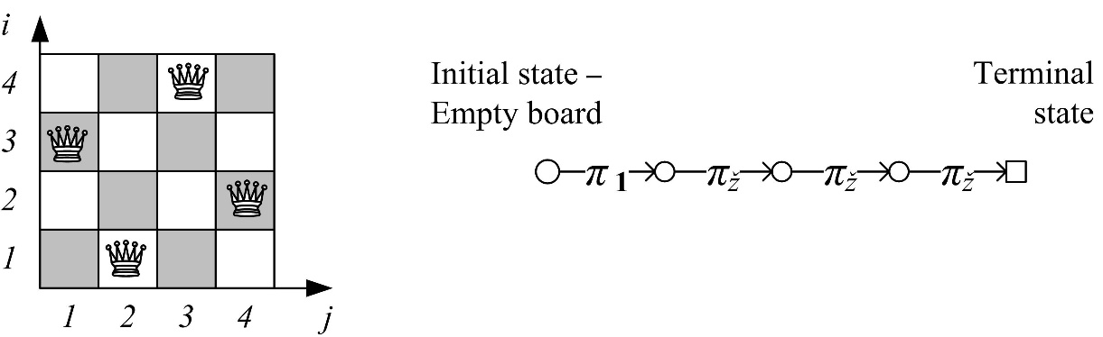

Fig. 5.8. Knight’s move on a 4×4 board with the heuristic

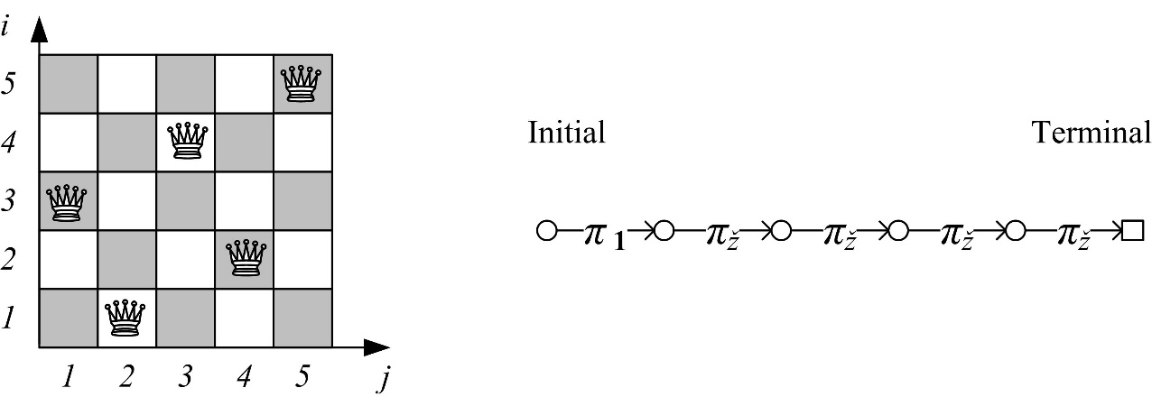

Fig. 5.9. Knight’s move on a 5×5 board with the heuristic

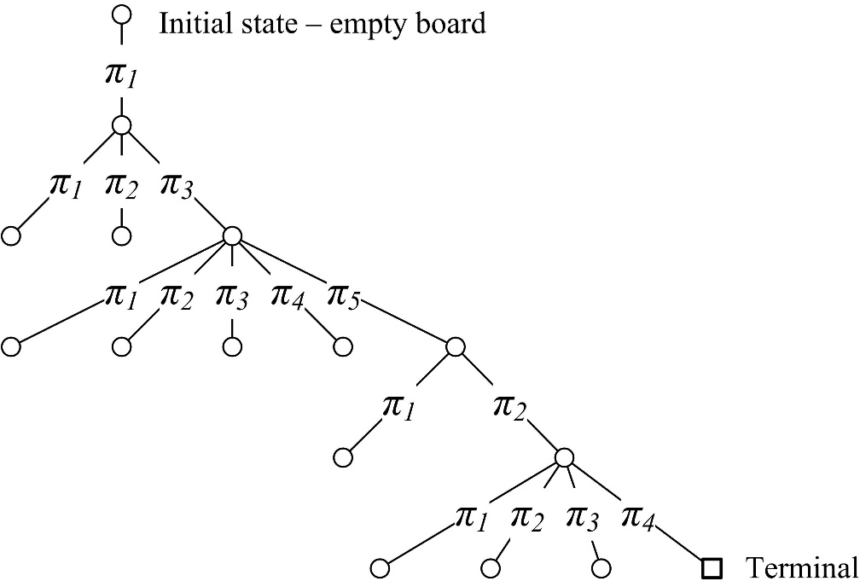

Fig. 5.10. Knight’s move on a 5×5 board with no heuristic – brute force search

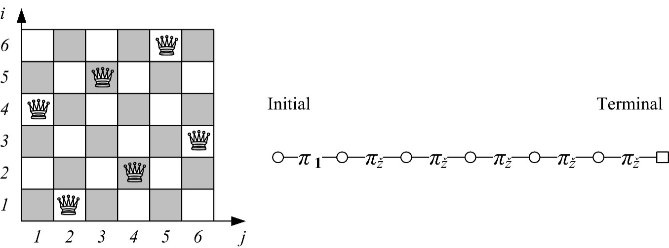

Fig. 5.11. Knight’s move on a 6×6 board with the heuristic

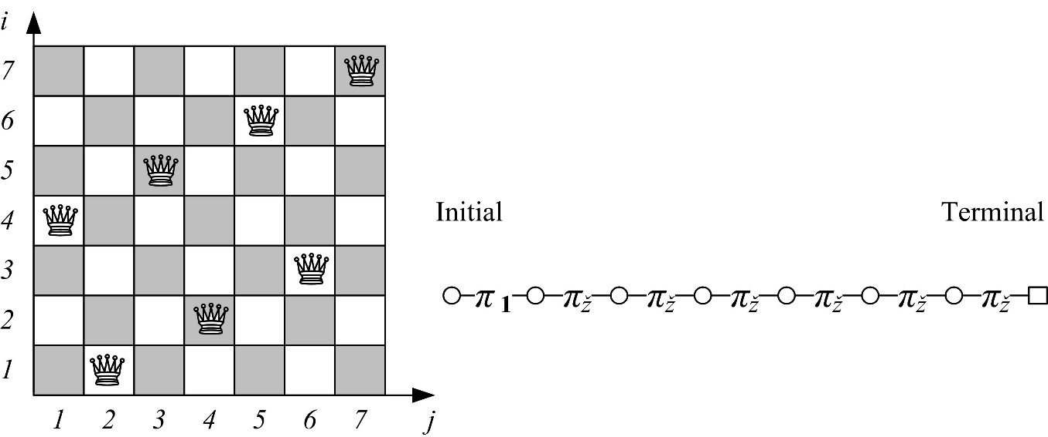

Fig. 5.12. Knight’s move on a 7×7 board with the heuristic

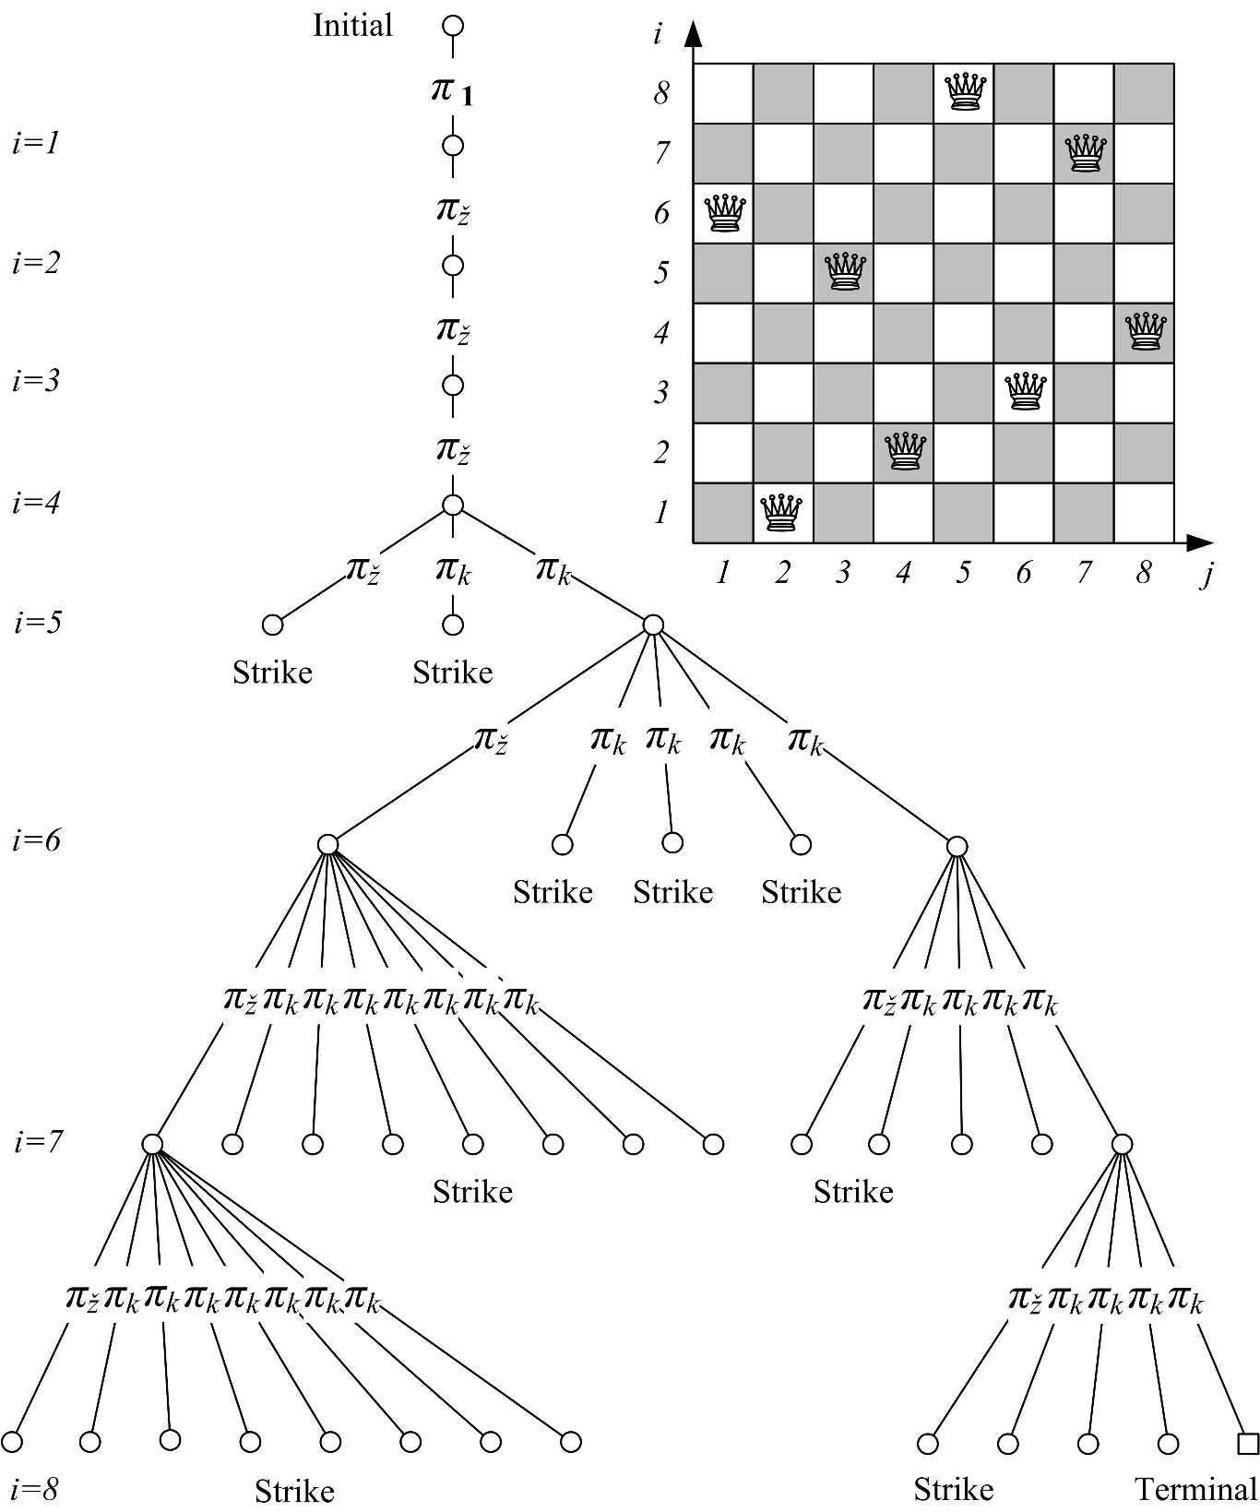

Fig. 5.13. Knight’s move on an 8×8 board with the heuristic. Search space consists of 38 states. This is a significantly smaller number than 204 states in the case of the shortest diagonal heuristic and 876 states in brute force search

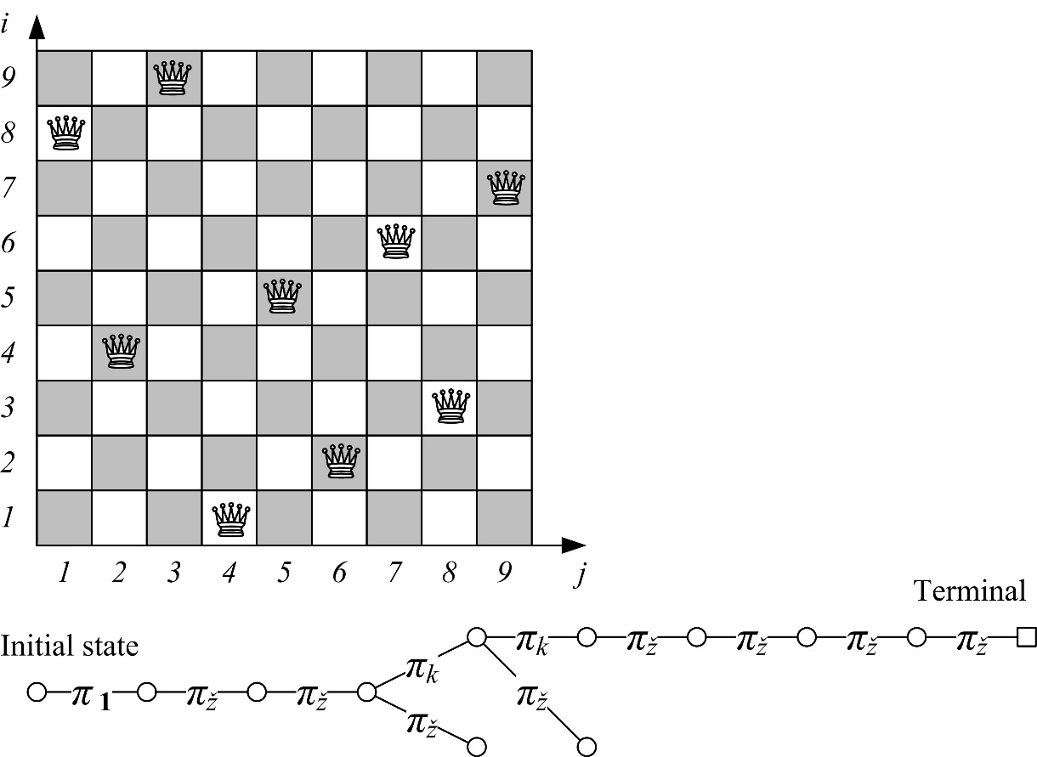

Fig. 5.14. Knight’s move on a 9×9 board with the heuristic

|  |  |  |  |
| --- | --- | --- | --- |
| ***N*** | **Number of states in a search space** | | |
| **Brute force** | **Shortest diagonal** | **Knight’s move** |
| 4 | 26 | 6 | 4 |
| 5 | 15 | 15 | 5 |
| 6 | 171 | 69 | 6 |
| 7 | 42 | 87 | 7 |
| 8 | 876 | 204 | 38 |
| 9 | 333 | 874 | 11 |
| 10 | 975 | 437 | 10 |
| 11 | 517 | 200 | 11 |
| 12 | 3066 | 297 | 12 |
| 13 | 1365 | 684 | 13 |
| 14 | 26495 | 1742 | 300 |
| 15 | 20280 | 487 | 17 |
| 16 | 160712 | 111 | 16 |
| 17 | 91222 | 294 | 17 |
| 18 | 743229 | 7130 | 18 |
| 19 | 48184 | 24714 | 19 |
| 20 | 3992510 | 918 | 372 |
| 21 | 179592 | 48222 | 23 |
| 22 | 38217905 | 40744 | 22 |
| 23 | 584591 | 10053 | 23 |
| 24 | 9878316 | 5723 | 24 |
| 25 | 1216775 | 2887 | 25 |
| 26 | 10339849 | 265187 | 2196 |
| 27 | 12263400 | 986476 | 29 |
| 28 | 84175966 | 2602283 | 28 |
| 29 | 44434525 | 1261296 | 29 |
| 30 | 1692888135 | 52601 | 30 |
| 31 | Many | 1850449 | 31 |
| 32 | Many | 2804692 | 2866 |
| 33 | Many | 2582396 | 35 |
| 34 | Many | 35784 | 34 |
| 35 | Many | 110473 | 35 |
| 36 | Many | 19605979 | 36 |
| 37 | Many | 135980 | 37 |
| 38 | Many | 642244758 | 30532 |
| 39 | Many | 193745 | 41 |
| 40 | Many | 4685041 | 40 |

Table 5.15. Number of states in a search space

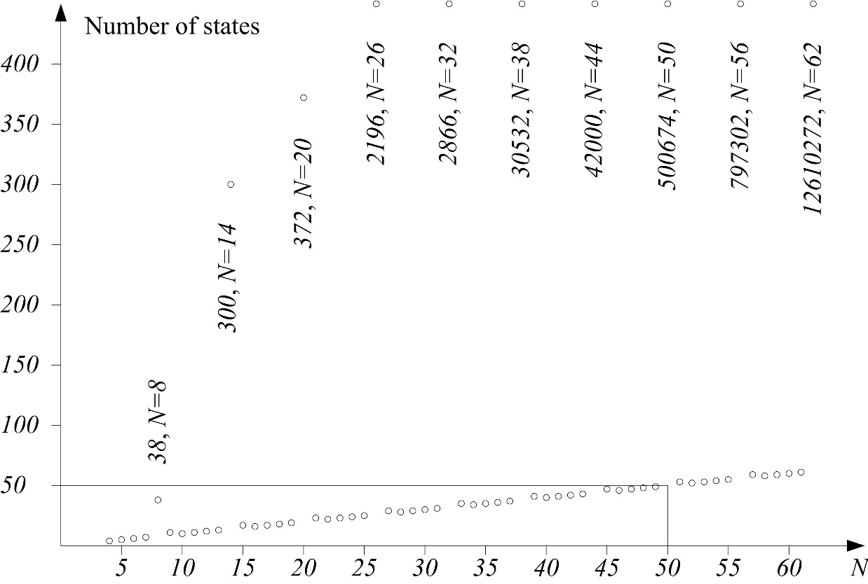

Fig. 5.16. Linear dependence – no backtrack in cases N ∈ {4, 5, 6, 7, 10, 11, 12, 13, 16, 17, 18, 19, 22, 23, 24, 25 etc.}. Backtrack in the remaining cases: N ∈ {8, 9, 14, 15, 20, 21, 26, 27 etc.}. Hypothesis: no backtrack in cases *N*=*6*⋅*n*, *N*=*6*⋅*n*+*1*, *N*=*6*⋅*n*+*4*, and *N*=*6*⋅*n*+*5*; backtrack in cases *N*=6⋅*n*+*2* and *N*=6⋅*n*+*3*

|  |  |  |  |  |
| --- | --- | --- | --- | --- |
| A student formulated the following hypothesis. Prove it or disprove it. | *N* = | { | *6*⋅*n*  *6*⋅*n*+*1*  *6*⋅*n*+*2*  *6*⋅*n*+*3*  *6*⋅*n*+*4*  *6*⋅*n*+*5* | * + - * No backtrack       * No backtrack       * Backtrack       * Backtrack       * No backtrack       * No backtrack |

# BACKTRACK1 – a cycle-avoiding algorithm

Below we follow [Nilsson 1982 Section 2.1, p. 56–61]. Procedure BACKTRACK may never terminate; it may generate new nonterminal databases indefinitely or it may cycle. (Cycling is demonstrated with a LABYRINTH depth-first search program in the next section.) Both of these cases can be arbitrarily prevented by imposing a *depth bound* on the recursion. Cycling can be more straightforwardly prevented by maintaining a list of the databases produced so far and by checking new ones to see that they do not match any on the list.

Therefore we need a slightly more complex algorithm to avoid cycles. All databases on a path back to the initial one must be checked to insure that none are revisited. In order to implement this backtracking strategy as a recursive procedure, the entire chain of databases must be an argument of the procedure. Again, practical implementations of AI backtracking production systems use various techniques to avoid the need for explicitly listing all of these databases in their entirety.

BACKTRACK1 takes a list of databases as its argument; when first called, this list contains the initial database as its single element. Upon successful termination, BACKTRACK1 returns a sequence of rules that can be applied to the initial database to produce one that satisfies the termination condition.

**procedure** BACKTRACK1(DATALIST); *{Returns a list of rules.}*  
*{ 1}* DATA := FIRST(DATALIST); *{DATALIST – is a list of all  
 databases on a path back to the initial one.  
 DATA is the most recent one produced.}*  
*{ 2}* **if** MEMBER(DATA, TAIL(DATALIST)) **then return** FAIL; *{The*  
  *procedure fails if it revisits an earlier database.}*  
*{ 3}* **if** TERM(DATA) **then** **return** NIL;  
*{ 4}* **if** DEADEND(DATA) **then** **return** FAIL;  
*{ 5}* **if** LENGTH(DATALIST) > BOUND **then** **return** FAIL;  
 *{The procedure fails if too many rules have been  
 applied. BOUND is a global variable specified  
 before the procedure is first called.}*  
*{ 6}* RULES := APPRULES(DATA);  
*{ 7}* LOOP: **if** NULL(RULES) **then** **return** FAIL;  
*{ 8}* R := FIRST(RULES);  
*{ 9}* RULES := TAIL(RULES); *{E.g., TAIL(〈a,b,c〉)=〈b,c〉.}*  
*{10}* RDATA := R(DATA);  
*{11}* RDATALIST := CONS(RDATA, DATALIST); *{The list of data-  
 bases visited so far is extended by adding RDATA.}*  
*{12}* PATH := BACKTRACK1(RDATALIST);  
*{13}* **if** PATH = FAIL **then** **goto** LOOP;  
*{14}* **return** CONS(R, PATH);  
**end** **procedure**;

The 8-puzzle example of backtracking that is examined further uses BOUND = 7. Note that BACKTRACK1 does not remember *all* databases that it visited previously. Backtracking involves “forgetting” all databases whose paths lead to failures. BACKTRACK1 remembers only those databases on the *current* path back to the initial one, i.e. the thread. Hence, DATALIST plays the role of a stack.

# Depth-first search in a labyrinth

This section demonstrates the BACKTRACK1 procedure in a labyrinth. The labyrinth is represented as a two-dimensional array. Wall tiles are marked with 1 and free ones with 0. Agent position is marked with 2; see Fig. 7.1. (See also <https://en.wikipedia.org/wiki/Labyrinth>; labyrinth variation maze see <https://en.wikipedia.org/wiki/Maze_solving_algorithm>.)

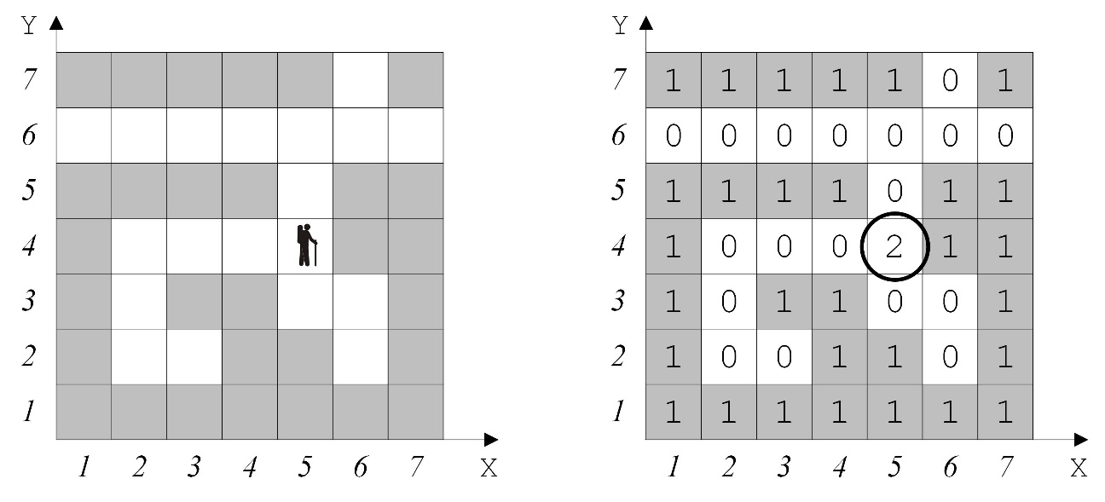

Fig. 7.1. A sample labyrinth and its representation with a two-dimensional array LAB. Wall tiles are marked 1 and free ones 0. Three exits are LAB[1,6], LAB[7,6] and LAB[6,7]. The agent starts from the position X=5, Y=4 marked 2, i.e. LAB[5,4] = 2

|  |  |
| --- | --- |
| The agent can move in four directions {*π1, π2, π3, π4*}; see Fig. 7.2. A BACKTRACK1 program is presented below. It finds a path. The list DATALIST plays the stack’s role. Metaphorically it corresponds to Ariadne’s thread; see the Greek myth, <https://en.wikipedia.org/wiki/Ariadne>.  7-2  Fig. 7.2. Agent’s four moves | 7-3  Fig. 7.3. A sample labyrinth with an infinite cycle for BACKTRACK. However, BACKTRACK1 finds a path. Agent starts from X=5, Y=4 |

**program** LABYRINTH; *{BACKTRACK1, i.e. depth-first, no infinite cycle.}*  
**const** M = 7; N = 7; *{Dimensions.}*  
**var** LAB : **array**[1..M, 1..N] **of** integer; *{Labyrinth.}*  
 CX, CY : **array**[1..4] **of** integer; *{4 production – shifts in X and Y.}*  
 L, *{Move’s number. Starts from 2. Visited positions are marked.}*  
 X, Y, *{Agent’s initial position.}*  
 I, J, *{Loop variables.}*  
 TRIAL : integer; *{Number of trials. To compare effectiveness.}*  
 YES : boolean; *{True – success, false – failure.}*  
  
**procedure** TRY(X, Y : integer; **var** YES : boolean);  
 **var** K, *{The number of a production rule.}*  
 U, V : integer; *{Agent’s new position.}*  
**begin** *{TRY}*  
*{K1}* **if** (X = 1) **or** (X = M) **or** (Y = 1) **or** (Y = N)  
 **then** YES := **true** *{TERM(DATA} = true on the boarder.}*  
 **else** **begin** K := 0;  
*{K2}* **repeat** K := K + 1; *{Next rule. Loop over production rules.}*  
*{K3}* U := X + CX[K]; V := Y + CY[K]; *{Agent’s new position.}*  
*{K4}* **if** LAB[U, V] = 0 *{If a cell is free.}*  
 **then** **begin** TRIAL := TRIAL + 1; *{Number of trials.}*  
*{K5}* L := L + 1; **LAB[U,V] := L**;*{Marking the cell.}*  
*{K6}* TRY(U, V, YES); *{Recursive call.}*  
 **if** **not** YES *{If failure}*  
*{K7}* **then begin**   
*{K8}* LAB[U,V] := **-1**; *{then mark. (****0*** *in case of BACKTRACK).}*  
 L := L - 1;  
 **end**;  
 **end**;  
 **until** YES **or** (K = 4);  
 **end**;  
**end**; *{TRY}*  
  
**begin** *{Main program.}*  
 *{1. Reading the labyrinth.}*  
 **for** J := N **downto** 1 **do** **begin** **for** I := 1 **to** M **do** read(LAB[I,J]);  
 readln;  
 **end**;  
 *{2. Reading agent’s position.}*  
 read(X, Y); L := 2; LAB[X,Y] := L;  
 *{3. Forming four production rules.}*  
 CX[1] := -1; CY[1] := 0; *{Go West. 4 }*  
 CX[2] := 0; CY[2] := -1; *{Go South. 1 \* 3 }*  
 CX[3] := 1; CY[3] := 0; *{Go East. 2 }*  
 CX[4] := 0; CY[4] := 1; *{Go North. }*  
 *{4. Initialising variables.}*  
 YES := **false**; TRIAL := 0;  
 *{5. Invoking the BACKTRACK1 procedure.}*  
 TRY(X, Y, YES);   
 **if** YES  
 **then** writeln('Path exists'); *{Please also print the path found.}*  
 **else** writeln('Path does not exist'); *{No paths exist.}*  
**end**.

***Three variations:***

V1) LAB[U,V] := –1. This is BACKTRACK\_ WITH\_CLOSED.

V2) LAB[U,V] := 0 and LAB[U,V]:=L above. This is BACKTRACK1. Two routes around an island, but no cycles.

V3) LAB[U,V] := 0 and **no** LAB[U,V]:=L. This is the classical BACKTRACK. Infinite cycle.

Search tree is shown in Fig. 7.4. Note three variations V1, V2 and V3. Following is the ordering according to time efficiency, where < denotes ordering:

BACKTRACK < BACKTRACK1 < BACKTRACK\_WITH\_CLOSED*.*

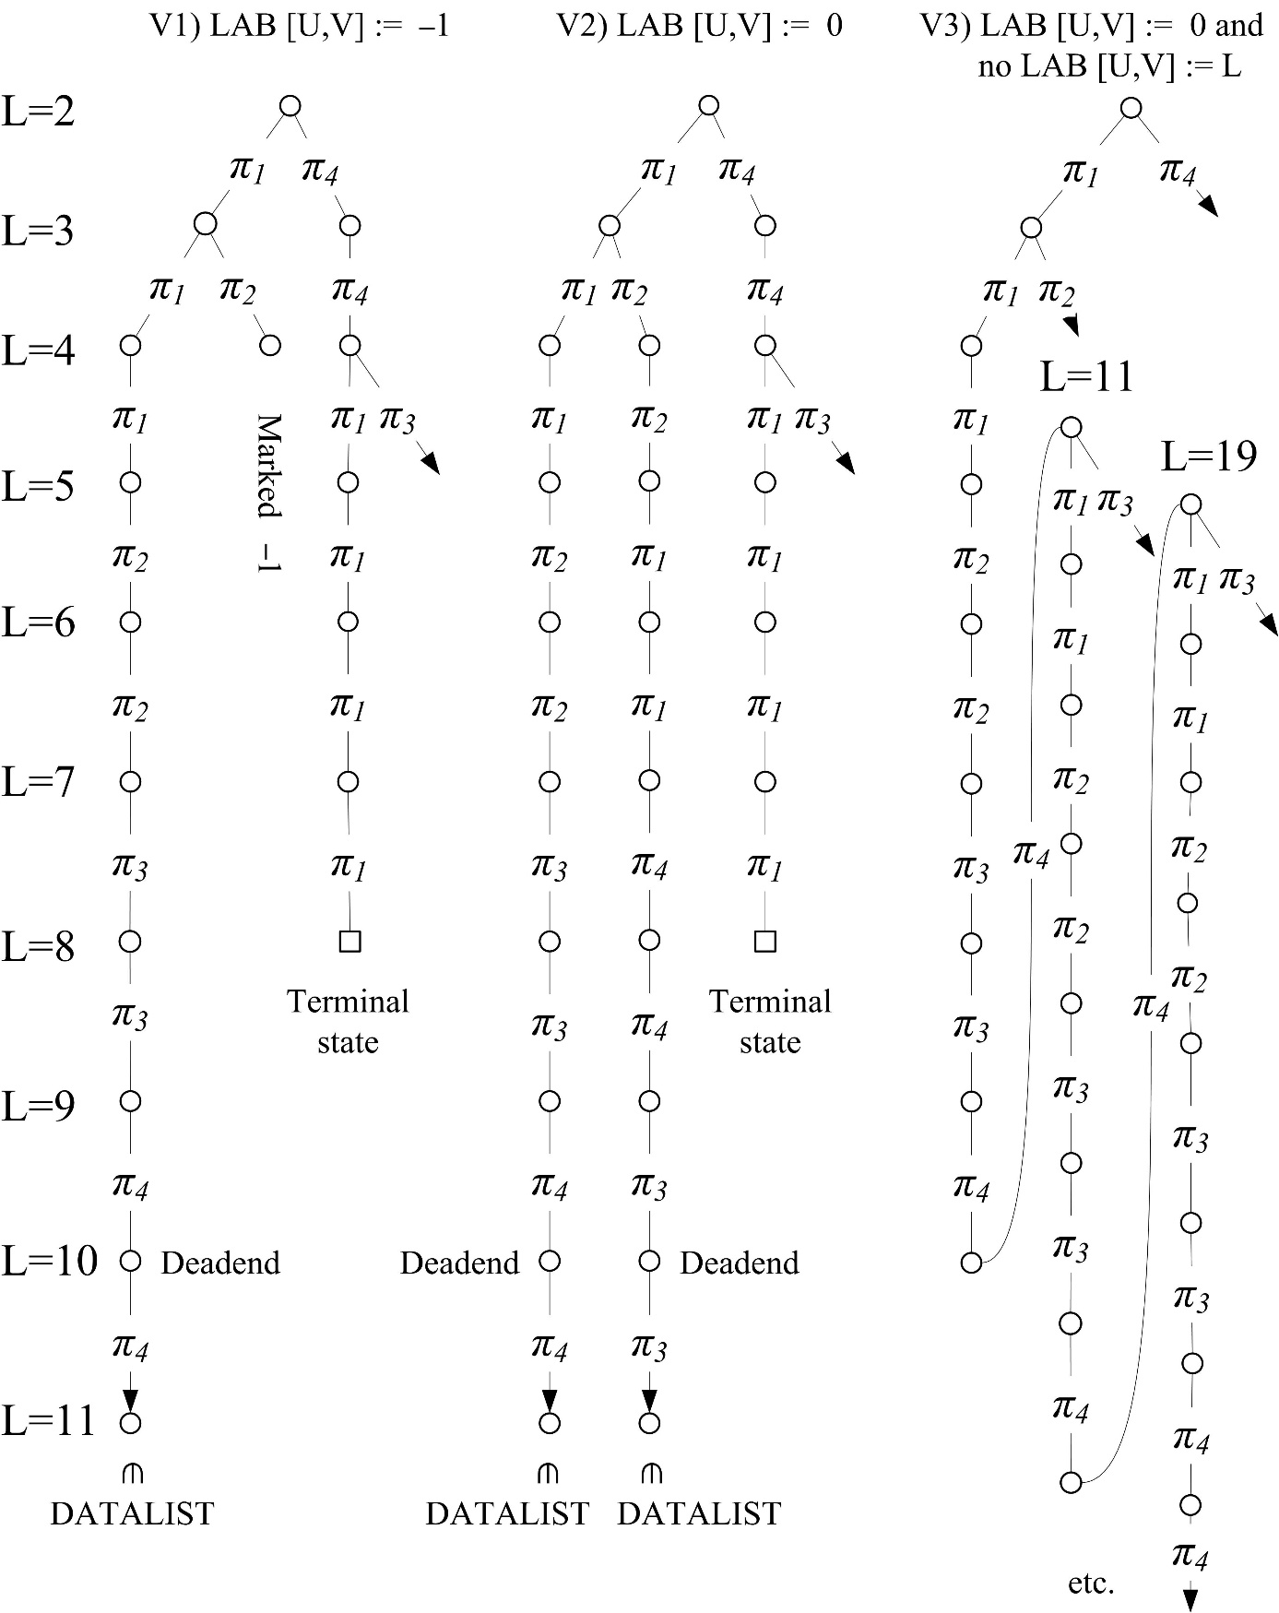

Fig. 7.4. Three variations of search tree in the labyrinth which is shown in Fig. 7.3. V1) LAB[U,V] := –1. BACKTRACK\_WITH\_CLOSED. V2) LAB[U,V] := 0 and LAB[U,V] := L. This is BACKTRACK1, i.e. BACKTRACK with DATALIST as a stack. An “island” is searched from two sides. No infinite cycles. V3) LAB[U,V] := 0 and no LAB[U,V] := L. This is the classical BACKTRACK that runs into infinite loop

## Testing depth-first search in a labyrinth

Modify your labyrinth depth-first solver to test it with the labyrinth in Fig. 7.3. Print the trace as follows. The second test: build your labyrinth 20×15 with the resulting path length over 100 productions and multiple deadends (to be marked –1 during the execution).

PART 1. Data

1.1. Labyrinth

Y, V

7 | 1 1 1 1 1 0 1

6 | 0 0 0 0 0 0 0

5 | 1 1 1 1 0 1 1

4 | 1 0 0 0 0 1 1

3 | 1 0 1 0 1 1 1

2 | 1 0 0 0 1 1 1

1 | 1 1 1 1 1 1 1

-------------------------------> X, U

1 2 3 4 5 6 7

1.2. Initial position X=5, Y=4. L=2.

PART 2. Trace

1) R1. U=4, V=4. Free. L:=L+1=3. LAB[4,4]:=3.

2) -R1. U=3, V=4. Free. L:=L+1=4. LAB[3,4]:=4.

3) --R1. U=2, V=4. Free. L:=L+1=5. LAB[2,4]:=5.

4) ---R1. U=1, V=4. Wall.

5) ---R2. U=2, V=3. Free. L:=L+1=6. LAB[2,3]:=6.

6) ----R1. U=1, V=3. Wall.

7) ----R2. U=2, V=2. Free. L:=L+1=7. LAB[2,2]:=7.

8) -----R1. U=1, V=2. Wall.

9) -----R2. U=2, V=1. Wall.

10) -----R3. U=3, V=2. Free. L:=L+1=8. LAB[3,2]:=8.

11) ------R1. U=2, V=2. Thread.

12) ------R2. U=3, V=1. Wall.

13) ------R3. U=4, V=2. Free. L:=L+1=9. LAB[4,2]:=9.

14) -------R1. U=3, V=2. Thread.

15) -------R2. U=4, V=1. Wall.

16) -------R3. U=5, V=2. Wall.

17) -------R4. U=4, V=3. Free. L:=L+1=10. LAB[4,3]:=10.

18) --------R1. U=3, V=3. Wall.

19) --------R2. U=4, V=2. Thread.

20) --------R3. U=5, V=3. Wall.

21) --------R4. U=4, V=4. Thread.

--------Backtrack from X=4, Y=3, L=10. LAB[4,3]:=-1. L:=L-1=9.

-------Backtrack from X=4, Y=2, L=9. LAB[4,2]:=-1. L:=L-1=8.

22) ------R4. U=3, V=3. Wall.

------Backtrack from X=3, Y=2, L=8. LAB[3,2]:=-1. L:=L-1=7.

23) -----R4. U=2, V=3. Thread.

-----Backtrack from X=2, Y=2, L=7. LAB[2,2]:=-1. L:=L-1=6.

24) ----R3. U=3, V=3. Wall.

25) ----R4. U=2, V=4. Thread.

----Backtrack from X=2, Y=3, L=6. LAB[2,3]:=-1. L:=L-1=5.

26) ---R3. U=3, V=4. Thread.

27) ---R4. U=2, V=5. Wall.

---Backtrack from X=2, Y=4, L=5. LAB[2,4]:=-1. L:=L-1=4.

28) --R2. U=3, V=3. Wall.

29) --R3. U=4, V=4. Thread.

30) --R4. U=3, V=5. Wall.

--Backtrack from X=3, Y=4, L=4. LAB[3,4]:=-1. L:=L-1=3.

31) -R2. U=4, V=3. Thread.

32) -R3. U=5, V=4. Thread.

33) -R4. U=4, V=5. Wall.

-Backtrack from X=4, Y=4, L=3. LAB[4,4]:=-1. L:=L-1=2.

34) R2. U=5, V=3. Wall.

35) R3. U=6, V=4. Wall.

36) R4. U=5, V=5. Free. L:=L+1=3. LAB[5,5]:=3.

37) -R1. U=4, V=5. Wall.

38) -R2. U=5, V=4. Thread.

39) -R3. U=6, V=5. Wall.

40) -R4. U=5, V=6. Free. L:=L+1=4. LAB[5,6]:=4.

41) --R1. U=4, V=6. Free. L:=L+1=5. LAB[4,6]:=5.

42) ---R1. U=3, V=6. Free. L:=L+1=6. LAB[3,6]:=6.

43) ----R1. U=2, V=6. Free. L:=L+1=7. LAB[2,6]:=7.

44) -----R1. U=1, V=6. Free. L:=L+1=8. LAB[1,6]:=8. Terminal.

PART 3. Results

3.1. Path is found.

3.2. Path graphically

Y, V

7 | 1 1 1 1 1 0 1

6 | 8 7 6 5 4 0 0

5 | 1 1 1 1 3 1 1

4 | 1 -1 -1 -1 2 1 1

3 | 1 -1 1 -1 1 1 1

2 | 1 -1 -1 -1 1 1 1

1 | 1 1 1 1 1 1 1

-------------------------------> X, U

1 2 3 4 5 6 7

3.3. Rules: R4, R4, R1, R1, R1, R1.

3.4. Nodes: [X=5,Y=4], [X=5,Y=5], [X=5,Y=6], [X=4,Y=6], [X=3,Y=6], [X=2,Y=6], [X=1,Y=6].

# Breadth-first search in a labyrinth

Suppose a labyrinth and four production rules {π1, π2, π3, π4}; see Fig. 8.1. The breadth-first search (BFS) tree is shown in Fig.8.2. The same tree is shown in Fig. 8.3 but in layers.

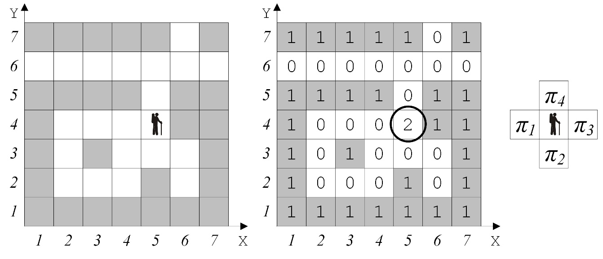

Fig. 8.1. A sample labyrinth and its representation to demonstrate breadth-first search. Agent starts from the position X=5, Y=4

|  |  |
| --- | --- |
| Fig. 8.2. Breadth-first search (BFS) tree. The nodes of each consecutive layer (“wave”) are shown in a separate ring |  |

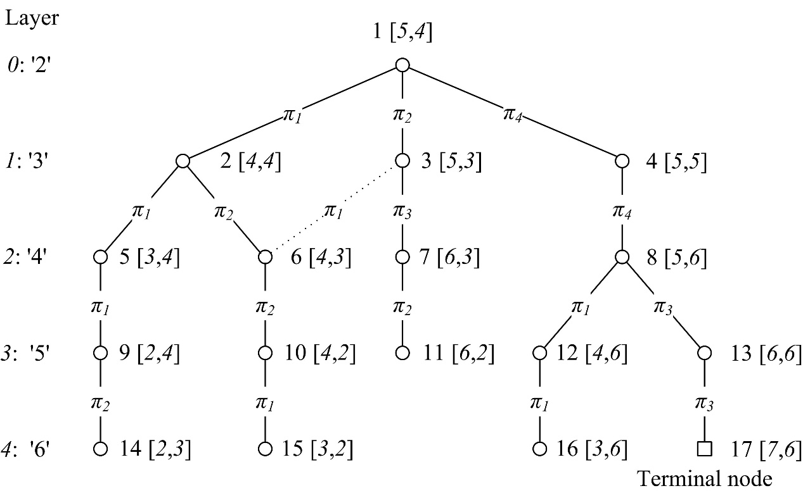

Fig. 8.3. A search tree with nodes sorted by layers (“waves”)

The global database after procedure’s completion is shown in Fig. 8.4 a. Array representation after the path is collected in order to print it is shown in Fig. 8.4 b.

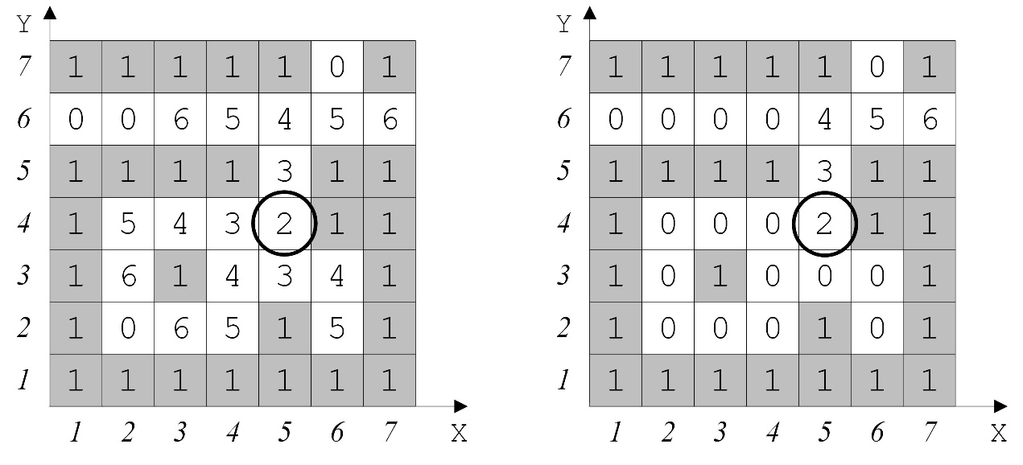

Fig. 8.4. a) The final state of the global database – the procedure is completed. b) Array representation after the path is collected

**program** LABYRINTH\_BREADTH\_FIRST (input, output);  
 **const** M = 7; N = 7; *{The dimensions of the labyrinth. }*  
 MN = 49; *{The number of cells M\*N. }*  
 **var** LAB, LABCOPY : **array**[1..M, 1..N] **of** integer; *{Labyrinth and its copy.}*  
 CX, CY : **array**[1..4] **of** integer; *{4 production rules. }*  
 FX, FY : **array**[1..MN] **of** integer; *{The “front” to store opened nodes.}*  
 CLOSE, *{The counter for a closed node. }*  
 NEWN, *{The counter for an opened node. }*  
 K, *{The counter for a production. }*  
 X, Y, *{The start position of the agent. }*  
 U, V, I, J : integer;  
 YES : boolean;  
  
**procedure** BACK(U, V : integer); *{Collect the path from the exit to start.}*  
 *{INPUT: 1) U, V – the coordinates of the exit, and 2) global LABCOPY.}  
 {OUTPUT: LAB. }*  
 **var** K, UU, VV : integer;  
**begin** *{BACK}*  
 LAB[U,V] := LABCOPY[U,V]; *{The exit position is marked. }*  
 K := 5;  
 **repeat** *{The search within 4 productions. Search for cell LABCOPY[UU,VV]}  
 {with the mark which is 1 less than LABCOPY[U,V]. }*  
 K := K - 1; UU := U + CX[K]; VV := V + CY[K];  
 **if** (1 <= UU) **and** (UU <= M) **and** (1 <= VV) **and** (VV <= N)  
 **then** *{Inside the boarders.}*  
 **if** LABCOPY[UU,VV] = LABCOPY[U,V] – 1  
 **then**  
 **begin**  
 LAB[UU,VV] := LABCOPY[UU,VV] ; *{Marking a cell in LAB. }*  
 U := UU; V := VV; K := 5; *{Swapping the variables. }*  
 **end**;  
 **until** LABCOPY[U, V] = 2;  
**end**; {BACK}  
  
**begin** *{Main program}*  
 *{ 1. Reading the labyrinth.}*  
 **for** J := N **downto** 1 **do**  
 **begin**  
 **for** I := 1 **to** M **do**  
 **begin** read(LAB[I,J]);  
 LABCOPY[I,J]:= LAB[I,J];  
 **end**  
 **readln**;  
 **end**;  
 *{ 2. Reading the starting position of the agent.}*  
 read(X,Y); LABCOPY[X,Y]:=2;  
  
 *{ 3. Initialising 4 production rules.}*  
 CX[1] := -1; CY[1] := 0; *{Go West. 2 }*  
 CX[2] := 0; CY[2] := -1; *{Go South. 1 \* 3 }*  
 CX[3] := 1; CY[3] := 0; *{Go East. 4 }*  
 CX[4] := 0; CY[4] := 1; *{Go North. }*  
  
 *{ 4. Assigning initial values.}*  
 FX[1] := X; FY[1] := Y; CLOSE := 1; NEWN := 1; YES := **false**;

{ *5. Breadth-first search -- the “wave” algorithm.}*  
 **if** (X = 1) **or** (X = M) **or** (Y = 1) **or** (Y = N)  
 **then** *{If an exit is reached then finish.}*  
 **begin** YES := **true**; U := X; V := Y;  
 **end**;  
 **if** (X > 1) **and** (X < M) **and** (Y > 1) **and** (Y < N)  
 **then**  
 **repeat** *{The loop through the nodes.}*  
 X := FX[CLOSE]; Y := FY[CLOSE]; *{Coordinates of node to be closed.}*  
 K := 0;  
 **repeat** *{The loop trough 4 production rules.}*  
 K := K + 1; U := X + CX[K]; V := Y + CY[K];  
 **if** LABCOPY[U, V] = 0 {*The cell is free.}*  
 **then** **begin**  
 LABCOPY[U,V] := LABCOPY[X,Y] + 1; *{New wave’s number.}*  
 **if** (U = 1) **or** (U = M) **or** (V = 1) **or** (V = N) *{Boarder. }*  
 **then** YES := **true**; *{Success. Here BACK(U,V) could be called.}*  
 **else** **begin** *{Placing a newly opened node into front’s end. }*  
 NEWN := NEWN + 1; FX[NEWN] := U; FY[NEWN] := V;  
 **end**;  
 **end**;  
 **until** (K = 4) **or** YES; *{Each of 4 productions is checked or success.}*  
 CLOSE := CLOSE + 1; *{Next node will be closed.}*  
 **until** (CLOSE > NEWN) **or** YES;  
  
 *{ 6. Printing the path found.}*  
 **if** YES  
 **then** **begin**  
 writeln('The path exists.');  
 BACK(U,V); *{Collecting the path.}*  
 *{ Here a procedure should be called to print the path.}*  
 **end**  
 **else** writeln('No path.');  
**end**.

A solution is 〈*π4*, *π4*, *π3*, *π3*〉. During program execution, the coordinates of newly opened nodes are placed into the arrays FX and FY. This is shown in Fig. 8.5.

|  |  |  |  |  |  |  |  |  |  |  |  |  |  |  |  |  |  |
| --- | --- | --- | --- | --- | --- | --- | --- | --- | --- | --- | --- | --- | --- | --- | --- | --- | --- |
| ***I*** | **1** | **2** | **3** | **4** | **5** | **6** | **7** | **8** | **9** | **10** | **11** | **12** | **13** | **14** | **15** | **16** | **17** |
| Wave | '2' | '3' | '3' | '3' | '4' | '4' | '4' | '4' | '5' | '5' | '5' | '5' | '5' | '6' | '6' | '6' | '6' |
| FX | 5 | 4 | 5 | 5 | 3 | 4 | 6 | 5 | 2 | 4 | 6 | 4 | 6 | 2 | 3 | 3 | 7 |
| FY | 4 | 4 | 3 | 5 | 4 | 3 | 3 | 6 | 4 | 2 | 2 | 6 | 6 | 3 | 2 | 6 | 6 |
| CLOSE:=1 | CLOSE=1 | CLOSE=1 | CLOSE=1 | CLOSE=1 | CLOSE=2 | CLOSE=2 | CLOSE=3 | CLOSE=4 | CLOSE=5 | CLOSE=6 | CLOSE=7 | CLOSE=8 | CLOSE=8 | CLOSE=9 | CLOSE=10 | CLOSE=12 | CLOSE=13 |
|  | NEWN:=2 | NEWN:=3 | NEWN:=4 | NEWN:=5 | NEWN:=6 | NEWN:=7 | NEWN:=8 | NEWN:=9 | NEWN:=10 | NEWN:=11 | NEWN:=12 | NEWN:=13 | NEWN:=14 | NEWN:=15 | NEWN:=16 | NEWN:=17 | NEWN:=18 |

Fig. 8.5. The frontier arrays FX[*i*] and FY[*i*] during the execution

Breadth-first search visits the neighbour vertices before visiting the child vertices, and a queue is used. Depth-first search visits the child vertices before visiting the sibling vertices. A stack (often the program’s call stack via recursion) is generally used when implementing the algorithm; see Wikipedia, <https://en.wikipedia.org/wiki/Breadth-first_search>, <https://en.wikipedia.org/wiki/Depth-first_search>, and also <https://en.wikipedia.org/wiki/Graph_traversal>.

## Testing breadth-first search in a labyrinth

Modify your labyrinth depth-first solver to print the labyrinth Fig. 8.1 test as follows. Then build your labyrinth 20x15 with multiple deadends and the path over 100 productions.

PART 1. Data

1.1. Labyrinth

Y, V

7 | 1 1 1 1 1 0 1

6 | 0 0 0 0 0 0 0

5 | 1 1 1 1 0 1 1

4 | 1 0 0 0 2 1 1

3 | 1 0 1 0 0 0 1

2 | 1 0 0 0 1 0 1

1 | 1 1 1 1 1 1 1

-------------------------------> X, U

1 2 3 4 5 6 7

1.2. Initial position X=5, Y=4. L=2.

PART 2. Trace

WAVE 0, label L="2". Initial position X=5, Y=4, NEWN=1

WAVE 1, label L="3"

Close CLOSE=1, X=5, Y=4.

R1. X=4, Y=4. Free. NEWN=2.

R2. X=5, Y=3. Free. NEWN=3.

R3. X=6, Y=4. Wall.

R4. X=5, Y=5. Free. NEWN=4.

WAVE 2, label L ="4"

Close CLOSE=2, X=4, Y=4.

R1. X=3, Y=4. Free. NEWN=5.

R2. X=4, Y=3. Free. NEWN=6.

R3. X=5, Y=4. CLOSED or OPEN.

R4. X=4, Y=5. Wall.

Close CLOSE=3, X=5, Y=3.

R1. X=4, Y =3. CLOSED or OPEN.

R2. X=5, Y =2. Wall.

R3. X=6, Y =3. Free. NEWN=7.

R4. X=5, Y =4. CLOSED or OPEN.

Close CLOSE =4, X=5, Y=5.

R1. X=4, Y=5. Wall.

R2. X=5, Y=4. CLOSED or OPEN.

R3. X=6, Y=5. Wall.

R4. X=5, Y=6. Free. NEWN=8.

WAVE 3, label L="5"

Close CLOSE=5, X=3, Y=4.

R1. X=2, Y=4. Free. NEWN=9.

R2. X=3, Y=3. Wall.

R3. X=4, Y=4. CLOSED or OPEN.

R4. X=3, Y=5. Wall.

Close CLOSE=6, X=4, Y=3.

R1. X=3, Y=3. Wall.

R2. X=4, Y=2. Free. NEWN=10.

R3. X=5, Y=3. CLOSED or OPEN.

R4. X=4, Y=4. CLOSED or OPEN.

Close CLOSE=7, X=6, Y=3.

R1. X=5, Y=3. CLOSED or OPEN.

R2. X=6, Y=2. Free. NEWN=11.

R3. X=7, Y=3. Wall.

R4. X=6, Y=4. Wall.

Close CLOSE=8, X=5, Y=6.

R1. X=4, Y=6. Free. NEWN=12.

R2. X=5, Y=5. CLOSED or OPEN.

R3. X=6, Y=6. Free. NEWN=13.

R4. X=5, Y=7. Wall.

WAVE 4, label L="6"

Close CLOSE=9, X=2, Y=4.

R1. X=1, Y=4. Wall.

R2. X=2, Y=3. Free. NEWN=14.

R3. X=3, Y=4. CLOSED or OPEN.

R4. X=2, Y=5. Wall.

Close CLOSE=10, X=4, Y=2.

R1. X=3, Y=2. Free. NEWN=15.

R2. X=4, Y=1. Wall.

R3. X=5, Y=2. Wall.

R4. X=4, Y=3. CLOSED or OPEN.

Close CLOSE=11, X=6, Y=2.

R1. X=5, Y=2. Wall.

R2. X=6, Y=1. Wall.

R3. X=7, Y=2. Wall.

R4. X=6, Y=3. CLOSED or OPEN.

Close CLOSE=12, X=4, Y=6.

R1. X=3, Y=6. Free. NEWN=16.

R2. X=4, Y=5. Wall.

R3. X=5, Y=6. CLOSED or OPEN.

R4. X=4, Y=7. Wall.

Close CLOSE=13, X=6, Y=6.

R1. X=5, Y=6. CLOSED or OPEN.

R2. X=6, Y=5. Wall.

R3. X=7, Y=6. Free. NEWN=17. Terminal.

PART 3. Results

3.1. Path is found.

3.2. Path graphically

LABCOPY

Y, V

7 | 1 1 1 1 1 0 1

6 | 0 0 6 5 4 5 6

5 | 1 1 1 1 3 1 1

4 | 1 5 4 3 2 1 1

3 | 1 6 1 4 3 4 1

2 | 1 0 6 5 1 5 1

1 | 1 1 1 1 1 1 1

-------------------------------> X, U

1 2 3 4 5 6 7

3.3. Rules: R4, R4, R3, R3.

3.4. Nodes: [X=5,Y=4], [X=5,Y=5], [X=5,Y=6], [X=6,Y=6], [X=7,Y=6].

# Breadth-first search in a graph

The BFS algorithm is presented below according to the book by Earl Hunt (1978), section 10.1.1. The algorithm finds the path with fewest edges. See also <https://en.wikipedia.org/wiki/Breadth-first_search>.

INPUT: 1) a graph *G*; 2) a starting vertex *s*; 3) a terminal vertex *t*.

OUTPUT: the shortest path from *s* to *t*.

The algorithm operates with two lists, OPEN and CLOSED, which initially are empty.

1. Add the starting vertex *s* to OPEN.
2. If OPEN is empty then there is no path. Return FAIL. This happens in the case of a disconnected graph; see Fig. 9.1.
3. Close the **first** vertex *n* from OPEN: move it from OPEN to CLOSED. If *n* is the terminal vertex, then collect the path and finish.
4. Take the set *S*(*n*) of adjacent vertices to *n*. Add all the vertices from *S*(*n*), which are neither in OPEN nor in CLOSED, to the **end** of OPEN. Formally, OPEN := OPEN ∪ *S*(*n*)/(OPEN∪CLOSED) .
5. Go to 2.

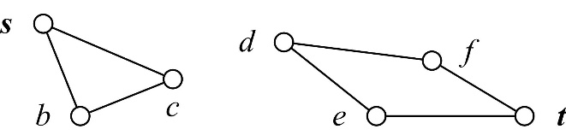

Fig. 9.1. A sample disconnected graph with no path from *s* to *t*

Following we show the search for a path from *a* to *e*, see Fig. 9.2. Note that the word node is usually interchangeable with the word vertex.

|  |  |
| --- | --- |
| 9-2 | 9-3 |
| Fig. 9.2. A graph with the starting node *a* and the terminal node *e* | Fig. 9.3. A search tree for a path from *a* to *e* in Fig. 9.2. |

The lists OPEN and CLOSED are shown in Table 9.4:

|  |  |  |  |
| --- | --- | --- | --- |
|  | OPEN | CLOSED | Comment |
| 1 | *a*(*start*) |  | Initial state |
| 2 | *b*(*a*)*, d*(*a*) | *a*(*start*) | *S*(*a*) *=* {*b,d*}. *a* is closed; *b* and *d* opened |
| 3 | *d*(*a*)*, c*(*b*) | *a*(*start*)*, b*(*a*) | *S*(*b*) *=* {*a, c*} but *a*CLOSED |
| 4 | *c*(*b*)*, e*(*d*) | *a*(*start*)*, b*(*a*)*, d*(*a*) | *S*(*d*) *=* {*a, e*} but *a* CLOSED |
| 5 | *e*(*d*) | *a*(*start*)*, b*(*a*)*, d*(*a*)*, c*(*b*) | *S*(*c*) *=* {*b, e*} but *b* CLOSED and *e*  OPEN. Therefore they are not placed twice |
| 6 |  | *a*(*start*)*, b*(*a*)*, d*(*a*)*, c*(*b*)*, e*(*d*) | The terminal node *e* is being closed. Its children are not analysed |

Table 9.4.The lists OPEN and CLOSED in every step of the algorithm. A path from *a* to *e* is searched in the graph which is shown in Fig. 9.2

Another example is more complicated. The graph, which is shown in Fig. 9.5, is searched for a path from *a* to *f*. A search tree is shown in Fig. 9.6.

|  |  |
| --- | --- |
| 9-5 | 9-6 |
| Fig. 9.5. A sample graph. Path search from *a* to *f* | Fig. 9.6. A search tree from *a* to *f* in Fig. 9.5 |

|  |  |  |  |
| --- | --- | --- | --- |
|  | OPEN | CLOSED | Comment |
| 1 | *a*(*start*) | ∅ |  |
| 2 | *b*(*a*), *c*(*a*) | *a*(*start*) | *S*(*a*) = {*b*,*c*} |
| 3 | *c*(*a*), *d*(*b*), *e*(*b*) | *a*(*start*), *b*(*a*) | *S*(*b*) = {*a*,*d*,*e*} but *a*∈CLOSED |
| 4 | *d*(*b*), *e*(*b*), *f*(*c*) | *a*(*start*), *b*(*a*), *c*(*a*) | *S*(*c*) = {*a*,*f*} but *a*∈CLOSED |
| 5 | *e*(*b*), *f*(*c*) | *a*(*start*), *b*(*a*), *c*(*a*), *d*(*b*) | *S*(*d*) = {*b*,*e*} but *b*∈CLOSED |
| 6 | *f*(*c*), *g*(*e*), *h*(*e*) | *a*(*start*), *b*(*a*), *c*(*a*), *d*(*b*), *e*(*b*) | *S*(*e*) = {*b*,*d*,*f*,*g*,*h*} but *b*,*d*∈CLOSED and *f*∈OPEN |
| 7 | *g*(*e*), *h*(*e*) | *a*(*start*), *b*(*a*), *c*(*a*), *d*(*b*), *e*(*b*), *f*(*c*) | The terminal node *f* is being closed. Its children are not analysed |

Table 9.7. The lists OPEN and CLOSED in every step of the algorithm. Path search from *a* to *f* is searched in the graph within Fig. 9.5

One more graph is shown in Fig. 9.8. A set of nodes is *V* = {*a,b,c,d,e,f,g,h,i,j,k,l,m,n,o*}. A set of edges is *E* = {(*a,b*), (*a,c*), (*a,d*), (*b,e*), (*b,f*), (*c,d*), (*c,f*), (*c,g*), (*c,h*) (*d,h*), (*d,i*), (*f,j*), (*f,k*), (*f,l*) (*g,l*), (*h,l*), (*h,m*), (*h,n*), (*i,n*),(*i,o*)}.

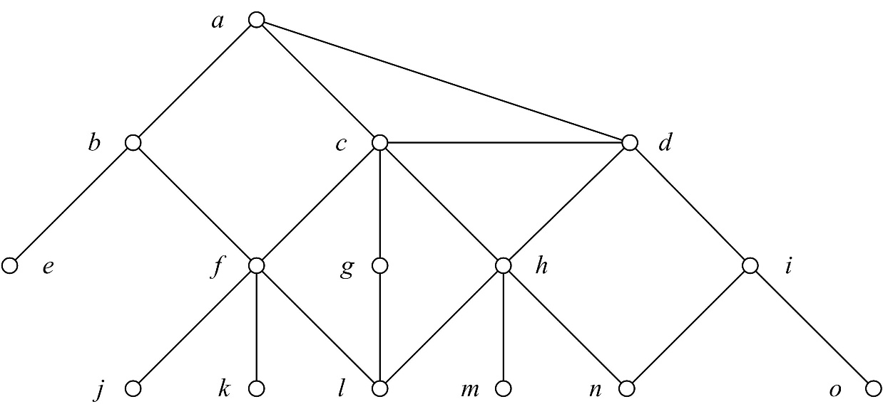

Fig. 9.8. Path search from *a* to *h*. An undirected graph *G*=〈*V*,*E*〉, where *V* = {*a*,*b*,*c*,*d*,*e*,*f*,*g*,*h*,*i*,*j*,*k*,*l*,*m*,*n*,*o*}, *E* = {(*a,b*), (*a,c*), (*a,d*), (*b,e*), (*b,f*), (*c,d*), (*c,f*), (*c,g*), (*c,h*) (*d,h*), (*d,i*), (*f,j*), (*f,k*), (*f,l*) (*g,l*), (*h,l*), (*h,m*), (*h,n*), (*i,n*),(*i,o*)}

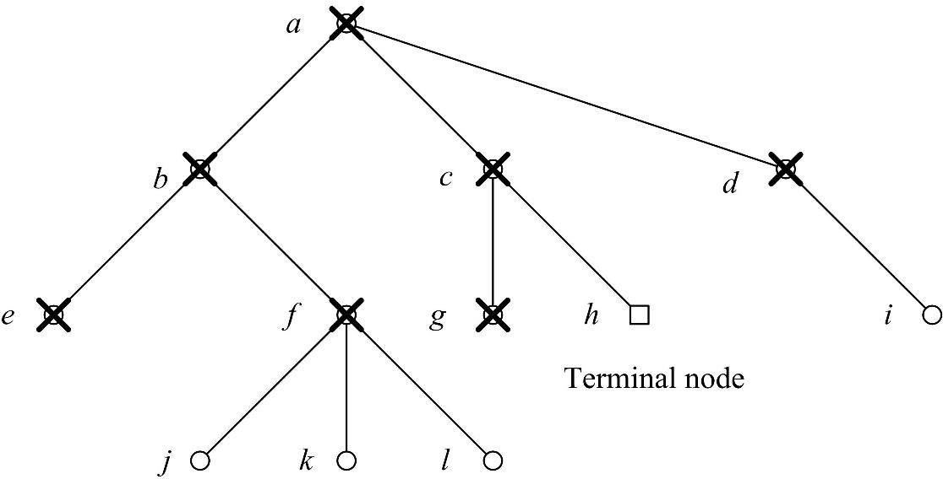

Fig. 9.9. Search tree from *a* to *h* in the graph, which is shown in Fig. 9.8

The lists OPEN and CLOSED can be comprised by the so called “frontier” notation:

~~a~~, ~~b~~, ~~c~~, ~~d~~, ~~e~~, ~~f~~, ~~g~~, ~~h~~, i, j, k, l

# Shortest path problem in a graph with edge weights

Suppose a graph with nonnegative edge weights. We provide an algorithm to search for the shortest path from an initial node *s* to a terminal node *t*. This is a classic algorithm and is presented in textbooks, see e.g. (Hunt 1978, 10.1.2). When each edge in the graph has unit weight 1, this is equivalent to finding the path with fewest edges (see previous section).

This algorithm is a variation of Dijkstra’s algorithm which is conceived by Dutch computer scientist Edsger Dijkstra in 1956. Dijkstra’s algorithm to find the shortest path between *s* and *t* starts from *s*, picks the unvisited vertex with the lowest distance, calculates the distance through it to each unvisited neighbour, and updates the neighbour’s distance if smaller, see <https://en.wikipedia.org/wiki/Dijkstra%27s_algorithm>.

INPUT: 1) a graph *G* with edge weights; 2) a starting node *s*; 3) a terminal node *t*.

OUTPUT: the shortest path from *s* to *t*.

Initially the lists OPEN and CLOSED are empty.

1. Add the starting node *s* to OPEN.
2. If OPEN is empty then there is no path. Return FAIL. This happens in the case of a disconnected graph.
3. Close the **first** node *n* from OPEN: move it from OPEN to CLOSED. Here *n* is the node with the shortest distance from *s*. (OPEN is sorted in this way.) If *n* is the terminal node then collect the path and return it.
4. Take the set *S*(*n*) of nodes adjacent to *n*. For each *n\** from *S*(*n*), which does not appear in CLOSED, calculate its distance and add it to OPEN. Formally, ∀*n\** ∈ *S*(*n*)/CLOSED, OPEN :=OPEN ∪ *S*(*n*)/CLOSED, assign *pathweight*(*s*,*n\**) := *pathweight*(*s*,*n*) + *edgeweight*(*n*,*n\**), and sort OPEN. For each such *n\** which appears twice (with an old *pathweight* and a new one) updates the distance for a smaller.
5. Go to 2.

Following we show the search for a path from *a* to *e*, see Fig. 10.1.

|  |  |
| --- | --- |
| 10-1 | 10-2 |
| Fig. 10.1. A sample graph with nonnegative edge costs. Suppose an initial node *a* and a terminal node *e* | Fig. 10.2. The search tree for a path from *a* to *e* in the graph, which is shown in Fig. 10.1 |

Following we show OPEN and CLOSED in each execution step of the algorithm.

|  |  |  |  |
| --- | --- | --- | --- |
|  | OPEN | CLOSED | Comment |
| 1 | *a(start,0)* | *∅* |  |
| 2 | *b(a,30), d(a,51)* | *a(start,0)* | *S*(*a*) = {*b*,*d* } |
| 3 | *c(b,50), d(a,51)* | *a(start,0), b(a,30)* | *S*(*b*) = {*a*,*c*} but *a*∈CLOSED |
| 4 | *d(a,51), e(c,60)* | *a(start,0), b(a,30), c(b,50)* | *S*(*c*) = {*b*,*e*} but *b*∈CLOSED |
| 5 | ***e(d,52)*** | *a(start,0), b(a,30), c(b,50), d(a,51)* | *S*(*d*) = {*a*,***e***} but *a*∈CLOSED and ***e***∈OPEN. New cost **e(d,52)** is better than the old one *e*(*c*,*60*). Take it |
| 6 | *∅* | *a(start,0), b(a,30), c(b,50), d(a,51),* ***e(d,52)*** | The terminal node ***e*** **is closed** |

Table 10.3. The lists OPEN and CLOSED in each step of the algorithm. A path between *a* and *e* is searched in the graph which is shown in Fig. 10.1. The path is 〈*a(start,0), d(a,51), e(d,52)*〉

Suppose a more complicated graph which is shown in Fig. 10.4.

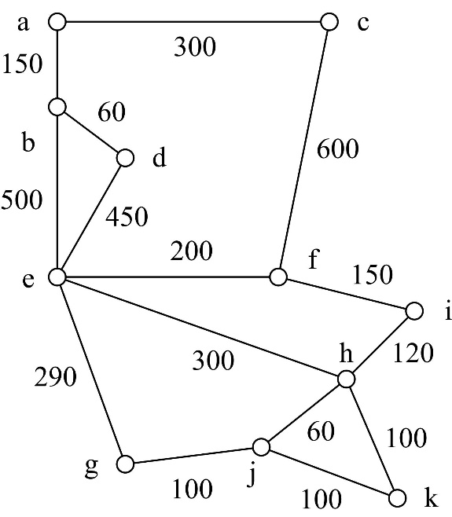

Fig. 10.4. A sample graph. A path is searched between *e* and *j*

The states of lists OPEN and CLOSED in each algorithm’s step.

|  |  |  |  |
| --- | --- | --- | --- |
|  | OPEN | CLOSED | Comment |
| 1 | *e(start,0)* | *∅* |  |
| 2 | *f(e,200), g(e,290), h(e,300), d(e,450), b(e,500)* | *e(start,0)* | *S*(*e*) = {*b,d,f,g,h*} |
| 3 | *g(e,290), h(e,300), i(f,350), d(e,450), b(e,500), c(f,800)* | *e(start,0), f(e,200)* | *S*(*f*) = {*c,e,i*}, but *e*∈CLOSED |
| 4 | *h(e,300), i(f,350), j(g,390), d(e,450), b(e,500), c(f,800)* | *e(start,0), f(e,200), g(e,290)* | S(*g*) = {*e,j*}, but *e*∈CLOSED |
| 5 | *i(f,350),* ***j(h,360)****, k(h,400), d(e,450), b(e,500), c(f,800)* | *e(start,0), f(e,200), g(e,290), h(e,300)* | *S*(*h*) = {*e,i,****j****,k*}, but *e*∈CLOSED and *i,****j***∈OPEN. New cost *i(h,420)* is worse than the old one *i(f,350)* and therefore the old one is chosen. New cost ***j(h,360)*** is better than the old one *j(g,390)* and therefore the new one is taken |
| 6 | *j(h,360), k(h,400), d(e,450), b(e,500), c(f,800)* | *e(start,0), f(e,200), g(e,290), h(e,300), i(f,350)* | *S*(*i*) = {*f,h*}, but *f,h*∈CLOSED |
| 7 | *k(h,400), d(e,450), b(e,500), c(f,800)* | *e(start,0), f(e,200), g(e,290), h(e,300), i(f,350), j(h,360)* | The terminal node *j* is closed. Its children are not analysed |

Table 10.5. The lists OPEN and CLOSED in each step of the algorithm. A path between *e* and *j* is searched in the graph which is shown in Fig. 10.4. The found path is 〈*e(start,0), h(e,300), j(h,360)*〉

The corresponding search tree is shown in Fig. 10.6.

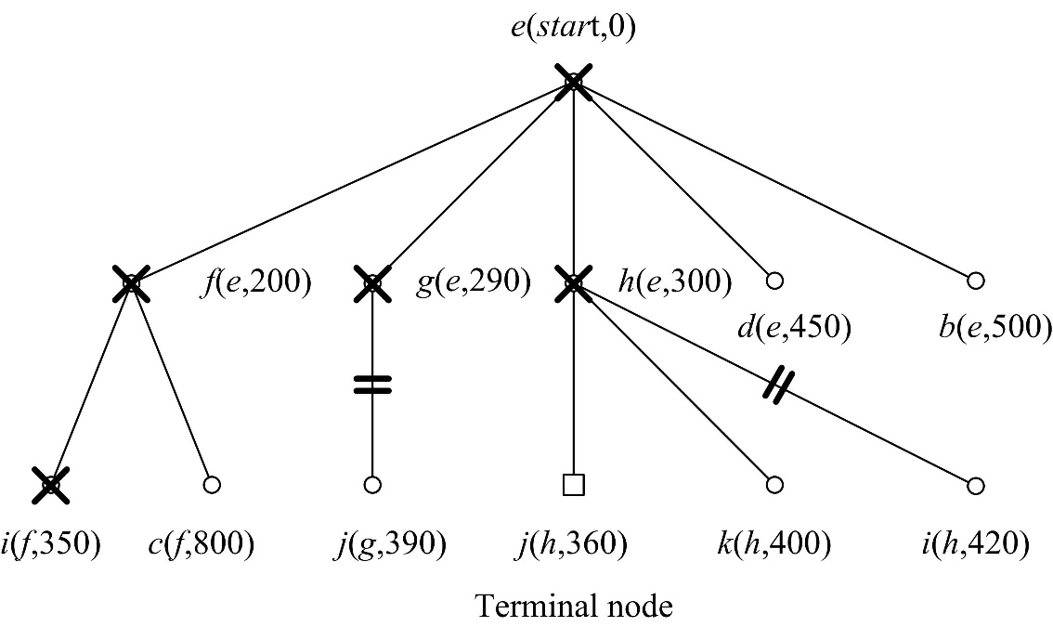

Fig. 10.6. The search tree for a path between *e* and *j* in Fig. 10.4

# Depth-first search in a graph with no weights

A difference between depth-first search and breadth-first search is illustrated in a sample graph; see Fig. 11.1 a. Here *s* stands for the initial node and *t* for the terminal. Suppose that production rules – the edges – are sorted contra-clockwise (Fig. 11.1 b). Depth-first search produces the path 〈*s*,*a*,*e*,*t*〉 of three edges, whereas breadth-first search produces the path 〈*s*,*t*〉, i.e. one edge only.

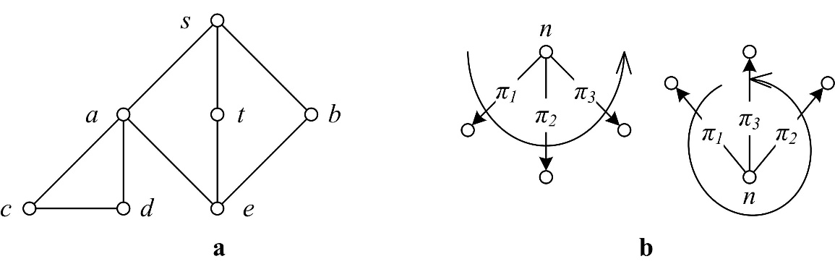

Fig. 11.1. a) A sample graph. Suppose depth-first search with the initial node *s* and the terminal node *t*. b) Contra-clockwise ordering of edges. The “12 hours” edge is the last one – not the first

INPUT: 1) a graph; 2) a starting node *s*; 3) a terminal node *t*.

OUTPUT: The depth-first search path. It is not necessarily the shortest path.

1. Add the initial node to OPEN.
2. If OPEN is empty then there is no path. Return FAIL. This happens in the case of a non-connected graph; see Fig. 9.1.
3. Close the **first** node *n* from OPEN: move it from OPEN to CLOSED. If *n* is the terminal node, then collect the path and finish.
4. Take the set *S*(*n*) of adjacent nodes to *n*. Add all the nodes from *S*(*n*), which are not in OPEN, to the **beginning** of OPEN (i.e. according to “depth-first”). Formally, OPEN := *S*(*n*)/OPEN ∪ OPEN. Delete duplicated nodes (i.e. the old ones) from the end of OPEN.
5. Go to 2.

Table 11.3 below presents the states of the lists OPEN and CLOSED in each step of the algorithm. The corresponding search tree is shown in Fig. 11.3.

|  |  |  |  |
| --- | --- | --- | --- |
|  | OPEN | CLOSED | Comment |
| 1 | *s(start)* | ∅ |  |
| 2 | *a(s), t(s), b(s)* | *s(start)* | *S*(*s*) = {*a*,*t*,*b*} |
| 3 | *c(a), d(a), e(a), t(s), b(s)* | *s(start), a(s)* | *S*(*a*) = {*c*,*d*,*e*,*s*}. But *s*∈CLOSED |
| 4 | ***d(c)****, e(a), t(s), b(s)* | *s(start), a(s), c(a)* | *S*(*c*) = {*d*,*a*}. But *a*∈CLOSED and ***d***∈OPEN. Therefore ***d(c)***, which is opened later, is placed into the OPEN’s head and *d(a)* is deleted the from OPEN’s tail |
| 5 | *e(a), t(s), b(s)* | *s(start), a(s), c(a), d(c)* | *S*(*d*) = {*c*,*a*}. But *c*,*a*∈CLOSED |
| 6 | ***b(e)****,* ***t(e)*** | *s(start), a(s), c(a), d(c), e(a)* | *S*(*e*) = {*a*,*b*,*t*}. But *a*∈CLOSED and *b*,*t*∈OPEN. Therefore ***b(e)*** and ***t(e)***, which are opened later, are placed into the OPEN’s head and *t(s)* and *b(s)* are deleted the from OPEN’s tail |
| 7 | *t(e)* | *s(start), a(s), c(a), d(c), e(a), b(e)* | *S*(*b*) = {*s*,*e*}. But *s*,*e*∈CLOSED |
| 8 | ∅ | *s(start), a(s), c(a), d(c), e(a), b(e), t(e)* | The terminal node *t* is closed. The resulting path is collected backwards: *t* is reached from *e*, *e* from *a*, and *a* from *s* |

Table 11.2. The lists OPEN and CLOSED in each step of the algorithm. A path from *s* to *t* is searched in the graph, which is shown in Fig. 11.1 a. The found path is 〈*s*,*a*,*e*,*t*〉

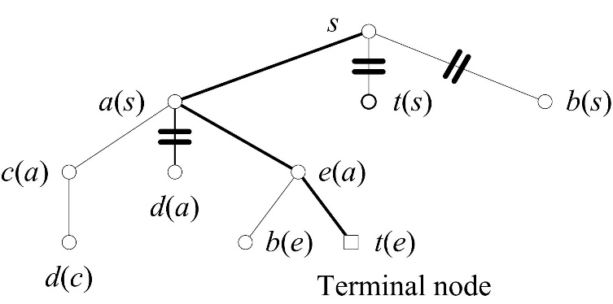

Fig. 11.3. The depth-first search tree for a path from *s* to *t* in the graph, which is shown in Fig. 11.1 a. The links of *d*, *b* and *t* are changed: ***d(c)*** replaces *d(a)*, ***b(e)*** replaces *b(s)* and ***t(e)*** replaces *t(s)*

**Solver and planner**. The depth-first search strategy is usually used by solvers and the breadth-first search by planners. Solver is shorthand for problem-solver and a solving agent. Planner – a planning agent. Their differences:

|  |  |  |
| --- | --- | --- |
|  | Solver | Planner |
| 1 | Does not have a map | Has a map |
| 2 | Does not find the shortest path | Can find the shortest path |
| 3 | Depth-first search | Normally breadth-first search |
| 4 | Onetime usage of the path | Multiple usage of the path |

# The prefix, infix and postfix order of tree traversal

Tree traversal refers to the problem of visiting all the nodes in a graph in a particular manner. Below we follow (Jensen and Wirth 1982, Section 12.1).

|  |  |
| --- | --- |
| 12-1 | 12-2 |
| Fig. 12.1. A sample binary tree from (Jensen, Wirth 1982, p. 66) It is encoded with the string *abc..de..fg...hi..jkl..m..n..* | Fig. 12.2. An isomorphic tree |

The tree in Fig. 12.1 is coded with the following string:

abc..de..fg...hi..jkl..m..n..

Following are the procedures to traverse a binary tree in prefix-, infix- and postfix order.

**program** traversal(input, output);  
**type** ptr = ↑node;  
 node = **record**  
 info : char;  
 llink, rlink : ptr;  
 **end**;  
**var** root : ptr;  
 ch : char;

**procedure** enter(var p:ptr);  
**begin**  
 read(ch);  
 write(ch);  
 **if**(ch ≠ '.') **then**   
 **begin**  
 new(p);  
 p↑.info:=ch;  
 enter(p↑.llink);  
 enter(p↑.rlink);  
 **end**;  
 **else** p := nil;  
**end**;

**procedure** preorder(p:ptr);  
**begin**  
 **if** p ≠ nil **then**  
 **begin**  
 write(p↑.info);  
 preorder(p↑.llink);  
 preorder(p↑.rlink);  
 **end**;  
**end**; { preorder }  
  
**procedure** inorder(p:ptr);  
**begin**  
 **if** p ≠ nil **then**  
 **begin**  
 inorder(p↑.llink);  
 write(p↑.info);  
 inorder(p↑.rlink);  
 **end**;  
**end**; { inorder }  
  
**procedure** postorder(p:ptr);  
**begin**  
 **if** p ≠ nil **then**  
 **begin**  
 postorder(p↑.llink);  
 postorder(p↑.rlink);  
 write(p↑.info);  
 **end**;  
**end**; { postorder }  
  
**begin**  
 write(' '); enter(root); writeln;  
 write(' '); preorder(root); writeln;  
 write(' '); inorder(root); writeln;  
 write(' '); postorder(root); writeln;  
**end**.

The program prints four lines:

|  |  |
| --- | --- |
| abc..de..fg...hi..jkl..m..n.. | – the echo of input data |
| Abcdefghijklmn | – preorder |
| Cbedgfaihlkmjn | – inorder |
| Cegfdbilmknjha | – postorder. |

The depth-first traversal of the tree which is shown in Fig. 12.1 is as follows:

abcdefghijklmn

It coincides with the prefix order. The breadth-first traversal is as follows:

abhcdijefknglm

Suppose an arithmetic expression

((A+B)\*(C–D)+E)\*F

The representation in the prefix notation is as follows:

\*+\*+AB–CDEF

The representation in the postfix notation is as follows:

AB+CD–\*E+F\*

Another example illustrates the compilation of expressions into stack machine’s code. The above expression ((A+B)\*(C–D)+E)\*F is compiled into the code in Fig. 12.3.

|  |  |  |
| --- | --- | --- |
| 12-3.jpg | |  | | --- | | Load A  Load B  Add  Load C  Load D  Subtract  Multiply  Load E  Add  Load F  Multiply | |
| Fig. 12.3. The syntactic tree and the stack machine code for the arithmetic expression ((A+B)\*(C–D)+E)\*F | |

Stack’s changes during interpretation of the code are shown in Fig. 12.4.

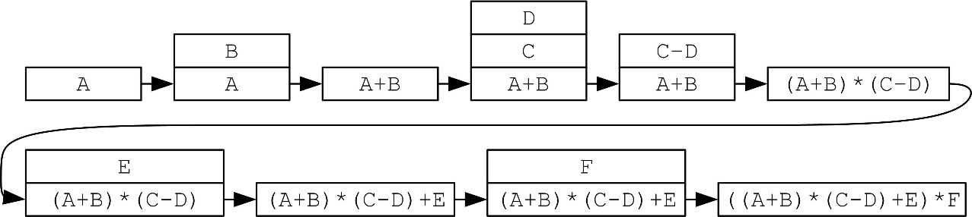

Fig. 12.4. State transitions of the stack while calculating the expression ((A+B)\*(C–D)+E)\*F. Arrows denote state transitions from time *t* to *t*+1

Exercises

1. Write expressions A\*B+C/D, A\*B+C–D and A+B\*C–(D+E)\*F–B in prefix, infix and postfix notations. Write the code of a stack machine for the expressions above. Draw state transitions of the stack.

2. Write procedures for general trees: 1) enter a general tree, 2) prefix order traversal, and 3) postfix order traversal. For example, the string ABC.DE...F.GHI.J.K.L encodes a sample tree in Fig. 12.5. There are other languages to encode trees, for example, A(B(CD(E))FG(H(IJKL))), where brackets denote hierarchy.

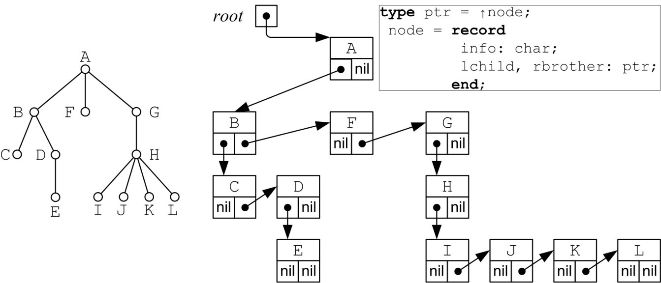

Fig. 12.5. A sample tree ABC.DE...F.GHI.J.K.L and its representation

Following is a pseudocode to enter a tree-coding string.

|  |
| --- |
| INPUT: *graph\_string* – a tree-coding string.  OUTPUT: *Node* – a reference to the root. |
| **function** construct\_tree(graph\_string) : **node**  current\_node := **nil**  **for all** character ∈ graph\_string  **if** character = dot\_character  new\_node := **node**(character)  set\_parent(new\_node, current\_node)  set\_children(new\_node, **nil**)  **if** current\_node ≠ **nil**  add\_child(current\_node, new\_node)  **end if**  current\_node := new\_node  **else**  current\_node := get\_parent(current\_node)  **end if**  **end for**  **while** get\_parent(current\_node) ≠ nil do  current\_node := get\_parent(current\_node)  **end while**  **return** current\_node  **end function** |

Test with the tree in Fig. 12.5. Test input is ABC.DE...F.GHI.J.K.L .

Test output is as follows.

|  |
| --- |
| PART 1. Data  A tree encoded with a string: "ABC.DE...F.GHI.J.K.L "  PART 2. Trace  0) . Read 'A'. Add child A to parent root. Down.  1) A. Read 'B'. Add child B to parent A. Down.  2) -B. Read 'C'. Add child C to parent B. Down.  3) --C. Read '.'. Node C has no children. Backtrack.  -B. Read 'D'. Add child D to parent B. Down.  4) --D. Read 'E'. Add child E to parent D. Down.  5) ---E. Read '.'. Node E has no children. Backtrack.  --D. Read '.'. Node D has no children. Backtrack.  -B. Read '.'. Node B has no children. Backtrack.  A. Read 'F'. Add child F to parent A. Down.  6) -F. Read '.'. Node F has no children. Backtrack.  A. Read 'G'. Add child G to parent A. Down.  7) -G. Read 'H'. Add child H to parent G. Down.  8) --H. Read 'I'. Add child I to parent H. Down.  9) ---I. Read '.'. Node I has no children. Backtrack.  --H. Read 'J'. Add child J to parent H. Down.  10) ---J. Read '.'. Node J has no children. Backtrack.  --H. Read 'K'. Add child K to parent H. Down.  11) ---K. Read '.'. Node K has no children. Backtrack.  --H. Read 'L'. Add child L to parent H. Down.  12) ---L. Read end of string symbol ' '.  PART 3. Results  Tree:  1) A  2) -B  3) --C  4) --D  5) ---E  6) -F  7) -G  8) --H  9) ---I  10) ---J  11) ---K  12) ---L |

**A grammar in Backus-Naur form for our language to encode a tree**

<tree> ::= <node> | <node> <branches>

<branches> ::= <branch> | <branches> <branch>

<branch> ::= <leaf> | <branching>

<leaf> ::= <node> <dot>

<branching> ::= <node> <branches> <dot>

<node> ::= ‘A’.. ‘Z’

<dot> ::= ‘.’

**Contextual rule.** The grammar above allows strings with dots at the end. These dots provide no meaning about the tree’s structure. Therefore these dots will be deleted.

A binary tree in Fig. 12.1 is coded abc.de.fg....hi.jkl.m..n. The latter string differs from *abc..de..fg...hi..jkl..m..n..* in(Jensen, Wirth 1982, p. 66).

# GRAPHSEARCH algorithm

GRAPHSEARCH is a generalisation of depth-first search, breadth-first search and heuristic search. See also (Nilsson 1982) Section 2.2.2.

INPUT: 1) a graph with nonnegative edge costs; otherwise the cost is 1; 2) an initial node *s*; 3) a terminal node (several terminal nodes can also exist, for example, defined by a predicate).

OUTPUT: a path from *s* to a terminal node.

Initially the lists OPEN and CLOSED are empty.

1. Add the initial node *s* to OPEN and create the search tree *T* which consists of one node, *s*.
2. If OPEN is empty then there is no path. Return FAIL.
3. Close the first node *n* from OPEN: move it from OPEN to CLOSED.
4. If *n* is the terminal node, then collect the path and finish.
5. Take the set *S*(*n*) of all nodes adjacent to *n*. Add each *n\**∈*S*(*n*), which is not present neither in OPEN nor in CLOSED, to OPEN and *T*. Link *n\** to *n* with the notation *n\**(*n*). Formally OPEN := OPEN ∪ *S*(*n*)/(OPEN∪CLOSED)
6. For each *n\**∈*S*(*n*), which was present in OPEN (in the old OPEN – to the right in the assignment above), i.e. *n\**∈(*S*(*n*)∩OPEN), decide to change or not to change the link. Do not analyse the rest *n\**, i.e. *n\**∈(*S*(*n*)∩CLOSED) because they are closed.
7. Sort OPEN according to a certain scheme, principle, or heuristic, for instance:
   1. cost
   2. **“depth-first”**. Place *S*(*n*)/CLOSED to the **beginning** of OPEN and delete duplicated nodes *n\** from the end of OPEN. Hence, OPEN is sorted as a **stack**, i.e. LIFO (Last In First Out).
   3. **“breadth-first”**. Place *S*(*n*)/CLOSED to the **end** of OPEN an delete duplicated nodes *n\** from the beginning of OPEN. Hence, OPEN is sorted as a **queue**, i.e. FIFO (First In First Out).
8. Go to 2.

# Differences between BACKTRACK1 and GRAPHSEARCH-DEPTH-FIRST

BACKTRACK1 operates with a stack (DATALIST). GRAPHSEARCH\_DEPTH\_FIRST operates with a list (OPEN and CLOSED). The two differences can be formulated as follows:

1. BACKTRACK1 operates with production rules and global database states whereas GRAPHSEARCH\_DEPTH\_FIRST operates with the lists OPEN and CLOSED.
2. BACKTRACK1 makes two cycles around an “island”. Therefore multiple cycles appear in case of multiple islands. The reason is that DATALIST keeps only the current path , but no past paths. GRAPHSEARCH\_DEPTH\_FIRST prevents multiple cycles by saving nodes in CLOSED.

Therefore BACKTRACK1 normally takes more time, but less stack memory, and GRAPHSEARCH\_DEPTH\_FIRST – less time, but more memory (OPEN and CLOSED). Hence a trade-off of time and space is observed. This trade-off is a principle of AI.

## Searching in a graph

Below is the graph which was explored in Fig. 11.1. Consider the starting node *s* and the terminal node *t*.



Fig. 14.1 a) A sample graph. b) Contra-clockwise order of edges. “12 hours” edge is the last one

BACKTRACK1 produces a search tree which is shown in Fig. 14.2 a. GRAPHSEARCH-DEPTH-FIRST produces a search tree which is shown in Fig. 14.2 b. It is smaller than the search tree in Fig. 14.1 a. This is due to cutting some branches, most importantly *d(a)*.

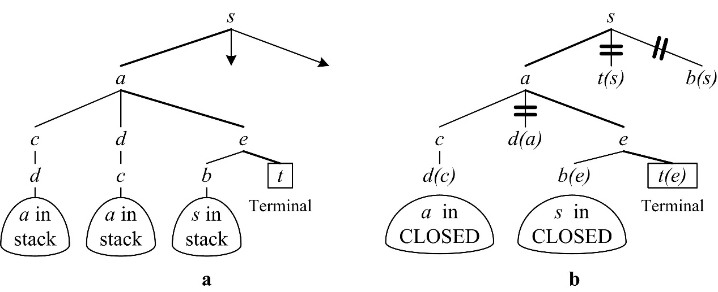

Fig. 14.2. Search trees: a) BACKTRACK1, b) GRAPHSEARCH-DEPTH-FIRST. The same path is 〈*s*,*a*,*e*,*t*〉 is found in both cases

GRAPHSEARCH-DEPTH-FIRST produces OPEN and CLOSED which are shown below in the frontier notation. Strikethrough denotes a node from CLOSED and a rectangle denotes a node which changed its parent link.

~~s(start)~~ {~~a(s)~~ t(s) b(s)} {~~c(a)~~ d(a) ~~e(a)~~} **~~d(c)~~** {**~~b(e)~~** **~~t(e)~~**

The table of cuts shows three situations to cut branches:

|  |  |  |
| --- | --- | --- |
| Situation | Opened earlier | Opened later. This is **chosen** |
| 1 | *d(a)* | ***d(c)*** |
| 2 | *b(s)* | ***b(e)*** |
| 3 | *t(s)* | ***t(e)*** |

Both algorithms find the same path. However BACKTRACK1 takes more time. The search tree consists of 11 edges: 11 loads into the stack and 3 times to check if a loaded node is already present in the stack. GRAPHSEARCH\_Į\_GYLĮ takes more memory: the search tree (and the frontier) consists of 10 nodes (including 3 duplicated names), whereas the stack in BACKTRACK1 takes depth 5.

## Multiple cycles in a labyrinth

Suppose a more complicated example. A labyrinth is shown in Fig. 14.3 a. The starting node is *s*. There are two terminal nodes – exits *y* and *t*.

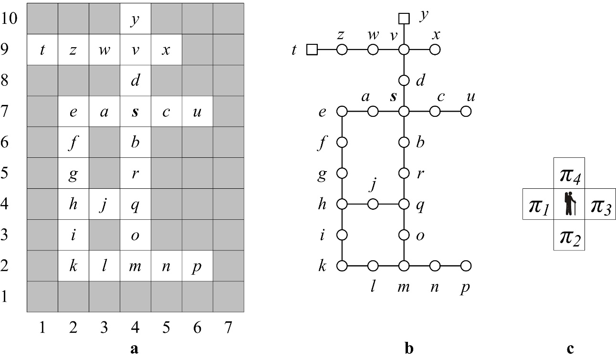

Fig. 14.3. a) A labyrinth with the starting node is *s* and two exits *y* and *t*.  
b) A representation in graph notation. c) The order of edges

Both algorithms find the same path 〈*s*,*d*,*v*,*w*,*z*,*t*〉.

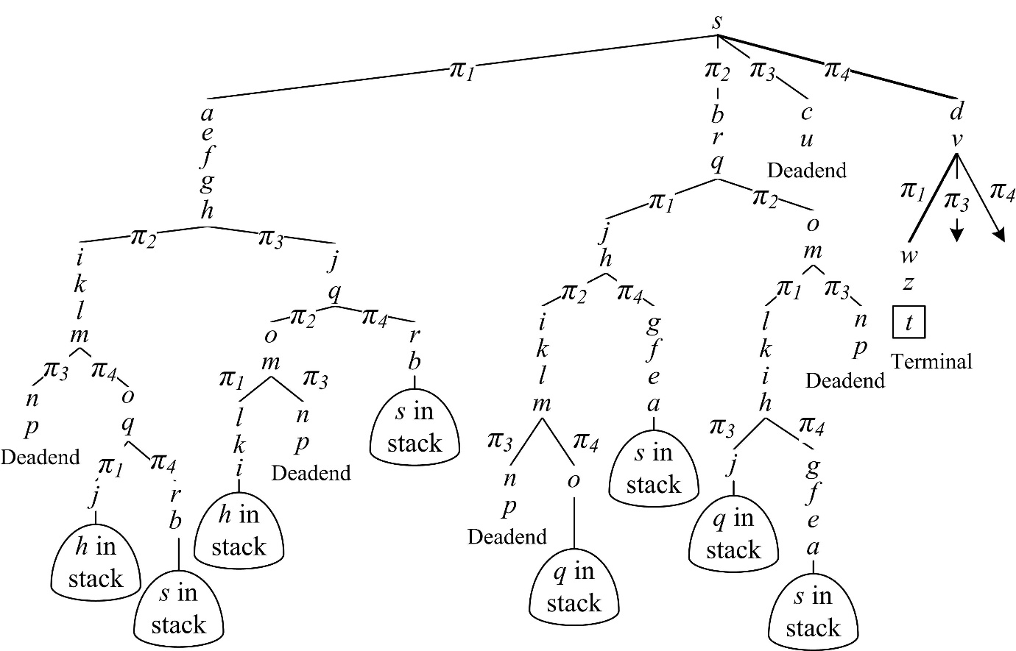

Fig. 14.4. A search tree by BACKTRACK1. It is implicit. Path is 〈*s*,*d*,*v*,*w*,*z*,*t*〉

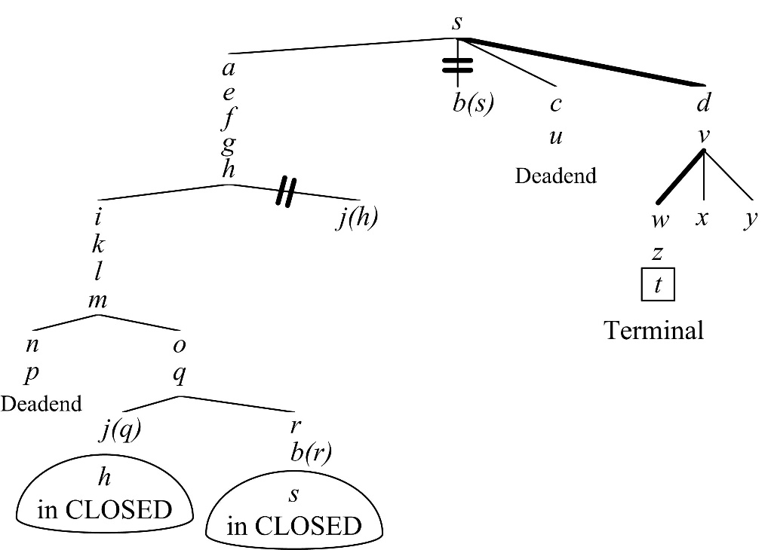

Fig. 14.5 A search tree by GRAPHSEARCH-DEPTH-FIRST. It is explicit due to OPEN and CLOSED. The path is 〈*s*,*d*,v,*w*,*z*,*t*〉

The table of cuts shows two situations to cut branches:

|  |  |  |
| --- | --- | --- |
| Situation | Opened earlier | Opened later. This is **chosen** |
| 1 | *j(h)* | ***j(q)*** |
| 2 | *b(s)* | ***b(r)*** |

## A counterexample of better performance with BACKTRACK1

Suppose a labyrinth which is shown in Fig. 14.7.

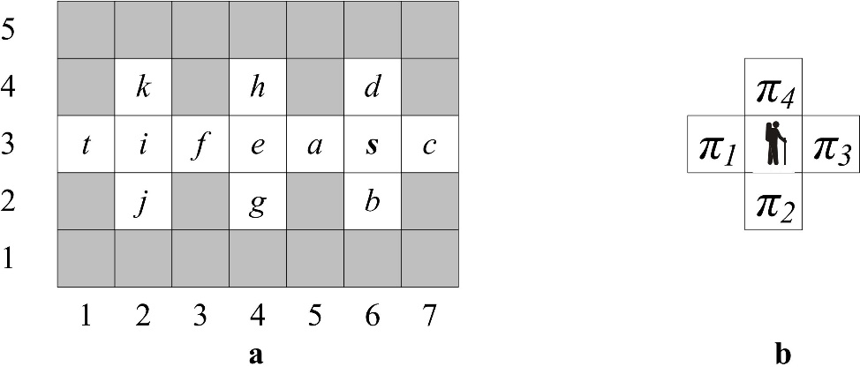

Fig. 14.7 a) A labyrinth for a search from *s* to an exit. There are two exits: *t* and *c*. b) The order of 4 production rules

BACKTRACK1 finds an exit straightforwardly without search: 〈*s*,*a*,*e*,*f*,*i*,*t*〉. To compare two algorithms suppose a cost criterion. Suppose the following costs in the case of BACKTRACK1:

* 1 – the cost of placing a production into the RULES list with the APPRULES function; see Section 2. In other words, this is the cost to have a look at the applicable production rules;
* 100 – for placing a node into the stack. This is the cost of the thread.

Suppose the following costs in the case of GRAPHSEARCH-DEPTH-FIRST:

* 50 – for opening a node. In other words, this is the cost to place a node into the OPEN list. This is the cost of space.

Both algorithms find the same path. However, BACKTRACK1 costs less; see Fig. 14.8.

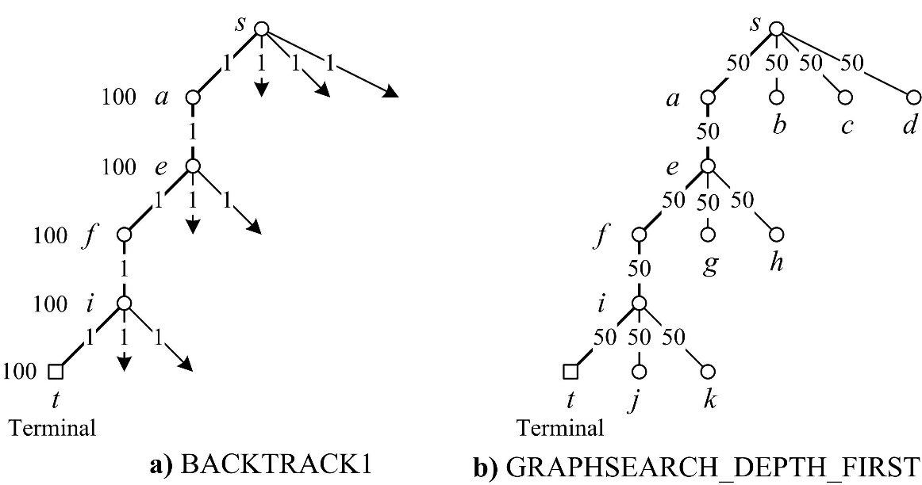

Fig. 14.8 a) BACKTRACK1 search tree costs 5⋅100 + 12⋅1 = 512. b) GRAPHSEARCH-DEPTH-FIRST costs more: 12⋅50 = 600

Exercise

Which algorithm – GRAPHSEARCH\_Į\_GYLĮ or BACKTRACK1 – performs better according to time and space in the labyrinth below? The starting node is *s*. Draw search tree with the following costs: lookup – 1, thread – 100, and space in OPEN – 50.

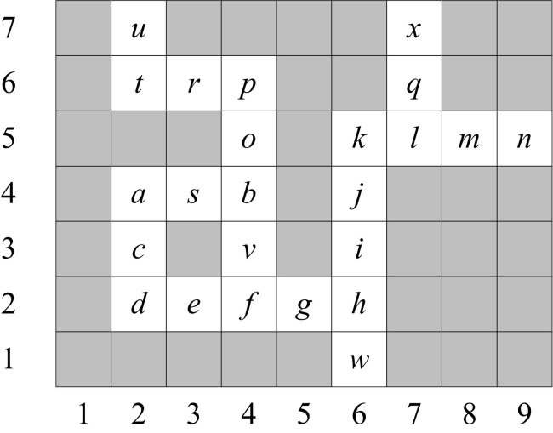

# Hill-climbing strategy

|  |  |
| --- | --- |
| Fig. 15.1 A black-box that produces local information about a function *f* in a point (x,y) | 15-1.jpg |

|  |  |
| --- | --- |
| 15-2.jpg | 15_3 |
| Fig. 15.2. Suppose maximisation of a function z=f(x,y). Hill-climbing is modelled with a sequence 〈[x0,y0], [x1,y1], [x2,y2], …〉 in the direction of steepest gradient. The agent is blind – no ability to view the whole landscape | Fig. 15.3. Hill-climbing in 2-dimensional space is modelled with a sequence 〈x0, x1, x2, …〉 in the direction of positive derivative f'(xi) |

Two control strategies are distinguished in artificial intelligence: irrevocable and tentative. Hill-climbing is an example of the irrevocable strategy. Dangers: local maximum (minimum) and plateau.

Hill climbing is demonstrated with the 8-puzzle; see (Nilsson 1982, Ch. 2.4.1). Here the evaluation function is f(n) = −w(n), where w(n) is the number of misplaced tiles (comparing with the terminal state) in that database associated with node n.

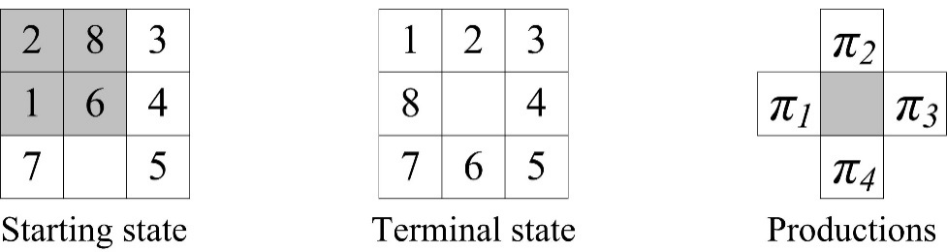

Fig. 15.4. a) A sample initial state *s* and the terminal state *t* in the 8-puzzle. f(s) = −4, f(t) = 0. The task is to maximize f. b) Four moves – a production set 〈π1, π2, π3, π4〉

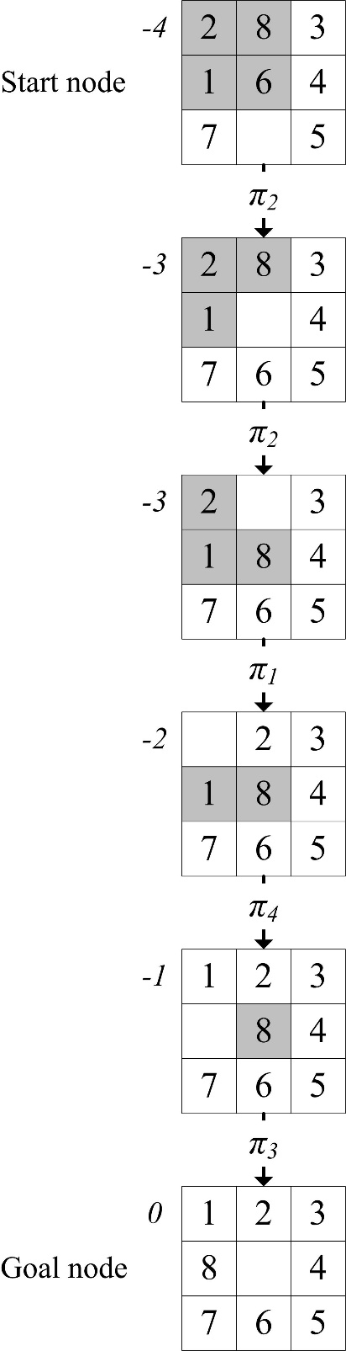

Fig. 15.5. Maximising f(n) = −w(n), where w(n) counts the number of misplaced tiles comparing with the goal node

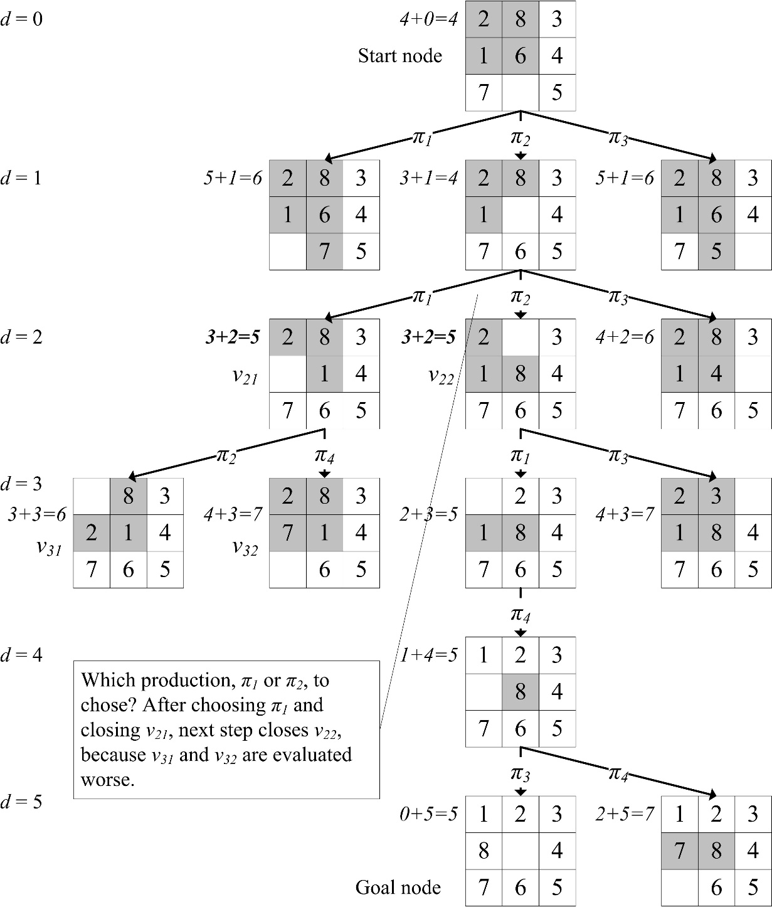

Fig. 15.6. Minimisation of f(n) = w(n)+d(n), where w(n) is the number of pieces in wrong places and d(n) is the depth of the node

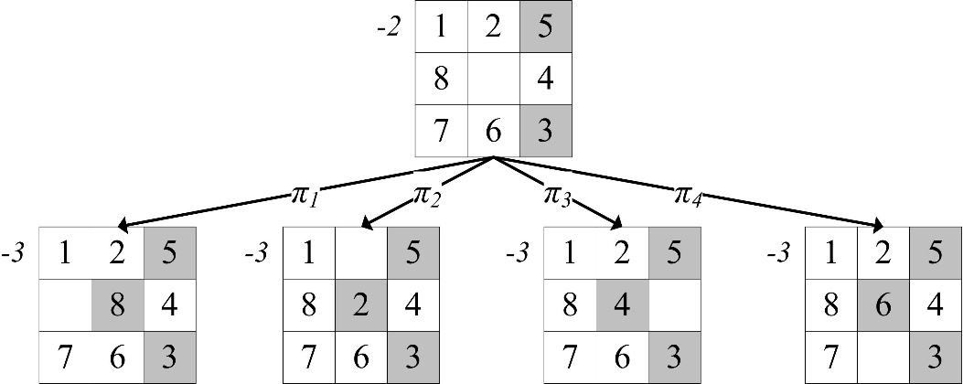

Fig. 15.7. The start state is in a local maximum. Each production makes worse

# Manhattan distance

Suppose a big graph and breadth-firs search from a start node *s* to a terminal node *t*. The wave can be spread out from *s* to *t*, or from *t* to *s*, or two parallel waves (Fig. 14.1). Two parallel waves require considerably less time and memory.

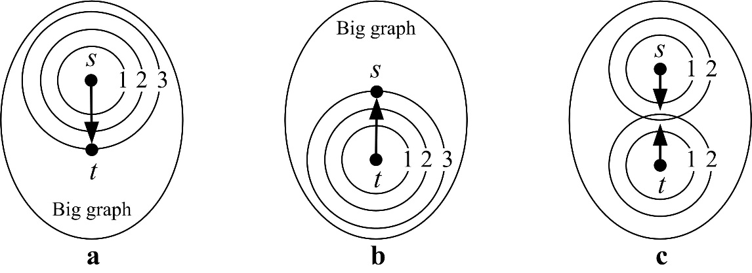

Fig. 16.1. Breadth-first search in a big graph: a) from *s* to *t*; b) from *t* to *s*; c) two parallel waves – from *s* and *t*

**Proof.** Let us denote *N* the length of the path. The number of nodes in the frontier is *O(Nα)*, where generally α>2. This number is greater than in two parallel breadth-first searches: *O(Nα) > O((N/2)α) + O((N/2)α)*. For example, in 2-dimensional space, *α = 2*, and two parallel frontiers take 2 times less memory: *N2 > (N/2)2 + (N/2)2 = N2/4 + N2/4 = N2/2.*

In 3-dimensional space, *α = 3*, two parallel frontiers take 3 times less memory: *N3 > (N/2)3 + (N/2)3 = N3/8 + N3/8 = N3/4*.

The frontier in Fig. 16.2 (total 145 nodes) is listed in Table 16.3 a. Any path comprises 5 productions “go East” and 3 productions “go South”. Therefore the search takes 8 waves.

|  |  |  |  |  |
| --- | --- | --- | --- | --- |
| **Wave no.** | **Number of nodes** |  | **Wave no.** | **Number of nodes** |
| 0 | 1 + 0 |  | 0 | 1 + 1 + 0 + 0 |
| 1 | 4 |  | 1 | 4 + 4 |
| 2 | 8 |  | 2 | 8 + 8 |
| 3 | 12 |  | 3 | 12 + 12 |
| 4 | 16 |  | 4 | 16 + 16 |
| 5 | 20 |  | Total | 82 |
| 6 | 24 |  |  |  |
| 7 | 28 |  |  |  |
| 8 | 32 |  |  |  |
| Total | 145 |  |  |  |
| **a** | |  | **B** | |

Table 16.3. The number of opened nodes: a) total 145 nodes in Fig. 16.2, and b) total 82 nodes in Fig. 16.4.

The *N*-th wave captures total *2· (N2 + N) + 1* nodes including the start node *s*. Therefore the complexity of breadth-first search in a Manhattan graph is quadratic, *O(N2)*:

4 + 8 + … + 4·N = 4· (1 + 2 + 3 + … + N) = 4· (N· (N + 1)/2) = 2· (N2 + N) = O(N2)

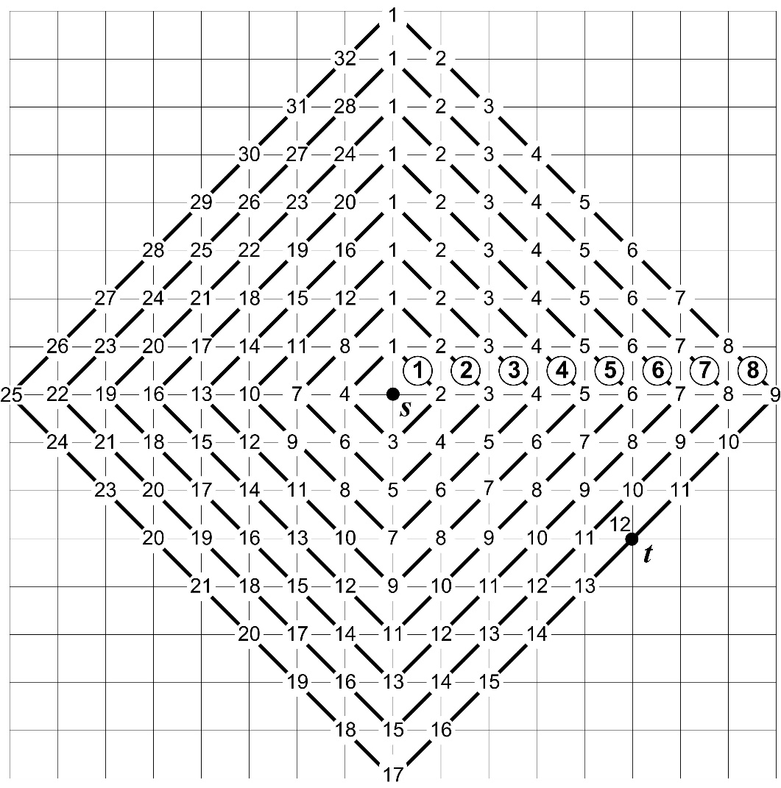

Fig. 16.2. From *s* to *t* requires 8 waves: 5 steps “go East” and 3 “go South”

Now suppose two parallel waves; see Fig 16.4. Total 82 nodes; see Table 16.3 b.

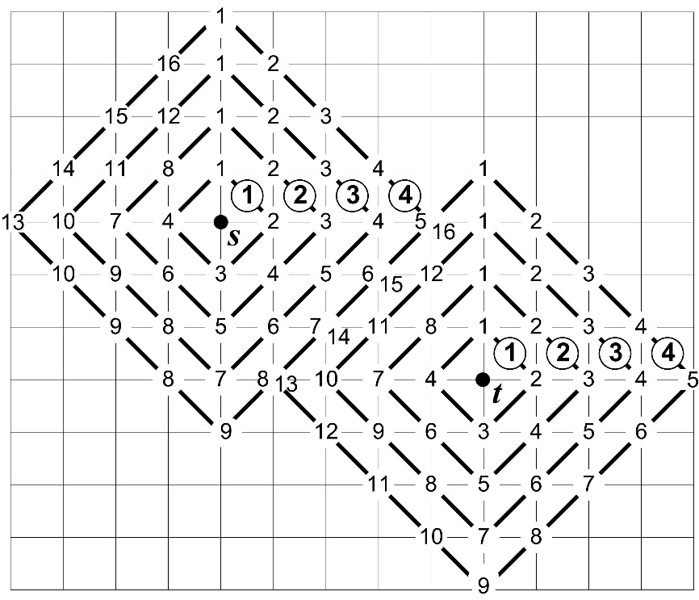

Fig. 16.4. Two parallel waves: from *s* to *t* and from *t* to *s*.

# A\* search algorithm

A\* (say A star) is the GRAPHSEARCH algorithm with the following evaluation function f of the current node n:

f(n) = g(n)+h(n) = distFactual(s,n) + distEstimate(n,t)

where

* g(n) is the shortest path from the starting node *s* to n, *distFactual(s,n)*,
* h(n) is an admissible heuristic estimate of the distance from n to the goal t, distEstimate(n,t).

Details see in (Hart, Nilsson, Raphael 1968; Nilsson 1982), numerous textbooks e.g. (Russell, Norvig 2003; Luger 2005) and Wikipedia, [https://en.wikipedia.org/wiki/A\*\_search\_algorithm](https://en.wikipedia.org/wiki/A*_search_algorithm). The algorithm employs the lists OPEN and CLOSED.

## Manhattan distance in the tile world

Further we present an example where the Manhattan distance stands for h(n).

DEFINITION (Manhattan distance) Manhattan norm d(n1,n2), i.e. distance between two points n1=(x1,y1) and n2=(x2,y2) is:

d(n1,n2)=|x2–x1|+|y2–y1|

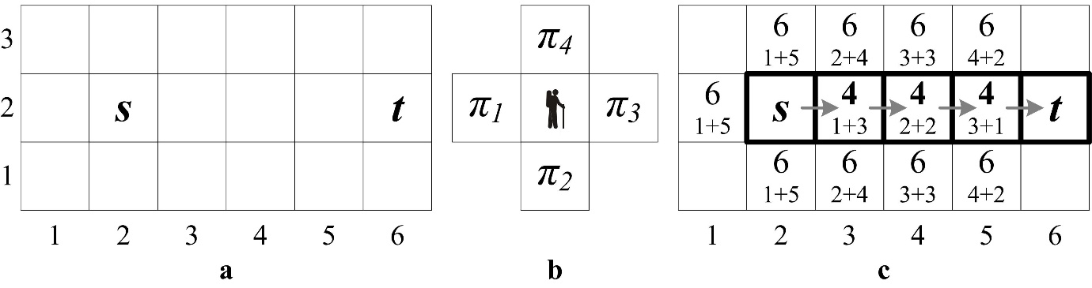

Fig. 17.1. a) A labyrinth with the start node *s* and the terminal node *t*. b) Four moves. c) Closed and opened nodes (frontier) and the path

A more complicated example is shown in Fig. 17.2.

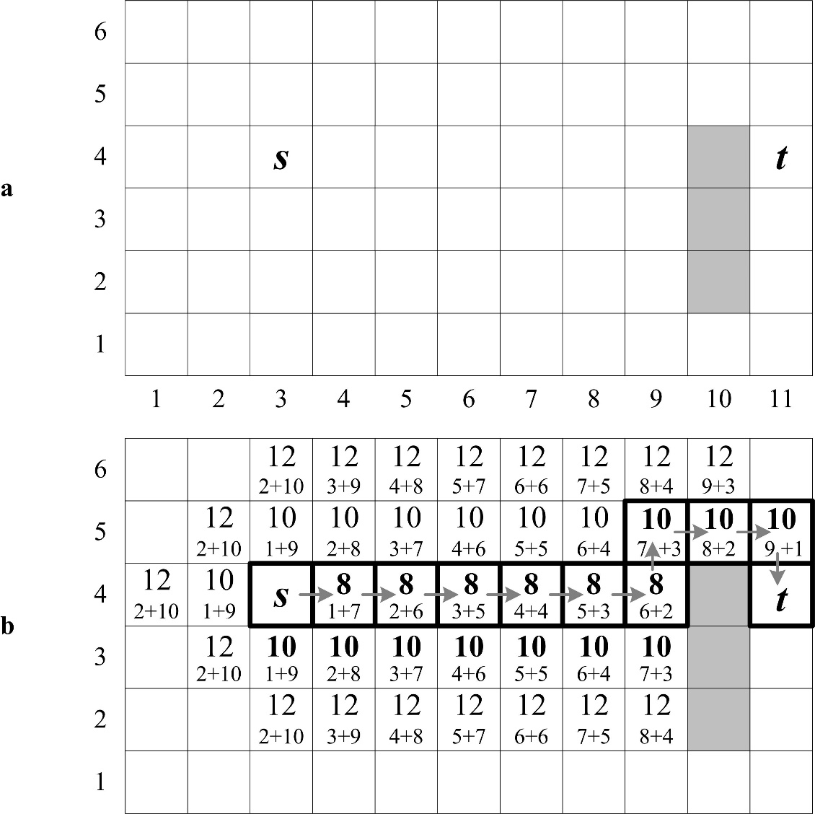

Fig. 17.2. a) The agent travels from *s* to *t*. Grey tiles denote obstacles.  
b) The path and the frontier

A more complicated example contains an obstacle of 5 tiles (Fig. 17.3).

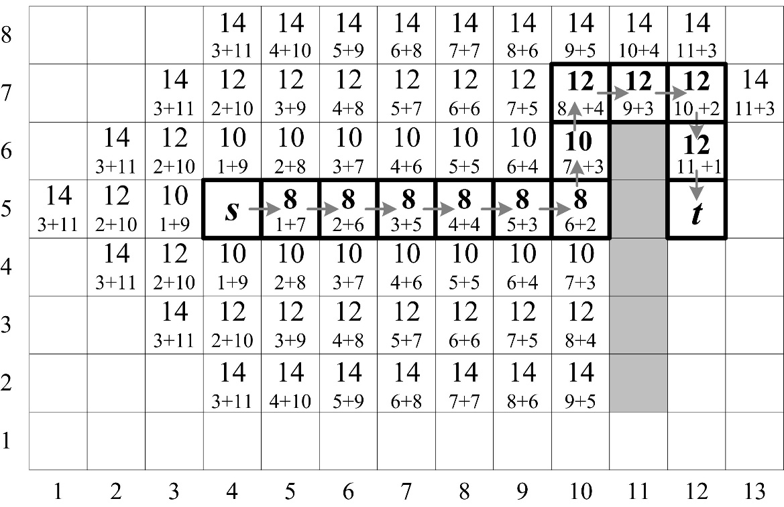

Fig. 17.3. The path from *s* to *t* and the frontier

The frontier is ellipse-shaped. This is more effective because the ellipse-shaped area contains fewer nodes than a circle-shaped one.

Next is an example with an L-shaped obstacle (Fig. 17.4).

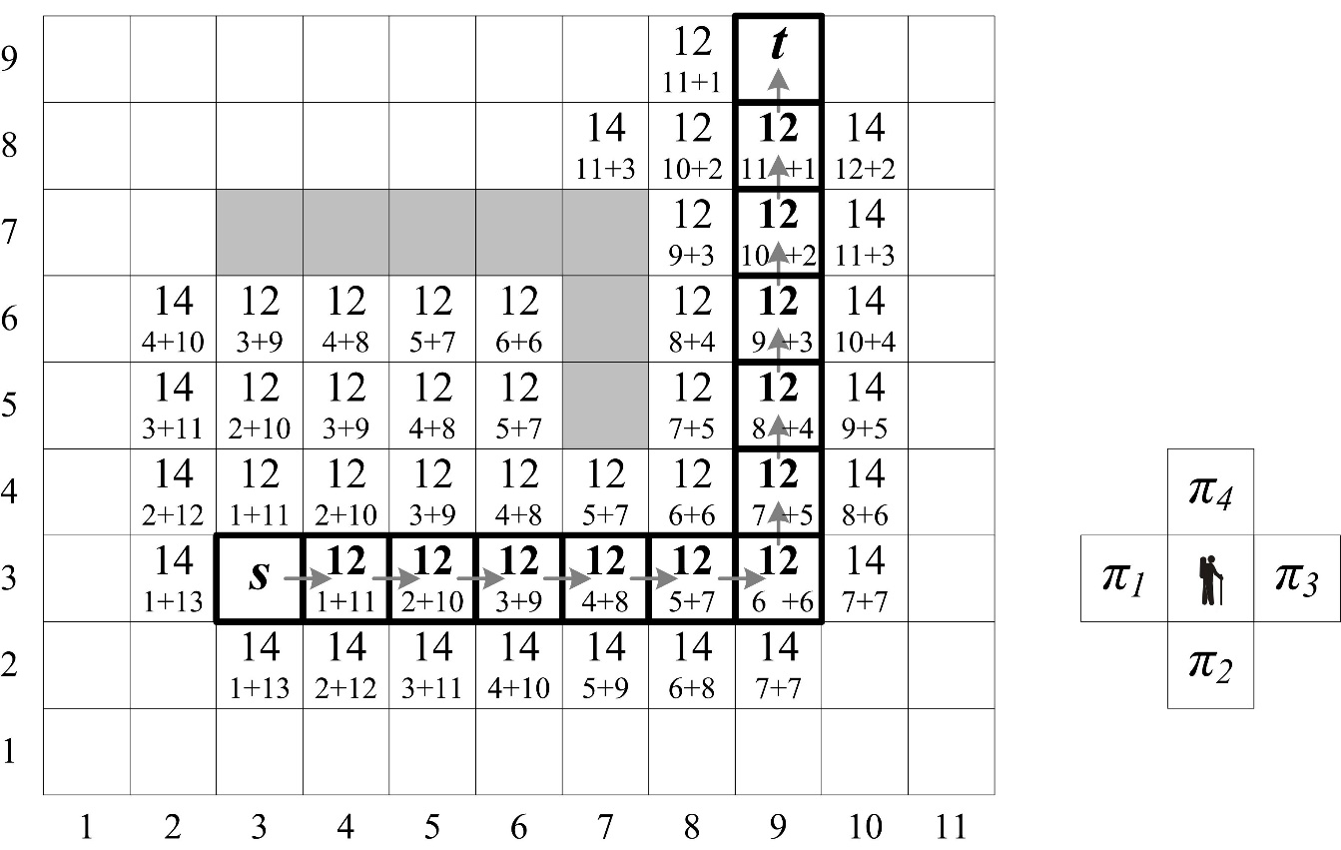

Fig. 17.4 A labyrinth with an L-shaped obstacle and a path from *s* to *t*

Next is an example with the same labyrinth, but 8 moves, in other words, the agent can move diagonally (Fig. 17.5). See also an animation in Wikipedia, [https://en.wikipedia.org/wiki/A\*\_search\_algorithm](https://en.wikipedia.org/wiki/A*_search_algorithm).

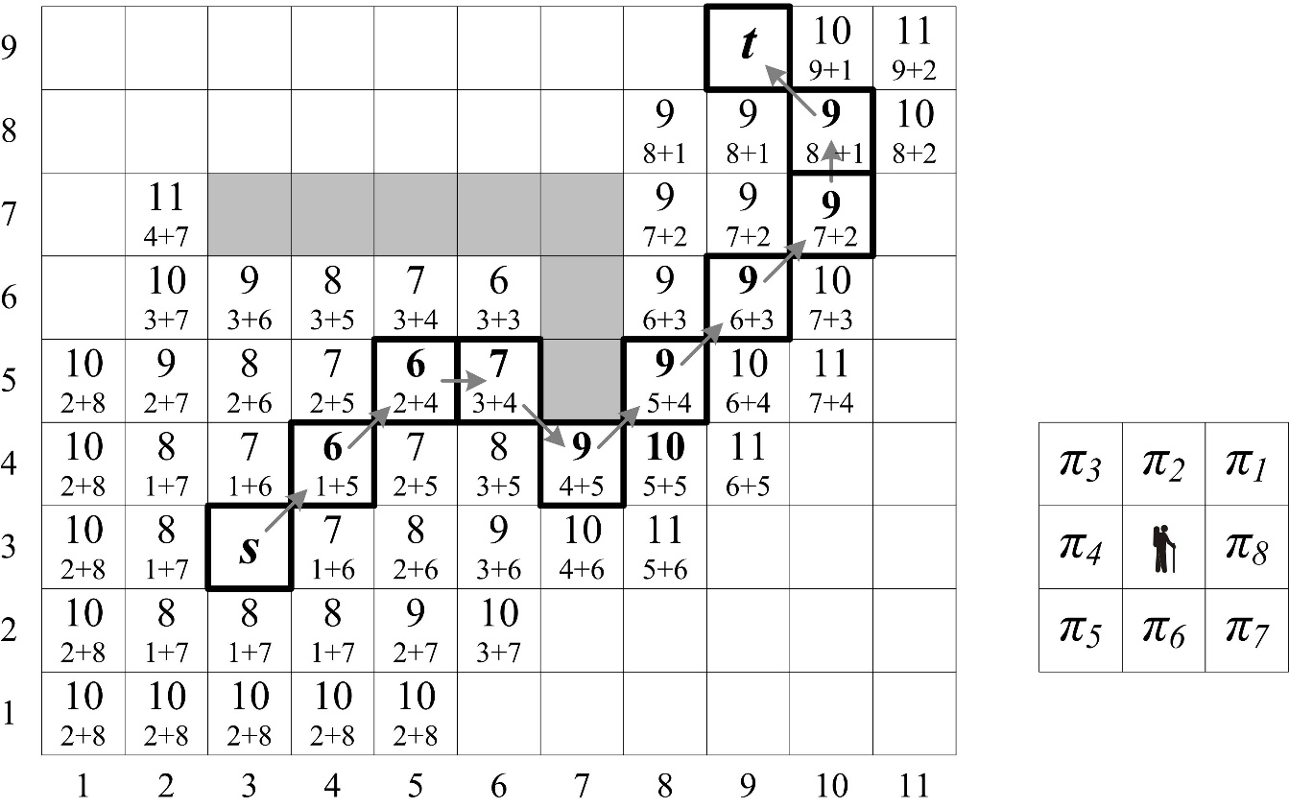

Fig. 17.5 A labyrinth with an L-shaped obstacle, but 8 moves. The path from *s* to *t* differs from the path in Fig. 17.4

The algorithm A\* is optimal when the heuristic function h(n) is optimistic; see (Russell, Norvig 2003). A heuristic function is called *optimistic* in case the evaluation is smaller than an actual path.

## An example from Russell & Norvig 2003

Further A\* explanation follows (Russell, Norvig 2003, Ch. 4, p. 94–98). A path is searched from A to B in the graph which is shown in Fig. 17.6.

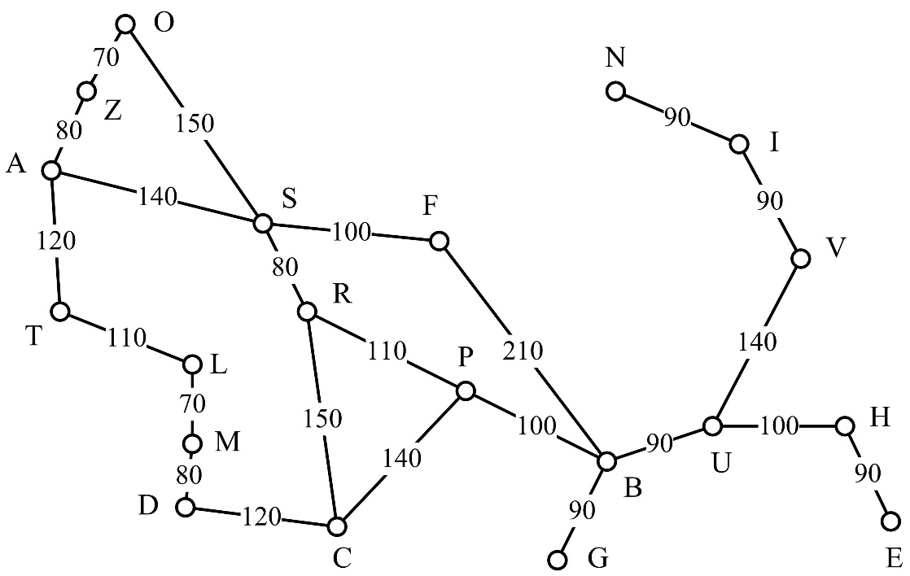

Fig. 17.6. The graph shows transport routes in Romania and is adapted from (Russell, Norvig 2003, p. 63). Path searching from A to B

Heuristic function h(n) is listed in Table 17.7. This heuristic evaluation presents straight distance from n to B.

|  |  |  |  |  |
| --- | --- | --- | --- | --- |
| **City** | ***h(n)*** |  | **City** | ***h(n)*** |
| A | 370 |  | M | 240 |
| B | 0 |  | N | 230 |
| C | 160 |  | O | 380 |
| D | 240 |  | P | 100 |
| E | 160 |  | R | 190 |
| F | 180 |  | S | 250 |
| G | 80 |  | T | 330 |
| H | 150 |  | U | 80 |
| I | 230 |  | V | 200 |
| L | 240 |  | Z | 370 |

Table 17.7. Heuristic function h(n). This heuristic evaluation presents straight distance from n to B

Search trees in each step of A\* are shown in Fig. 17.8.

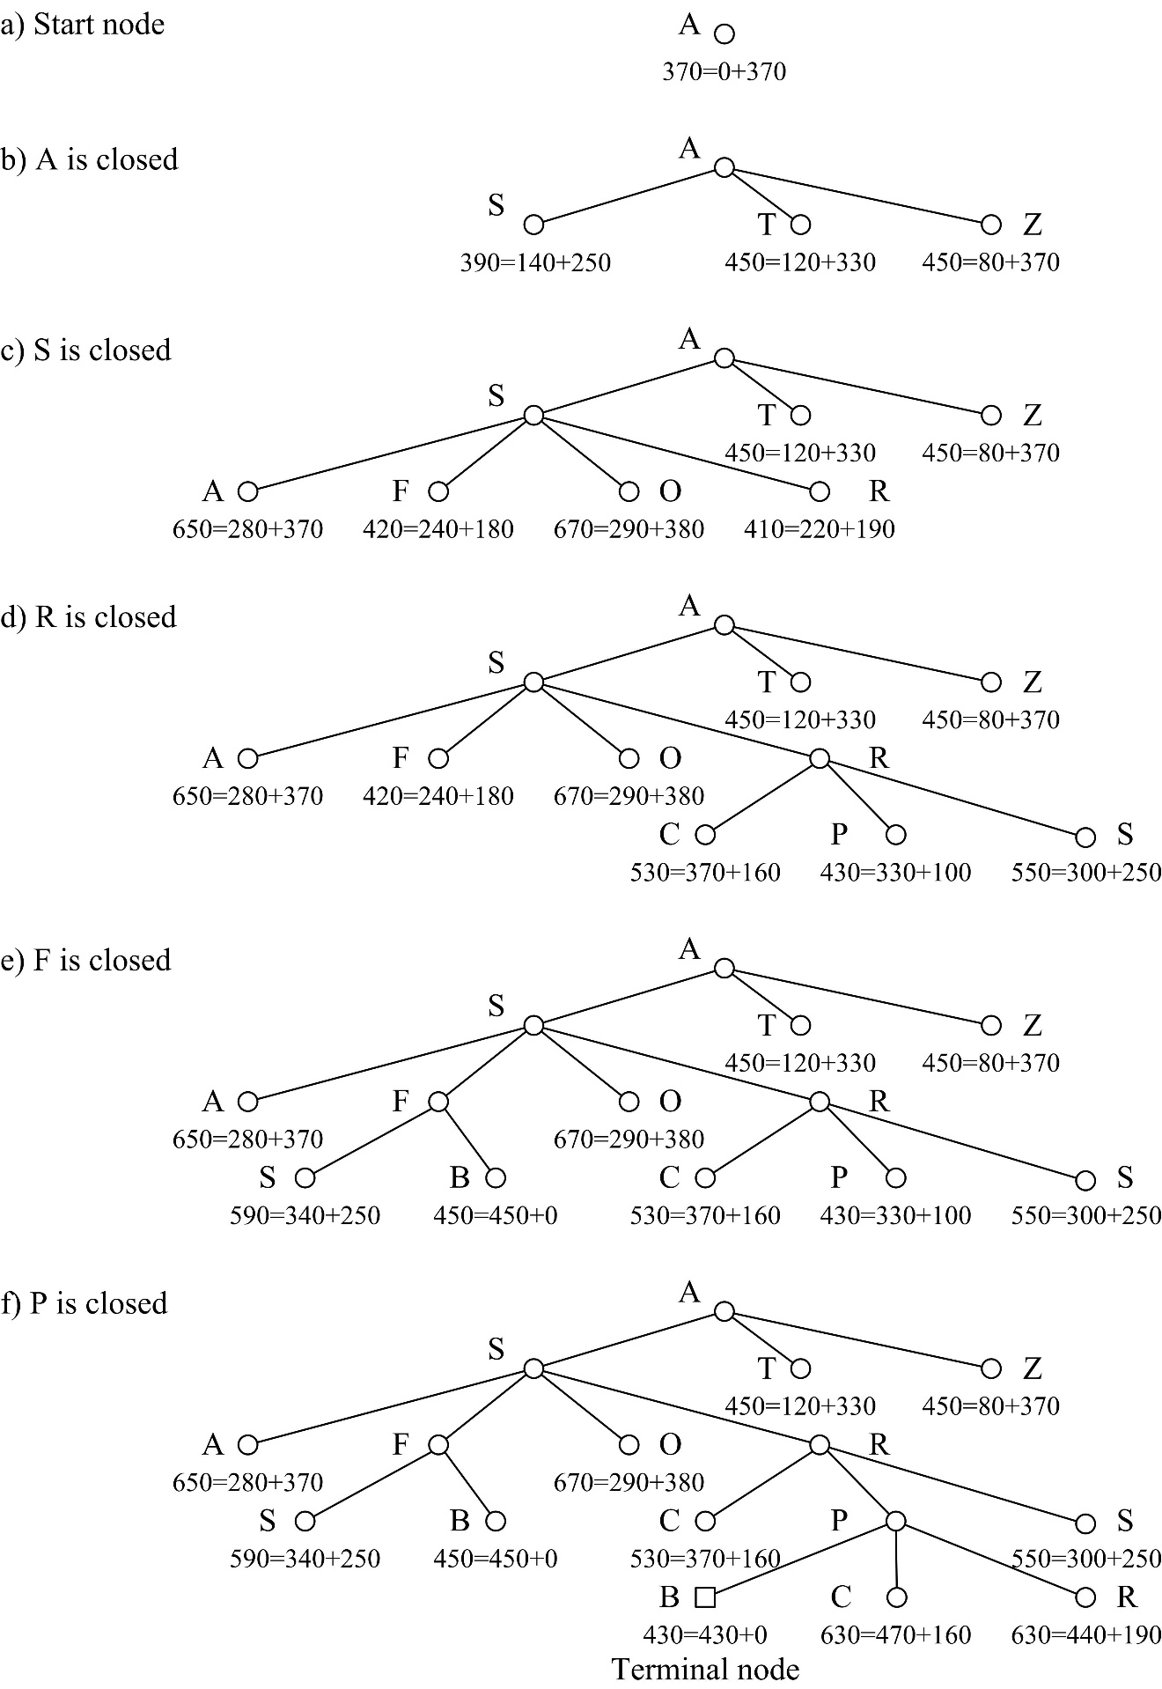

Fig. 17.8. Search trees in each step of A\*. Nodes mark f(n)=g(n)+h(n), where h(n) presents a straight distance from n to B

# Forward chaining and backward chaining

Suppose a sample rule system with propositional variables {A,B,C,D,F,Z}:

|  |  |  |
| --- | --- | --- |
| π1: | F, B → Z |  |
| π2: | C, D → F | (18.1) |
| π3: | A → D |  |

Each rule is of the form rule\_name: antecedent → consequent. The consequent (right hand side) consists of one propositional variable and the antecedent (left hand side) of one or more. In the case the consequent would consist of several propositional variables, the rule can be replaced by several rules. For example, πj: A, B, C → J, K is replaced with

|  |  |
| --- | --- |
| πj1: | A, B, C → J |
| πj2: | A, B, C → K |

Global data base (GDB) consists of facts, for example, {A,B,C}. Facts are represented as propositional variables, i.e. true or false. A goal is a new fact, for example, Z.

The problem is to find a sequence of rules which produces the goal from the facts. Two algorithms – forward chaining and backward chaining – are discussed further.

Both algorithms are implemented in Web services; see the server at <http://juliuschainingexample.appspot.com/>. A client requires to copy-paste the JSON format result, which is produced by the server.

## Forward chaining

It starts from facts and proceeds to the goal.

Suppose a rule system (18.1). Suppose an initial state of the GDB which consists of three facts {A,B,C}; see Fig. 18.1.

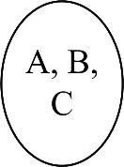

**Fig. 18.1.** The initial state of the GDB is {A,B,C}

**Iteration 1.** Rule π3 is applied; see Fig. 18.2.

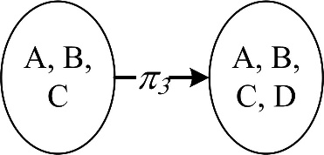

**Fig. 18.2.** Rule π3 is applied. A new GDB state is {A,B,C,D}

Proceed with next iteration.

**Iteration 2.** Rule π2 is applied; see Fig. 18.3.

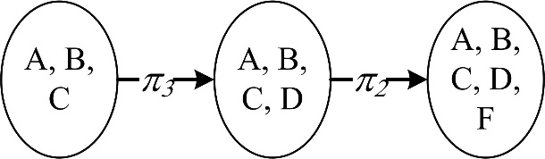

Fig. 18.3. Rule π2 is applied. A new GDB state is {A,B,C,D,F}

Proceed with next iteration.

**Iteration 3.** Rule π1 is applied; see Fig. 18.4.

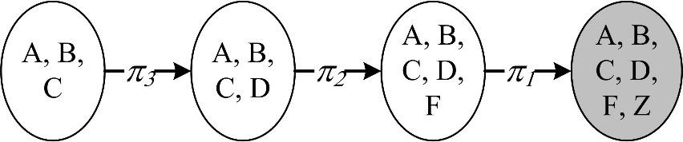

**Fig. 18.4.** Rule π1 is applied. A new GDB state is {A,B,C,D,F,Z}. This is a terminal state because it contains the goal Z

The following result – a sequence of rules – is obtained. It is called a *path* (or a plan):

|  |  |
| --- | --- |
| 〈π3, π2, π1〉 | (18.2) |

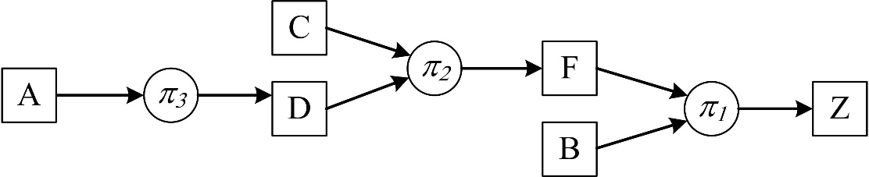

**Fig. 18.5.** The resulting semantic network shows a derivation of Z from {A,B,C} with the sequence 〈π3, π2, π1〉 in the rule system (18.1)

## Backward chaining

Backward chaining starts from the goal and proceeds towards the facts. This is in contrast to forward chaining. Suppose (18.1) as an example.

**Iteration 1.** Rule π1 is selected in (18.1). See Fig 18.6.

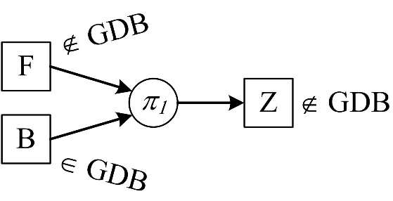

**Fig. 18.6.** The semantic network of the rule π1. It shows the derivation of Z backwards. The input object B belongs to {A,B,C}, but F does not. Therefore F is taken as a new goal

Proceed with next iteration.

**Iteration 2.** Rule π2 is selected in (18.1). See Fig. 18.7.

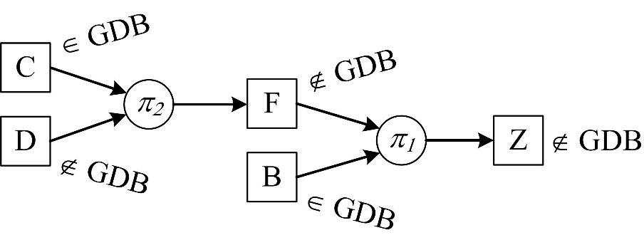

**Fig. 18.7.** The semantic network of the rule π2. It shows the derivation of F backwards. The input object C belongs to {A,B,C}, but D does not. Therefore D is a new goal

Proceed with next iteration.

**Iteration 3.** Rule π3 is selected in (18.1). See Fig 18.8.

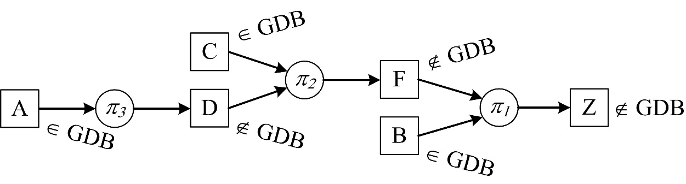

**Fig. 18.8.** A semantic network shows the derivation of Z from {A,B,C}. The rule sequence 〈π3, π2, π1〉 stands for result

## Program synthesis

Suppose procedures (18.3). Their semantics in terms of input-output pairs is represented in (18.1). The list of object names {A,B,C,D,E,F,Z} stands for the alphabet. The objects are of arbitrary type and need not to be Boolean variables as in the case of a rule system.

|  |  |
| --- | --- |
| **procedure** P1;  Z := f1(B,F) | (18.3) |
| **procedure** P2;  F := f2(C,D) |  |
| **procedure** P3;  D := f3(A) |  |

Procedures P1, P2, P3 program functional dependencies f1, f2, f3 among objects {A,B,C,D,E,F,Z} in a programming environment. This sort of procedures serves to represent procedural knowledge in a certain domain. Procedures normally form a software library. The semantics of procedures P1, P2, P3 is represented with rules π1, π2 and π3. This is graphically represented in Fig. 18.9.

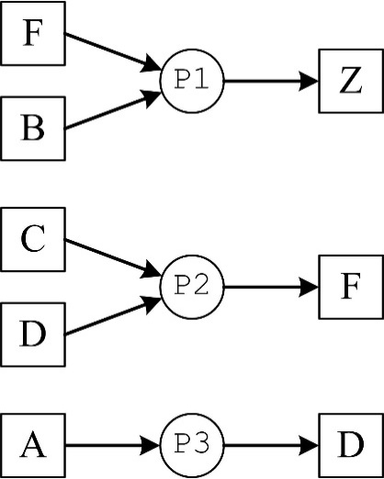

**Fig. 18.9.** A graphical representation of P1, P2 and P3 semantics

The sequence 〈π3, π2, π1〉 (18.2) corresponds to the following *synthesized* program:

|  |  |
| --- | --- |
| **call** P3; |  |
| **call** P2; | (18.4) |
| **call** P1 |  |

The semantics of this program is shown in Fig. 18.10.

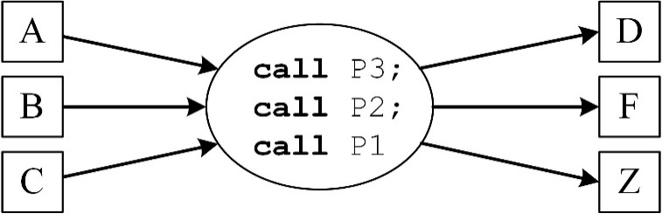

**Fig. 18.10.** Semantic network representation of the synthesized program

This program can be executed many times. However, it synthesized once. Each execution can read new values of objects A, B, C:

|  |
| --- |
| **for** J := 1 **to** 900 **do** *{ Repeat }* **begin**  readln (A, B, C); *{ 1) Read A, B ir C }*    **call** P3; *{ 2) Invoke synthesized program }*  **call** P2;  **call** P1;    writeln(Z); *{ 3) Print Z }* **end** |

## Superfluous rules in forward chaining

Suppose rules (18.1) and add two redundant rules π' ir π":

|  |  |  |
| --- | --- | --- |
| π': | A → L |  |
| π": | L → K |  |
| π1: | F, B → Z | (18.5) |
| π2: | C, D → F |  |
| π3: | A → D |  |

Facts are {A,B,C} and goal Z. Forward chaining is shown in Fig. 18.11.

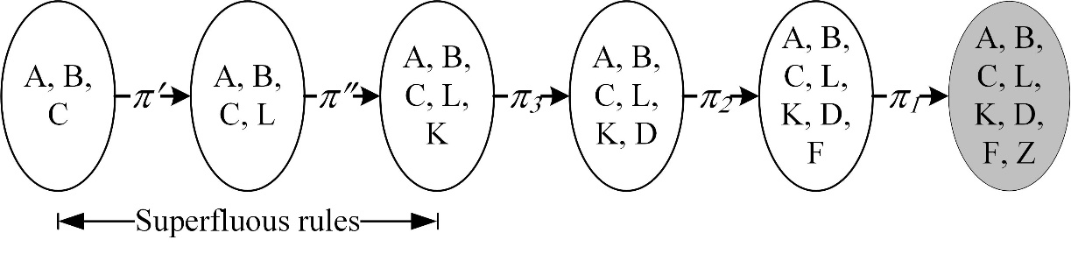

**Fig. 18.11.** Forward chaining produces 〈π', π", π3, π2, π1〉. It contains superfluous rules π' and π" that derive redundant objects L and K

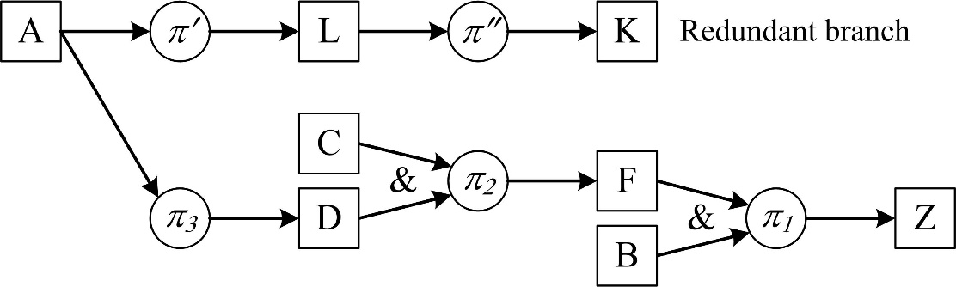

**Fig. 18.12.** Superfluous rules π' and π" derive redundant objects L and K

## Superfluous rules in backward chaining

Suppose rules (18.1) and add two superfluous different rules π' and π":

|  |  |  |
| --- | --- | --- |
| π': | K → M |  |
| π": | M, N→ Z |  |
| π1: | F, B → Z | (18.6) |
| π2: | C, D → F |  |
| π3: | A → D |  |

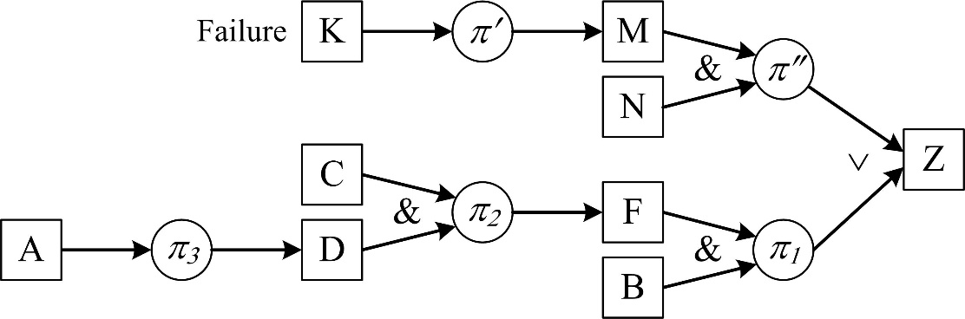

**Fig. 18.13.** Two superfluous rules π' and π" in backward chaining. Their goals N and K cannot be derived. Therefore these rules are not included in the resulting path 〈π3, π2, π1〉

## Complexity of forward chaining

**Theorem.** The complexity of forward chaining in a rule system of *N* rules (18.1) is O(N2).

**Proof.** The first iteration searches among *N* rules, the second iteration searches among *N–1* rules, etc. In each iteration one rule is found. Thus the search space for the next iteration is reduced by one. The worst case to search is *N* iterations. The largest sum of iterations is:

N + N–1 + N–2 + … + 1 = N⋅(N–1)/2 = O(N2)

## Testing forward chaining

|  |  |  |
| --- | --- | --- |
| 1. **Initial fact in right hand side** | R1: | A → L |
| Rules see in the table.  Facts A, B, C.  Goal Z.  Path R1, R2, R7, R4, R6, R5.  Input file: | R2: | L → K |
| R3: | D → A |
| R4: | D → M |
| R5: | F, B → Z |
| R6: | C, D → F |
| R7 | A → D |

Student First name Last name. University, study program.

Test 1. Initial fact in right hand side

1) Rules

L A // R1: A -> L. Comments.

K L // R2: L -> K

A D // R3: D -> A

M D // R4: D -> M

Z F B // R5: F, B -> Z

F C D // R6: C, D -> F

D A // R7: A -> D

2) Facts

A B C

3) Goal

Z

The trace:

PART 1. Data

1) Rules

R1: A -> L

R2: L -> K

R3: D -> A

R4: D -> M

R5: F, B -> Z

R6: C, D -> F

R7: A -> D

2) Facts A, B, C.

3) Goal Z.

PART 2. Trace

ITERATION 1

R1:A->L apply. Raise flag1. Facts A, B, C and L.

ITERATION 2

R1:A->L skip, because flag1 raised.

R2:L->K apply. Raise flag1. Facts A, B, C and L, K.

ITERATION 3

R1:A->L skip, because flag1 raised.

R2:L->K skip, because flag1 raised.

R3:D->A not applied, because of lacking D.

R4:D->M not applied, because of lacking D.

R5:F,B->Z not applied, because of lacking F.

R6:C,D->F not applied, because of lacking D.

R7:A->D apply. Raise flag1. Facts A, B, C and L, K, D.

ITERATION 4

R1:A->L skip, because flag1 raised.

R2:L->K skip, because flag1 raised.

R3:D->A not applied, because RHS in facts. Raise flag2.

R4:D->M apply. Raise flag1. Facts A, B, C and L, K, D, M.

ITERATION 5

R1:A->L skip, because flag1 raised.

R2:L->K skip, because flag1 raised.

R3:D->A skip, because flag2 raised.

R4:D->M skip, because flag1 raised.

R5:F,B->Z not applied, because of lacking F.

R6:C,D->F apply. Raise flag1. Facts A, B, C and L, K, D, M, F.

ITERATION 6

R1:A->L skip, because flag1 raised.

R2:L->K skip, because flag1 raised.

R3:D->A skip, because flag2 raised.

R4:D->M skip, because flag1 raised.

R5:F,B->Z apply. Raise flag1. Facts A, B, C and L, K, D, M, F, Z.

Goal achieved.

|  |  |  |  |  |
| --- | --- | --- | --- | --- |
|  | |  |  |  |
| PART 3. Results  1) Goal Z achieved.  2) Path R1, R2, R7, R4, R6, R5. | |  |  |  |
|  | |  |  |  |
| 2. **Čyras vs. Negnevitsky; Čyras wins** | 18-14.jpg | R1: | G → Z |
| Rules see in the table.  Fact A.  Goal Z.  Path R2, R1. | R2: | A → G |
| R3: | A → B |
| R4: | B → C |
| R5: | C → D |
| R6: | D → Z |

3. **Čyras vs. Negnevitsky; Negnevitsky wins** (however, witha redundant rule)

|  |  |  |  |
| --- | --- | --- | --- |
| Rules see in the table.  Fact A.  Goal Z.  Path R4, R3, R2, R1. | 18-15.jpg | R1: | D → Z |
| R2: | C → D |
| R3: | B → C |
| R4: | A → B |
| R5: | A → G |
| R6: | G → Z |

4. **Goal in facts**

PART 3. Results

Goal A in facts. Empty path.

5. **No path**

Rules R1: A → B; R2: C → Z. Fact A. Goal Z.

6. **Negnevitsky’s example**

Take the 5 rules example from Negnevitsky (2011) section about forward chaining.

## Testing backward chaining

1. **Failed branch**

Rules R1: C, D → Z; R2: T → C; R3: T → Z. Fact T. Goal Z. Path R3. Note that the path is not R2, R3. Facts in the end are T and Z and not T and C, Z. This happens due to backtracking and the failed branch from Z to C.

PART 2. Trace

1) Goal Z. Find R1:C,D->Z. New goals C, D.

2) -Goal C. Find R2:T->C. New goals T.

3) --Goal T. Fact (initial), as facts are T. Back, OK.

4) -Goal C. Fact (presently inferred). Facts T and C.

5) -Goal D. No rules. Back, FAIL.

6) Goal Z. Find R3:T->Z. New goals T.

7) -Goal T. Fact (initial), as facts are T. Back, OK.

8) Goal Z. Fact (presently inferred). Facts T and Z. OK.

|  |  |
| --- | --- |
| PART 3. Results  1) Goal Z achieved.  2) Path: R3. | 18-16 |

|  |  |  |
| --- | --- | --- |
| 2. **Nine rules D, C** | R1: | D, C → Z |
| Rules see in the table. | R2: | C → D |
| Fact T.  Goal Z.  Path R6, R5, R4, R3, R1.  PART 2. Trace | R3: | B → C |
| R4: | A → B |
| R5: | D → A |
| R6: | T → D |
| R7 | G → A |
| R8 | H → B |
| R9 | J → C |

1) Goal Z. Find R1:D,C->Z. New goals D, C.

2) -Goal D. Find R2:C->D. New goals C.

3) --Goal C. Find R3:B->C. New goals B.

4) ---Goal B. Find R4:A->B. New goals A.

5) ----Goal A. Find R5:D->A. New goals D.

6) -----Goal D. Cycle. Back, FAIL.

7) ----Goal A. Find R7:G->A. New goals G.

8) -----Goal G. No rules. Back, FAIL.

9) ----Goal A. No more rules. Back, FAIL.

10) ---Goal B. Find R8:H->B. New goals H.

11) ----Goal H. No rules. Back, FAIL.

12) ---Goal B. No more rules. Back, FAIL.

13) --Goal C. Find R9:J->C. New goals J.

14) ---Goal J. No rules. Back, FAIL.

15) --Goal C. No more rules. Back, FAIL.

16) -Goal D. Find R6:T->D. New goals T.

17) --Goal T. Fact (initial), as facts T. Back, OK.

18) -Goal D. Fact (presently inferred). Facts T and D.

19) -Goal C. Find R3:B->C. New goals B.

20) --Goal B. Find R4:A->B. New goals A.

21) ---Goal A. Find R5:D->A. New goals D.

22) ----Goal D. Fact (earlier inferred), as facts T and D. Back, OK.

23) ---Goal A. Fact (presently inferred). Facts T and D, A. Back, OK.

24) --Goal B. Fact (presently inferred). Facts T and D, A, B. Back, OK.

25) -Goal C. Fact (presently inferred). Facts T and D, A, B, C. Back, OK.

26) Goal Z. Fact (presently inferred). Facts T and D, A, B, C, Z. OK.

PART 3. Results

1) Goal Z achieved.

2) Path: R6, R5, R4, R3, R1.

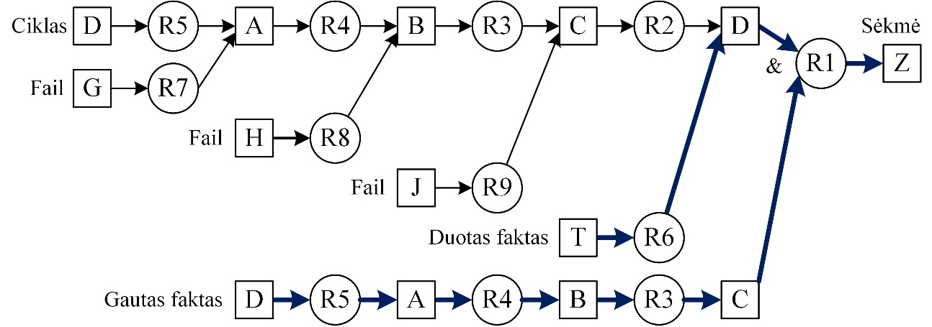

3. **Nine rules C, D**

See above butR1: C, D → Z. Same path.

4. **A loop and a failed branch**

Rules R1: A → Z; R2: B → A; R3: A, C → B; R4: T → B; R5: T → C. Fact T. Goal Z.

Path R4, R2, R1.

|  |  |  |  |
| --- | --- | --- | --- |
| 5. **Graph and a short path** |  | R1: | E → G |
| Rules in the table.  Fact A.  Goal Z.  Path R4, R3. | 18-16.jpg | R2: | F → B |
| R3: | G → Z |
| R4: | A → G |
| R5: | A → B |
| R6: | B → C |
| R7: | C → D |
| R8: | D → Z |

|  |  |  |  |
| --- | --- | --- | --- |
| 6. **Graph and a long path** |  | R1: | F → B |
| Rules in the table.  Fact A.  Goal Z.  Path R6, R5, R4, R3. | 18-17 | R2: | E → G |
| R3: | D → Z |
| R4: | C → D |
| R5: | B → C |
| R6: | A → B |
| R7: | A → G |
| R8: | G → Z |

7. **Three alternatives**

Rules R1: A → Z; R2: B → Z; R3: C → Z. Fact C. Goal Z. Path R3.

8. **Unachievable goal**

Rules R1: C, D → Z; R2: C, E → Y. Facts C, D. Goal Y. No path.

9. **Goal among facts – empty path**

PART 3. Results

Goal A among facts. Empty path.

10. **Negnevitsky’s example**

Take the 5 rules example from Negnevitsky (2011) section about backward chaining.

# Resolution

The word resolution denotes inference rule and also inference method which is explained below. See also <https://en.wikipedia.org/wiki/Resolution_(logic)>. The method is introduced with an example from (Thayse et al. 1988). Suppose a statement “A professor can examine students of a distinct faculty”. Suppose two facts:

1. James is a professor at the faculty of informatics;
2. Mary is a student at the faculty of mathematics.

The task is to prove that James is allowed to examine Mary.

Two facts are represented with predicates:

|  |  |  |
| --- | --- | --- |
| Fact F1: | Prof(Info,James) | (19.1) |
| Fact F2: | Stud(Mat,Mary) | (19.2) |

The statement “A professor can examine students of a distinct faculty” is represented with the following rule:

|  |  |
| --- | --- |
| R1: Prof(x,y) & Stud(z,w) & ¬Eq(x,z) ⇒ Exam(y,w) | (19.3) |

Implication P ⇒ Q can be replaced with negation and conjunction ¬P ∨ Q. This replacement can be treated as a term rewriting rule (see Fig. 19.1):

|  |  |  |
| --- | --- | --- |
| P ⇒ Q | Elimination of implication. (Write also P ⇒ Q |– ¬P ∨ Q) | (19.4) |
| ¬P ∨ Q |

Implication elimination is sound. The tables of both formulas coincide: P ⇒ Q ≡ ¬P ∨ Q (consider true ∨ true = true, true ∨ false = true, false ∨ false = false):

|  |  |  |  |  |
| --- | --- | --- | --- | --- |
| P | Q | ¬P | ¬P ∨ Q | P ⇒ Q |
| true | true | false | true | true |
| true | false | false | false | false |
| false | true | true | true | true |
| false | false | true | true | true |

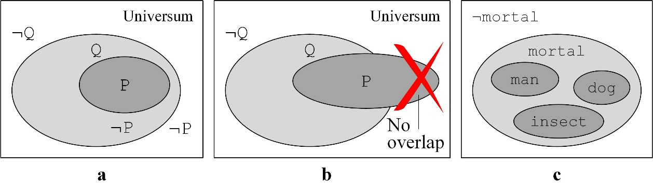

**Fig. 19.1.** a) Venn diagram showing implication P ⇒ Q. b) No overlap of P and ¬Q. c) Three implications

In the case of P ⇒ Q, a set of world states for P (where P = true) is a subset of states for Q (where Q = true): *states*(P) ⊂ *states*(Q) (Fig. 19.1 a). Note that the set inclusion is in the opposite direction than the implication. Fig. 19.1 b illustrates that P and ¬Q do not overlap. See also Fig. 19.1 c showing a Venn diagram with three implications man ⇒ mortal, insect ⇒ mortal, and dog ⇒ mortal.

Eliminating implication can be generalised:

|  |  |  |
| --- | --- | --- |
| P1 & P2 & … & Pn ⇒ Q | Elimination of implication (general) | (19.5) |
| ¬P1 ∨ ¬P2 ∨ … ∨ ¬Pn ∨ Q |

Following is the rule to eliminate double negation. It is sound because ¬¬P ≡ P:

|  |  |  |
| --- | --- | --- |
| ¬¬P | Double negation elimination | (19.6) |
| P |

We rewrite the rule (19.3) taking into account (19.5) and obtain

¬Prof(x,y) ∨ ¬Stud(z,w) ∨ ¬¬Eq(x,z) ∨ Exam(y,w)

Double negation is eliminated:

|  |  |
| --- | --- |
| Rule R1: ¬Prof(x,y) ∨ ¬Stud(z,w) ∨ Eq(x,z) ∨ Exam(y,w) | (19.7) |

To apply resolution we start explaining the *modus ponens* rule: 1) Suppose P. 2) Suppose the implication if P, then Q. 3) Therefore Q.

|  |  |  |
| --- | --- | --- |
| P | 1) Small premise |  |
| P ⇒ Q | 2) Great premise | *modus ponens* |
| Q | 3) Conclusion |  |

A horizontal representation of the *modus ponens* rule (with comma between premises):

|  |  |
| --- | --- |
| P, P ⇒ Q | *modus ponens* |
| Q |

An example of *modus ponens* application with formulas in predicate logic, where {Socrates/x} is a *unifier*:

|  |  |
| --- | --- |
| 1) man(Socrates) | {Socrates/x} |
| 2) ∀x man(x) ⇒ mortal(x) |
| 3) mortal(Socrates) |

The resolution rule is written as follows:

|  |  |  |  |
| --- | --- | --- | --- |
| P, ¬P ∨ Q | σ | **Resolution rule** (simple form) | (19.8) |
| Q |

The above rule is depicted in Fig. 19.2. Formulas ∀x1∀x2…∀xnQ(x1,x2,…,xn) are considered; see e.g. (Norgėla 2007, p. 26, 92, 158–163), (Nilsson 1998, p. 253–268).

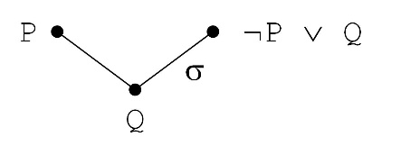

**Fig. 19.2.** Graphical representation of the resolution rule

Another form of representing the resolution rule is with replacing P with ¬P:

|  |  |  |
| --- | --- | --- |
| ¬P, P ∨ Q |  | (19.9) |
| Q |

The resolution rule (19.9) and deduction is illustrated with an example. Suppose a parallel circuit of two electric bulbs P and Q (Fig. 19.3). The circuit is modelled with the formula P ∨ Q. Suppose the bulb P is broken (meaning ¬P= true) but electric current is on (meaning P ∨ Q = true). Therefore we deduce that the bulb Q is light (meaning Q = true).

|  |  |
| --- | --- |
| **Fig. 19.3.** Parallel circuit of two bulbs is modelled with the disjunction P ∨ Q. The statement „Bulb P is off“ (i.e. the bulb is broken) means ¬P. A conclusion of these two statements is that Q is on |  |

A general case, where n ≥ 0:

|  |  |  |  |
| --- | --- | --- | --- |
| P ∨ H, ¬P ∨ Q | {A1/x1, A2/x2,… An/xn} | **Resolution rule**  (general) | (19.10) |
| H ∨ Q |

In the unifier the variables xi, if any, are replaced with Ai; see Fig. 9.4. The unifier σ is of the form {A1/x1, A2/x2,… An/xn}.

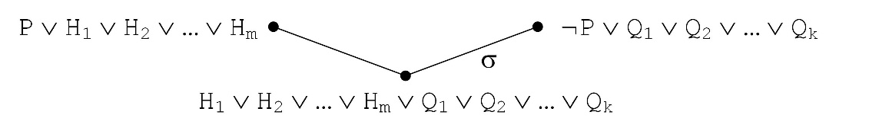

**Fig. 19.4.** Graphical representation of the resolution rule, where m, k ≥ 0

## Inference example

There are two directions of proof (inference) with the resolution rule: *backward proof* and *forward proof*. Backward proof goes from the goal to the facts. Forward proof goes from the facts to the goal.

**Backward proof – from the goal to the facts.** To prove Exam(James,Mary) suppose the opposite, i.e. the goal’s negation:

|  |  |
| --- | --- |
| ¬Exam(James,Mary) | (19.11) |

Take (19.11) and the rule (19.7) and apply the resolution rule (19.9). To resolve the negative disjunct ¬Exam(James,Mary) with the positive one Exam(y,w), the unifier is {James/y, Mary/w}.

|  |
| --- |
| ¬Exam(James,Mary), ¬Prof(x,James) ∨ ¬Stud(z,Mary)∨Eq(x,z)∨Exam(James,Mary) |
| ¬Prof(x,James) ∨ ¬Stud(z,Mary) ∨ Eq(x,z) |

Further take the above conclusion and the fact F1 (19.1) and apply the resolution rule (19.8). The unifier is {Info/x}.

|  |
| --- |
| ¬Prof(Info,James) ∨ ¬Stud(z,Mary) ∨ Eq(Info,z), Prof(Info,James) |
| ¬Stud(z,Mary) ∨ Eq(Info,z) |

Further take the conclusion above and fact F2 (19.2) and apply the resolution rule (19.8). The unifier is {Mat/z}.

|  |
| --- |
| ¬Stud(Mat,Mary) ∨ Eq(Info,Mat), Stud(Mat,Mary) |
| Eq(Info,Mat) |

Faculties of informatics and mathematics are distinct ones, formally, Eq(Info,Mat) = false. Therefore the conclusion above is false. Hence, a contradiction is obtained. Thus the goal negation leads to contradiction. Therefore the goal Exam(James,Mary) is true. The inference tree is shown in Fig. 19.5. **End of proof.**

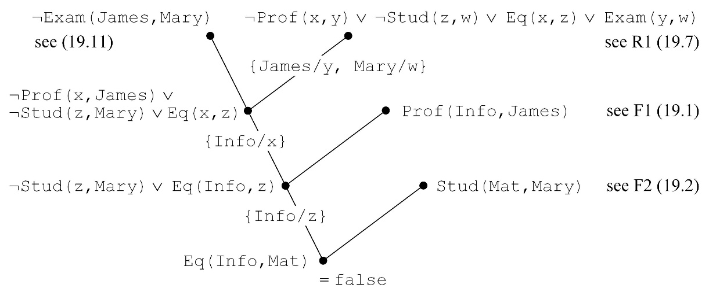

**Fig. 19.5.** Inference tree for the statement Exam(James,Mary). Theorem’s negation leads to contradiction

**Forward proof (direct inference) – from facts to goal.** Suppose two facts F1 (19.1) and F2 (19.2) and one rule R1 (19.7). We will prove Exam(James,Mary).

Take fact F1 Prof(Info,James) and find a rule to match. Take the rule (19.7) and apply the resolution rule (19.8). The unifier is {Info/x, James/y}:

|  |
| --- |
| Prof(Info,James), ¬Prof(Info,James) ∨ ¬Stud(z,w) ∨ Eq(Info,z) ∨Exam(James,w) |
| ¬Stud(z,w) ∨ Eq(Info,z) ∨ Exam(James,w) |

Then take fact F2 Stud(Mat,Mary) and match with the conclusion above. Apply the resolution rule (19.8) with the unifier {Mat/z, Mary/w}:

|  |
| --- |
| Stud(Mat,Mary), ¬Stud(Mat,Mary) ∨ Eq(Info,Mat) ∨ Exam(James,Mary) |
| Eq(Info,Mat) ∨ Exam(James,Mary) |

As Eq(Info,Mat) = false and false ∨ H ≡ H, therefore Exam(James,Mary). Q.E.D. – *quod erat demonstrandum*. The inference tree is shown in Fig. 19.6. **End of proof.**

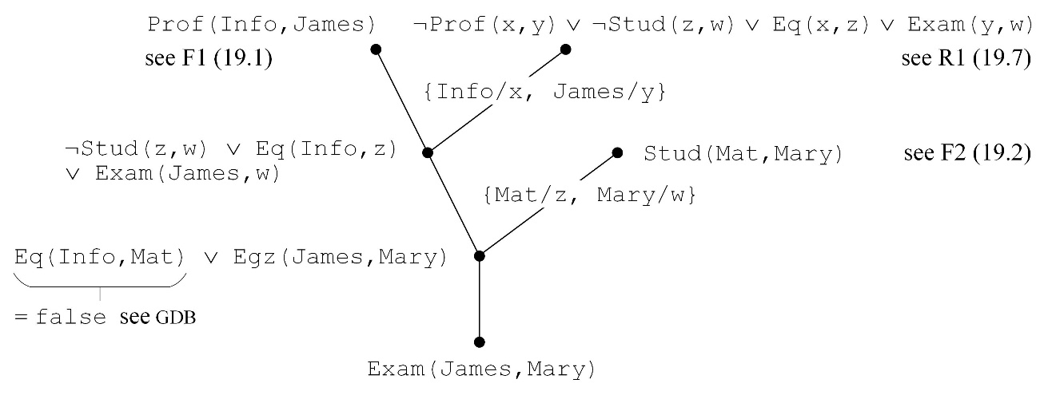

**Fig. 19.6.** Inference tree to prove Exam(James,Mary). This is a direct proof – from the facts to the goal

Suppose one more fact: Irma is a student at the faculty of informatics. Formally, F3: Stud(Info,Irma). However, the rule 19.3 fails to prove that professor James examines student Irma.

## Example with three rules

Suppose the rules (18.1). Implication elimination leads to normal disjunctive form below.

|  |  |  |  |
| --- | --- | --- | --- |
|  | Rule | Formula | Implication eliminated |
| π1: | F, B → Z | F & B ⇒ Z | ¬F ∨ ¬B ∨ Z |
| π2: | C, D → F | C & D ⇒ F | ¬C ∨ ¬D ∨ F |
| π3: | A → D | A ⇒ D | ¬A ∨ D |

Suppose three facts, F1: A, F2: B, and F3: C. In other words, A=true, B=true, and C=true. Prove Z.

**Proof backward.** Start from goal’s negation ¬Z.

Find a rule to match. The rule π1 is found. Apply the resolution rule (19.8):

|  |
| --- |
| ¬Z, ¬F ∨ ¬B ∨ Z |
| ¬F ∨ ¬B |

Take the above conclusion ¬F ∨ ¬B and find a rule to match. Find π2. Then apply the resolution rule (19.10):

|  |
| --- |
| ¬F ∨ ¬B, ¬C ∨ ¬D ∨ F |
| ¬B ∨ ¬C ∨ ¬D |

Take the above conclusion ¬B∨¬C∨¬D and find a rule to match. Find π3. Then apply the resolution rule (19.10):

|  |
| --- |
| ¬B ∨ ¬C ∨ ¬D, ¬A ∨ D |
| ¬B ∨ ¬C ∨ ¬A |

The above conclusion can be rewritten because ¬B ∨ ¬C ∨ ¬A ≡ ¬(B & A & C). Next consider the facts A, B and C. Therefore the formula A & B & C is true. Apply the resolution rule (19.10) (or apply resolution three times with formulas A, B and C sequentially):

|  |
| --- |
| ¬(B & A & C), A & B & C |
| ∅ |

Empty resolvent ∅ means contradiction (P & ¬P = false). Hence, goal’s negation ¬Z implies contradiction. Therefore the goal Z is true. The proof tree is shown in Fig. 19.7. **End of proof.**

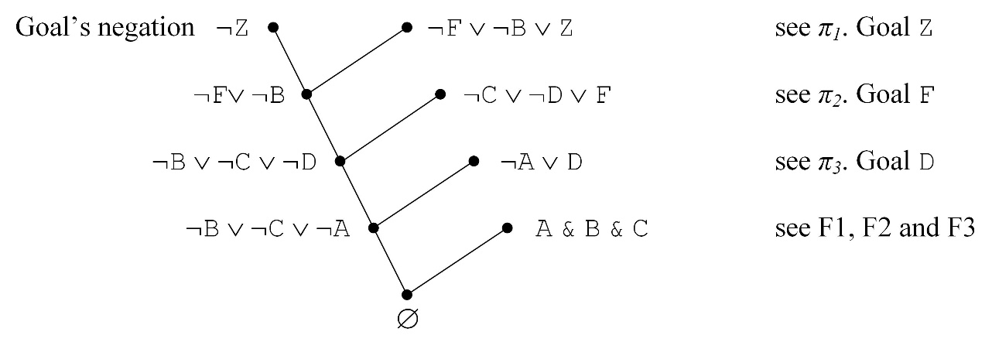

**Fig. 19.7.** Proof tree for Z. Inference is backward: from goal’s negation to contradiction

Intelligence lies in the sequence π1, π2, π3 which is inherent in the proof. This sequence is extracted from the proof and listed from its end to produce the plan 〈π3, π2, π1〉.

**Proof forward (direct inference).** Start from facts. Take fact F1: A. Search a rule to match. Find π3, i.e. ¬A ∨ D. Apply the resolution rule (19.8):

|  |
| --- |
| A, ¬A ∨ D |
| D |

Search a rule to match. Find π2, i.e. ¬C ∨ ¬D ∨ F. Apply the resolution rule (19.8):

|  |
| --- |
| D, ¬C ∨ ¬D ∨ F |
| ¬C ∨ F |

Take fact F3, i.e. C. Apply the resolution rule (19.8):

|  |
| --- |
| C ¬C ∨ F |
| F |

Search a rule to match. Find π1, t. y. ¬F ∨ ¬B ∨ Z. Apply the resolution rule (19.8):

|  |
| --- |
| F, ¬F ∨ ¬B ∨ Z |
| ¬B ∨ Z |

Take fact F2, i.e. B. Apply the resolution rule (19.8):

|  |
| --- |
| B, ¬B ∨ Z |
| Z |

The goal Z is obtained. Q.E.D. Proof tree is shown in Fig. 19.8. **End of proof**.

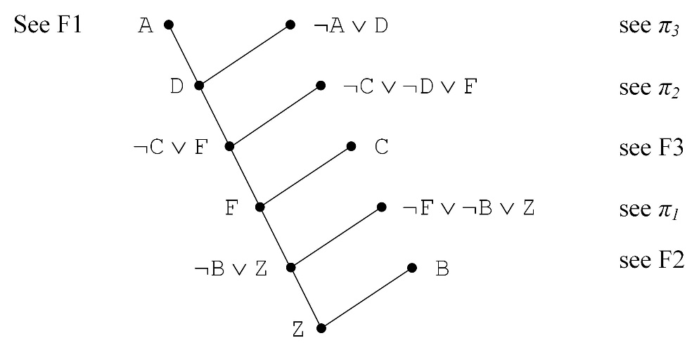

**Fig. 19.8.** Proof tree of Z. The proof is direct forward: from facts to the goal

Using resolution to prove theorem

This section follows (Nilsson 1998, 16.5, p. 260–261).

|  |
| --- |
| (1) ∀x,y Package(x) & Package(y) & Inroom(x,27) &  Inroom(y,28) ⇒ Smaller(x,y) |

Shortly, after the elimination of implication:

(2) ¬P(x) ∨ ¬P(y) ∨ ¬I(x,27) ∨ ¬I(y,28) ∨ S(x,y)

Robot knows that A is in room 27 or 28 (but does not know in which one), formally, I(A,27) ∨ I(A,28). Robot knows that B is in room 27, I(B,27). Robot knows that B is not smaller than A, ¬S(B,A). Hence:

(3) P(A). Fact.

(4) P(B). Fact.

(5) I(A,27) ∨ I(A,28). Robot knows.

(6) I(B,27). Robot knows.

(7) ¬S(B,A). Robot knows.

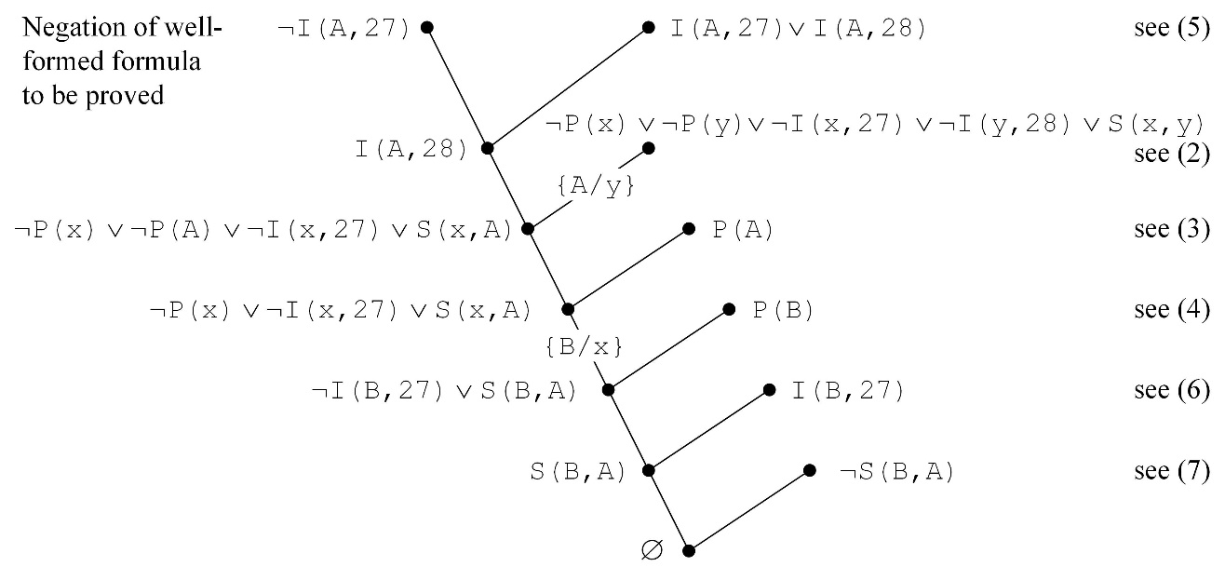

**Fig. 19.9.** Proof tree; adapted from (Nilsson 1998, p. 261)

A possible world is shown in Fig. 19.10.

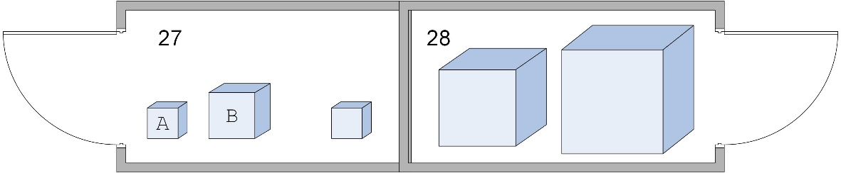

**Fig. 19.10.** A possible world the robot knows about

# Expert systems

A general architecture of expert systems is shown in Fig. 20.1; see e.g. Sawyer and Foster (1986).

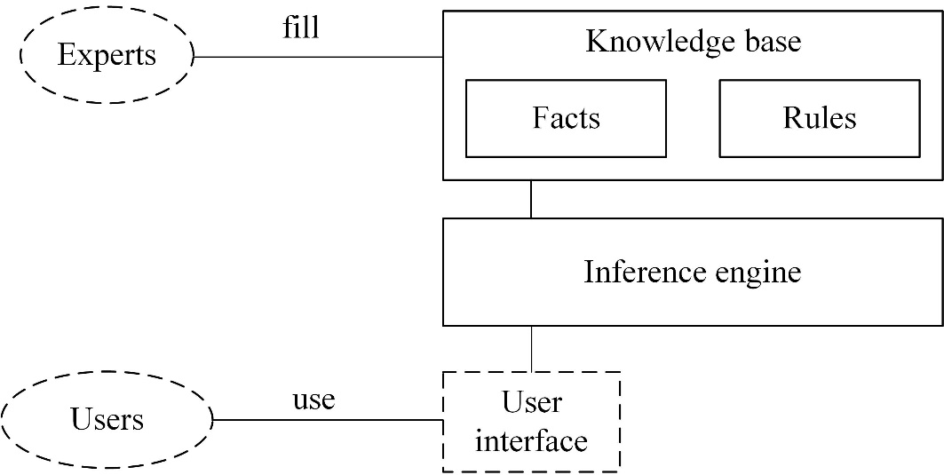

**Fig. 20.1.** A general architecture of an expert system

Following is an example “Health Assessment Knowledge Base” from (Sawyer, Foster 1986, p. 169–181). Facts are shown below in Fig. 20.2.

|  |  |  |
| --- | --- | --- |
| 1) age=  1. '25\_or\_less'  2. **'25-55'**  3. '55\_or\_over' | 2) gender=  1. 'm'  2. **'f'** | 3) weight=  1. **'55\_or\_less'**  2. '55-85'  3. '85\_or\_more |
| 4) frame=  1. **'small'**  2. 'large' | 5) cholesterol=  1. **'normal'**  2. 'high' | 6) salt=  1. **'normal'**  2. 'high' |
| 7) smoker=  1. 'yes'  2. **'no'** | 8) personality=  1. **'aggressive'**  2. 'docile' | 9) alcohol=  1. 'none'  2. **'moderate'**  3. 'excessive' |

**Fig. 20.2.** Facts in an expert system. Bold text shows a selection by the user

Several rules of total about 100 are shown below.

|  |  |
| --- | --- |
| R1 | If relative weight is normal then general assessment is “yes”.  **if** relative\_weight='normal' **then** val='yes' |
| R4 | If heart disease risk is average then heart disease danger is low.  **if** heart\_disease\_risk='average' **then** hddanger='low' |
| R8 | If age is 25-55 years and gender is female then base longevity is 67 years.  **if** age='25-55' & gender='f' **then** base\_longevity='67' |
| R12 | If weight is smaller than 55 kg, and frame is small and gender is female then relative weight is normal.  **if** weight='55\_or\_less' & frame='small' & gender='f' **then** relative\_weight='normal' |
| R27 | If cholesterol is normal then heart disease risk is average.  **if** cholesterol='normal' **then** heart\_disease\_risk='average' |
| R29 | If salt consumption is normal then blood pressure is average.  **if** salt='normal' **then** blood\_pressure='average' |
| R37 | If general evaluation is “yes” and heart disease danger is low and blood pressure is average and non-smoker then outlook is excellent.  **if** val='yes' & hddanger='low' & blood\_pressure='average' & smoker='no' **then** outlook ='excellent' |
| R43 | If personality is aggressive then personality type is A.  **if** personality='aggressive' **then** personality\_type='type\_a' |
| R45 | If personality type is A then general risk is high.  **if** personality\_type='type\_a' **then** risk='high' |
| R47 | If alcohol consumption is moderate then additional factor is good.  **if** alcohol='moderate' **then** add='good' |
| R52 | If outlook is excellent and risk is high and additional factor is good then factor is none.  **if** outlook='excellent' & risk='high' & add='good' **then** factor='none' |
| R64 | If base\_longevity is 67 years and factor is none then longevity prognosis is 67 years.  **if** base\_longevity='67' & factor='none' **then** longevity='67\_yrs' |

**Fig. 20.3.** Sample rules in an expert system

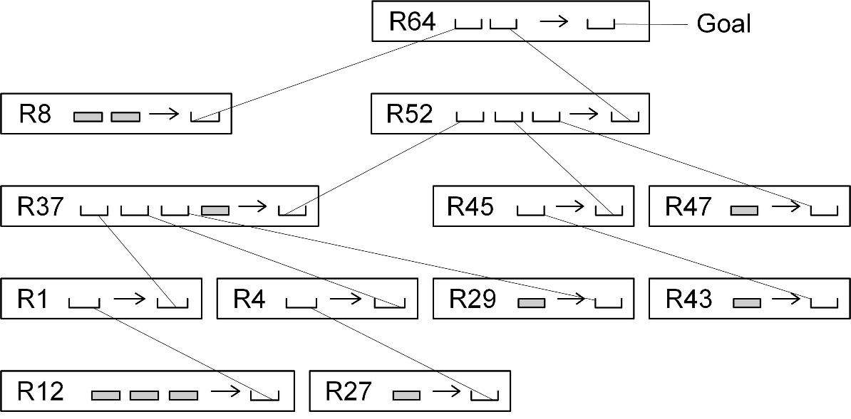

**Fig. 20.4.** A simplified proof tree. Facts are denoted by grey rectangles

Here rules are of the form ***if*** *o1=v1 & o2=v2 & … & on=vn* ***then*** *on+1=vn+1* . Therefore the polynomial complexity of inference results. The reason is that every object *oi* obtains a value from a finite enumeration set {*vi1, vi2, …,vim*}. This is a distinction from exponential complexity in Prolog, where rules are represented with predicates, e.g., *P1(x,y) & P2(x) & P3(y) → P4(x,y)*. Therefore variables *x*, *y*, etc. require matching in infinite sets.

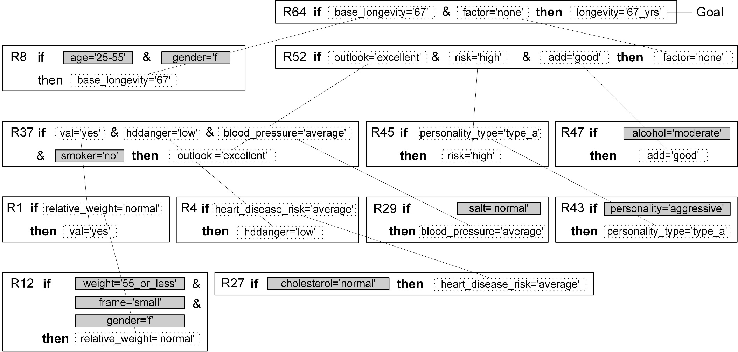

**Fig. 20.5.** A sample proof tree in an expert system. Facts are shown in grey rectangles. The goal longevity='67\_yrs' is at the root. The longevity of 67 years is predicted for a small-framed aggressive woman (gender='f'), aged 25–55 years (age='25-55'), non-smoker (smoker='no'), consuming salt normally (salt='normal'), weight smaller than 55 kilograms (weight='55\_or\_less'), and normal amount of cholesterol in her blood.

# Internet shopping

This section follows (Russell, Norvig 2003, p. 344–348) and adds more details.

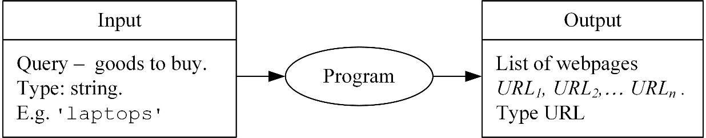

**Fig. 21.1.** Input-output description of an internet shopping program

The program is treated as a computer agent (Fig. 21.2); see Russell, Norvig (2003) chapter 2 Intelligent Agents.

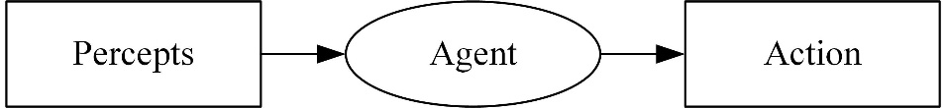

**Fig. 21.2.** Input-output description of a computer agent

A typical internet shop is shown in Fig. 21.3.



<html>

<body>

<h1>Generic Online Store</h1>

<i>Select</i> from our fine line of products

<ul>

<li><a href="http://www.gen-store.com/compu">Computers</a>

<li><a href="http://www.gen-store.com/camer">Cameras</a>

<li><a href="http://www.gen-store.com/books">Books</a>

<li><a href="http://www.gen-store.com/video">Videos</a>

<li><a href="http://www.gen-store.com/music">Music</a>

</ul>

</body>

</html>

**Fig. 21.3.** A web page which is perceived in the internet and its HTML code. Suppose its address http://www.gen-store.com and named GenStore

We will use top-down refinement to formulate requirements. A computer agent is required to return URLs of internet shopping webpages.

*Step 1. Predicate* **RelevantOffer**

It is decomposed below. Types: page – HTML text, url – URL, query – String:

**RelevantOffer**(page,url,query) ⇔

**Relevant**(page,url,query) & **Offer**(page)

*Step 2. Predicate* **Offer**. Either a tag “a” or “form” should contain the word ‘buy’ or ‘price’:

**Offer**(page) ⇔ ( **InTag**('a',str,page) ∨

**InTag**('form',str,page) )

& ( **In**('buy',str) ∨ **In**('price',str) )

**InTag**(tag,str,page) ⇔ **In**('<'+tag+str+'</'+tag+'>', page)

**In**(sub,str) ⇔ ∃i str[i:i+Length(sub)-1] = sub

For example,

**In**('KAD', 'ABRAKADABRA') = true

**In**('laptop', 'ABRAKADABRA') = false

'ABC' + 'DEFG' = 'ABCDEFG'

*Step 3. Predicate* **OnlineStores**(store)

The set of well-known internet shops is not empty because Amazon and eBay are the cases. Equally we would treat our GenStore. This is specified:

Amazon ∈ **OnlineStores**

& **Homepage**(Amazon, 'http://www.amazon.com')

Ebay ∈ **OnlineStores**

& **Homepage**(Ebay, 'http://www.ebay.com')

GenStore ∈ **OnlineStores**

& **Homepage**(GenStore, 'http://www.gen-store.com')

*Step 4. Predicate* **Relevant**. It is decomposed below; see Fig. 21.4:

|  |  |
| --- | --- |
| **Relevant**(page,url,query) ⇔ ∃ store ∃ home (  store∈**OnlineStores** & **Homepage**(store,home)  & ∃ url2 **RelevantChain**(home,url2,query)  & **Link**(url2,url)& page = **GetPage**(url) ) | (21.1) |

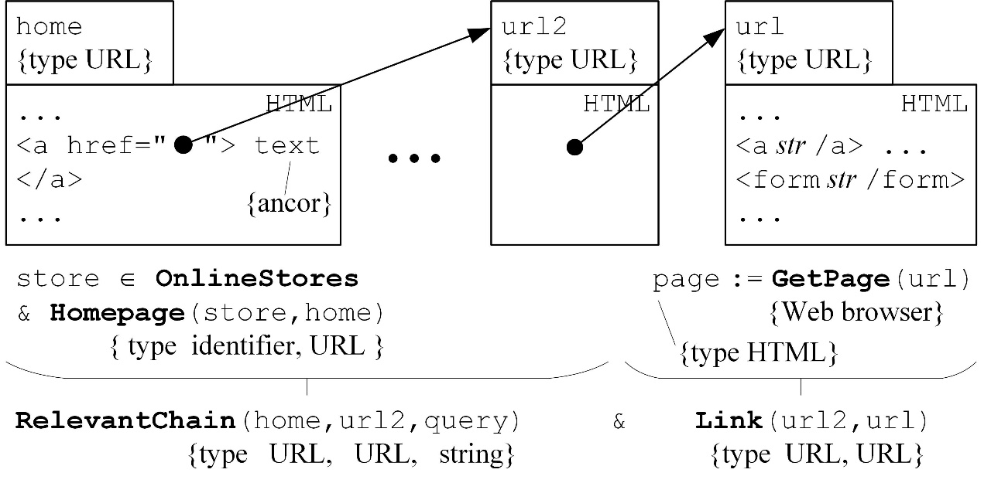

**Fig. 21.4.** Internet shopping specification. For example, home = 'http://www.gen-store.com' and store = GenStore

*Step 5. Predicate* **RelevantChain**.

It is decomposed below. Types: start – URL, end – URL, query – String (Fig. 21.5):

|  |  |
| --- | --- |
| **RelevantChain**(start,end,query) ⇔ (start = end)  ∨ ( ∃u ∃text **LinkText**(start,u,text)  & **RelevantCategoryName**(query,text)  & **RelevantChain**(u,end,query) ) | (21.2) |

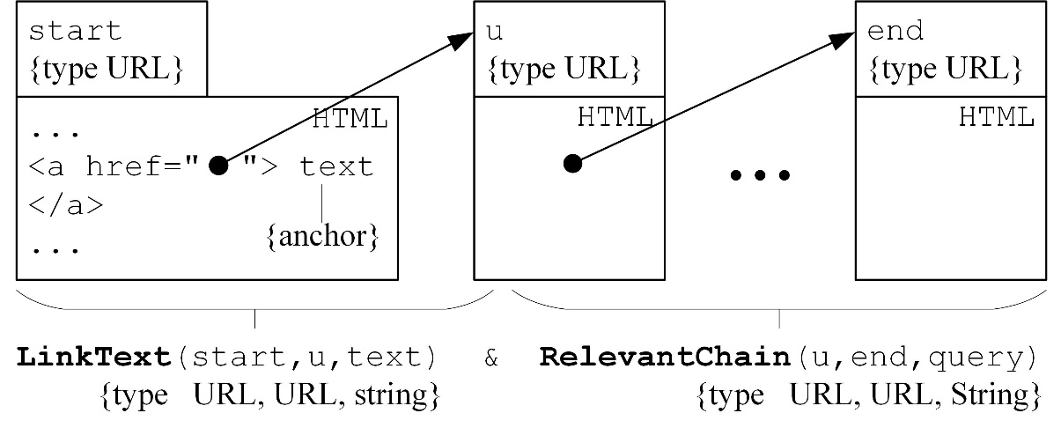

**Fig. 21.5.** Predicate **RelevantChain**(start,end,query)

For example, following is a specification of forward chaining:

ForwardChaining(s,t) ⇔ Link(s,u) & ForwardChaining(u,t)

Following is a specification of backward chaining:

BackwardChaining(s,t) ⇔ BackwardChaining(s,v) & Link(v,t)

|  |  |
| --- | --- |
| **Fig. 21.6.** Forward chaining and backward chaining algorithms can be used for path searching in a graph |  |

*Step 6. Assigning words to categories*

Recall **RelevantChain**(start,end,query) (21.2):

**LinkText**(start,u,text) & **RelevantChain**(u,end,query)

Here, for example, text obtains value 'Computers', and query – 'I need laptops'.

A supposed is-a categorisation of products is shown in Fig. 21.7.

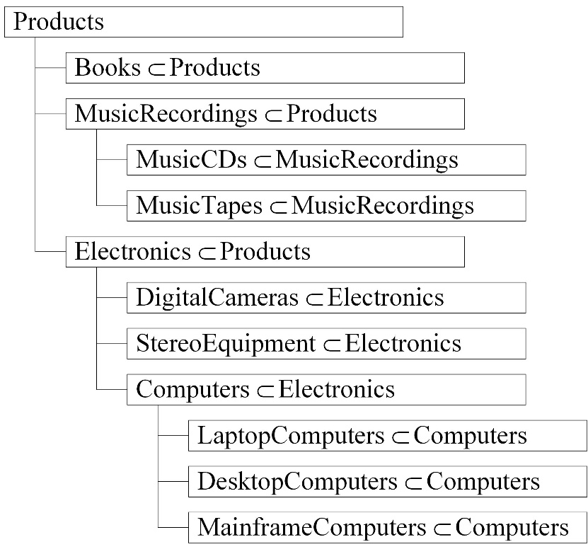

**Fig. 21.7.** Product hierarchy

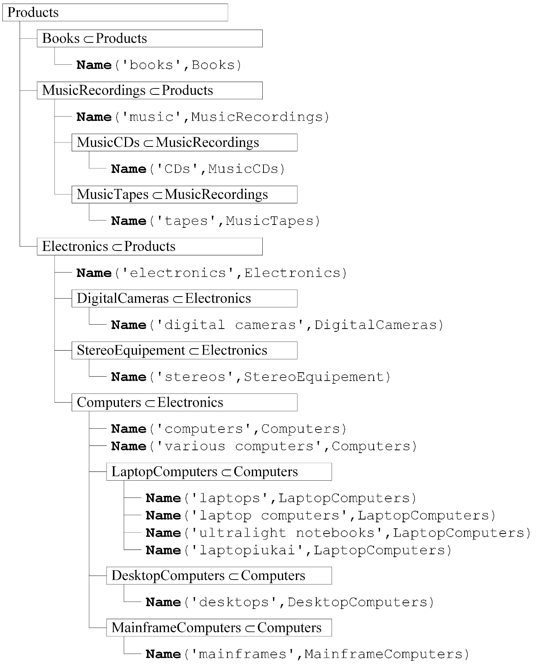

**Fig. 21.8.** Assigning words to categories

*Step 7. Predicate* **RelevantCategoryName**(query,text)

**RelevantCategoryName**(query,text) ⇔

∃c1 ∃c2 Name(query,c1) & Name(text,c2) & (c1=c2 ∨ c1⊂c2 ∨ c1⊃c2)

The case c1⊂c2 is shown in Fig. 21.9 a and the case c1⊃c2 in Fig. 21.9 b.

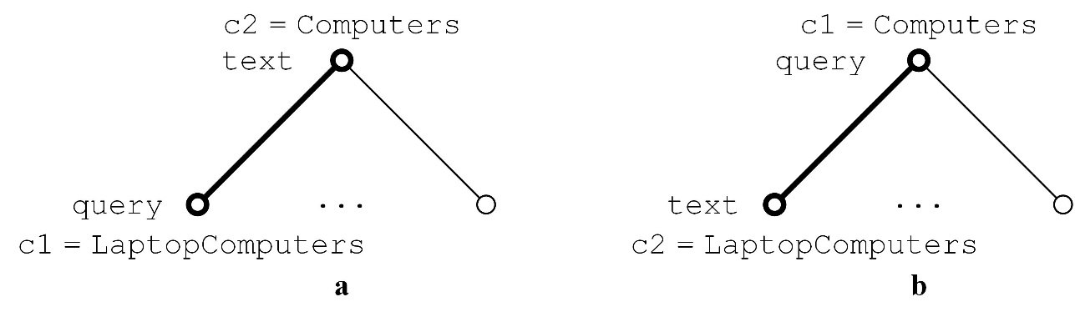

**Fig. 21.9.** a) The case c1⊂c2. b) The case c1⊃c2

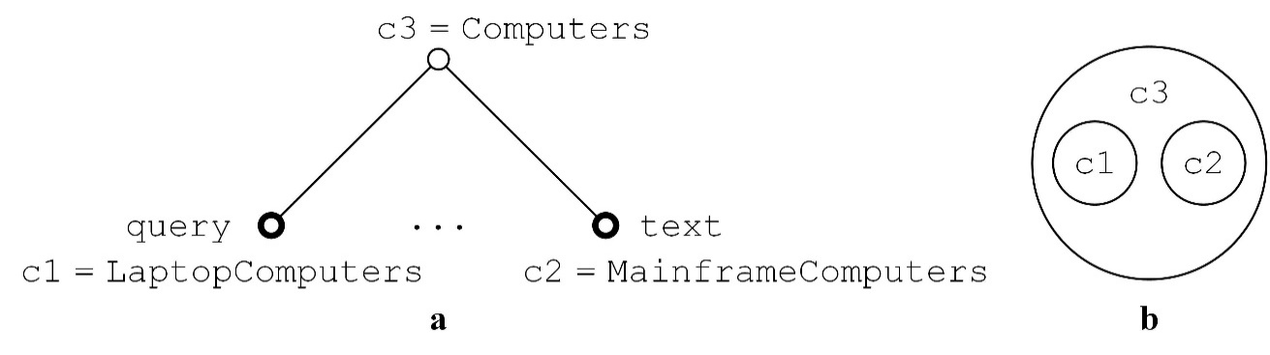

**Fig. 21.10**. a) The predicate is not satisfied when none of relations c1=c2, c1⊂c2 and c1⊃c2 is satisfied. b) The categories c1 are c2 not comparable

# The Turing test

See textbooks, e.g. (Luger 2005) and also Wikipedia <https://en.wikipedia.org/wiki/Turing_test>.

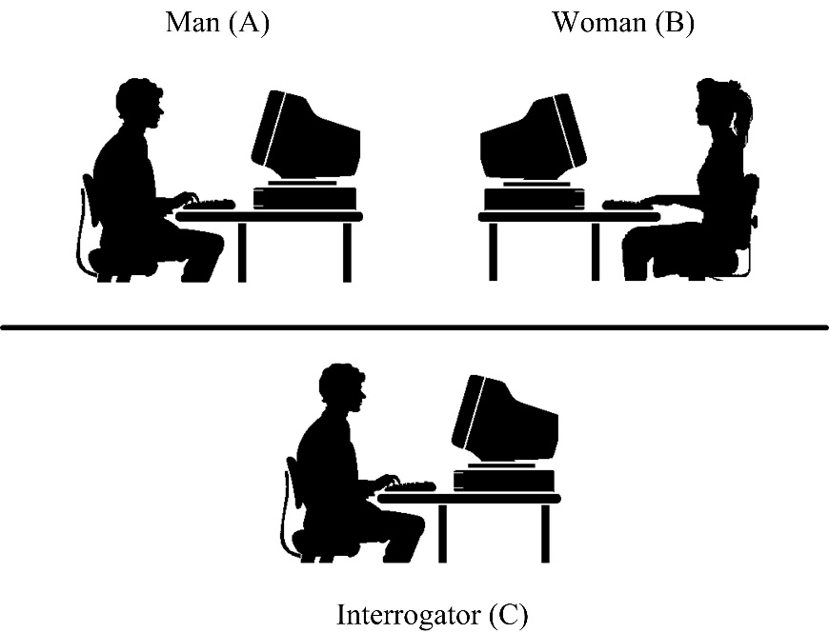

**Fig. 22.1.** Imitation game

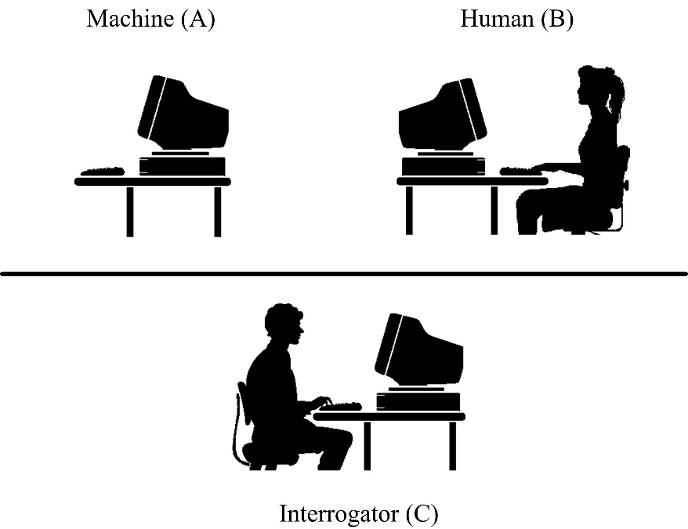

**Fig. 22.2.** The Turing test

A related material is John Searle’s Chinese Room argument, <https://en.wikipedia.org/wiki/Chinese_room>); see also 1 minute film by the Open University available at <https://www.youtube.com/watch?v=TryOC83PH1g>. See also Weizenbaum’s program Eliza, <https://en.wikipedia.org/wiki/ELIZA>.

# Intension, extension and ontology

“An intensional definition provides the meaning of an expression by specifying *necessary* and *sufficient conditions* for correct application of the expression. An intensional definition should be distinguished from an *extensional definition*, which merely provides a list of those instances in which the expression being defined is applicable. For example, we might provide an intensional definition of “bachelor” by specifying that bachelors are unmarried men. An extensional definition of bachelor, on the other hand, would consist merely of a list of those men.” (Roy T. Cook. Intensional definition, in: A Dictionary of Philosophical Logic, p. 155, Edinburgh University Press, Edinburgh, 2009); see also Wikipedia, <https://en.wikipedia.org/wiki/Extensional_and_intensional_definitions>.

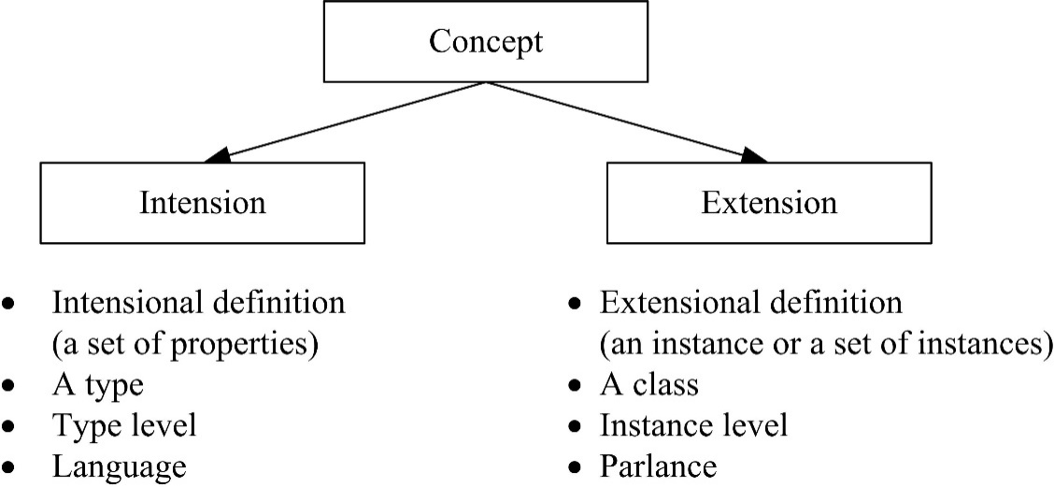

**Fig. 23.1.** The notion of a concept is a triad

As becomes clear, intensional definitions are best used when something has a clearly defined set of properties, and it works well for sets that are too large to list in an extensional definition. It is impossible to give an extensional definition for an infinite set, but an intensional one can often be stated concisely — there is an infinite number of even numbers, impossible to list, but they can be defined by saying that even numbers are integer multiples of two.

Definition by genus and difference, in which something is defined by first stating the broad category it belongs to and then distinguished by specific properties, is a type of intensional definition. As the name might suggest, this is the type of definition used in Linnaean taxonomy to categorize living things, but is by no means restricted to biology. Suppose we define a miniskirt as “a skirt with a hemline above the knee.” We’ve assigned it to a genus, or larger class of items: it is a type of skirt. Then, we’ve described the differentia, the specific properties that make it its own sub-type: it has a hemline above the knee.

Intensional definition also applies to rules or sets of axioms that generate all members of the set being defined. For example, an intensional definition of “square number” can be “any number that can be expressed as some integer multiplied by itself.” The rule—“take an integer and multiply it by itself”—always generates members of the set of square numbers, no matter which integer one chooses, and for any square number, there is an integer that was multiplied by itself to get it.

Similarly, an intensional definition of a game, such as chess, would be the rules of the game; any game played by those rules must be a game of chess, and any game properly called a game of chess must have been played by those rules; see Wikipedia, the link above.

## Signs

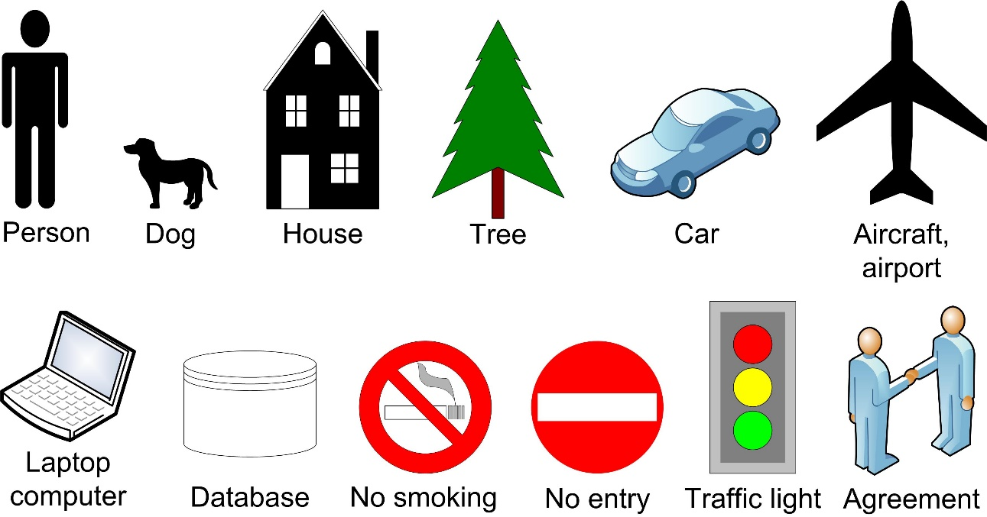

**Fig. 23.2.** Graphical signs

In semiotics, a *signifier* refers to a *significant*, i.e. a *meaning* (Fig. 23.3). Semiotika yra mokslas apie ženklus ir jų aiškinimą (interpretavimą).

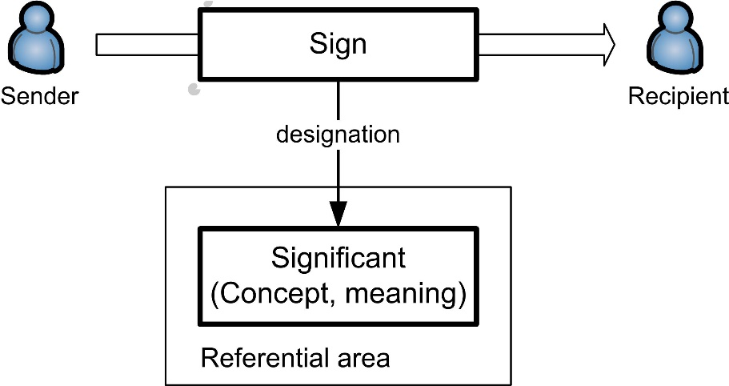

**Fig. 23.3.** A sign (i.e. a signifier) refers to its significant

See the problem of universals, <https://en.wikipedia.org/wiki/Problem_of_universals>. Example of universals: redness, cupness, homo sapiens.

Three viewpoints (Fig. 23.4):

* *universalia ante rem* (Platon)
* *universalia in re* (Aristotle)
* *universalia post rem* (nominalism, Latin *nomen* – name)

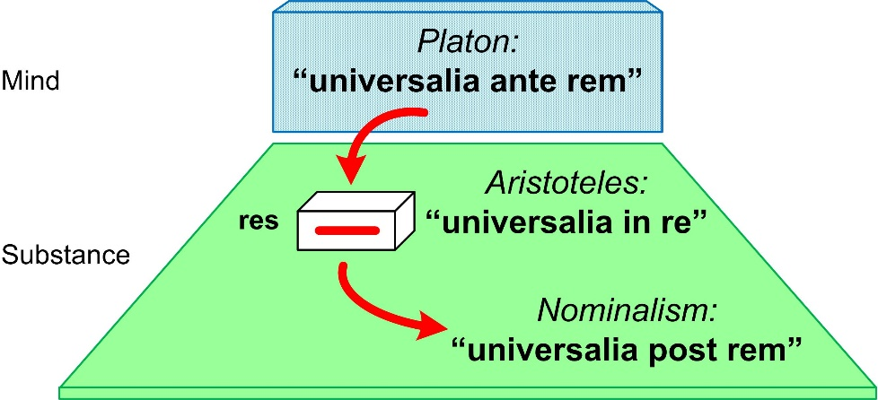

**Fig. 23.4.** Different viewpoints in philosophy

## What is a conceptualization?

This section follows (Guarino et al. 2009). An ontology is a formal, explicit specification of a shared conceptualization [ibid., p. 3].

**Definition 23.1** **(Extensional relational structure** *S*= (*D*, **R**) **)** An extensional relational structure is a tuple (*D*, **R**), where

* *D* is a set called the universe of discourse
* **R** is a set of relations on *D.* (Guarino et al. 2009, definition 2.1) □

Every element of **R** is an *extensional relation*, i.e., a mathematical relation, a subset of the Cartesian product.

**Example 23.2**. Let us consider human resources management in a large software company with 50.000 people, each one identified by a number (e.g., the social security number, or a similar code) preceded by letter *I*. Let us assume that our universe of discourse *D* contains all these people, and that we are only interested in relations involving people. Our **R** will contain some unary relations, such as *Person*, *Manager*, and *Researcher* as well as the binary relations reports-to and cooperates-with.[[3]](#footnote-3) (Guarino et al. 2009, example 2.1)

Consider an information system of the company. Let us assume that *D* contains 4 elements: *D*= {*I1*, *I2*, *I3*, *I4*} (Fig. 23.5).

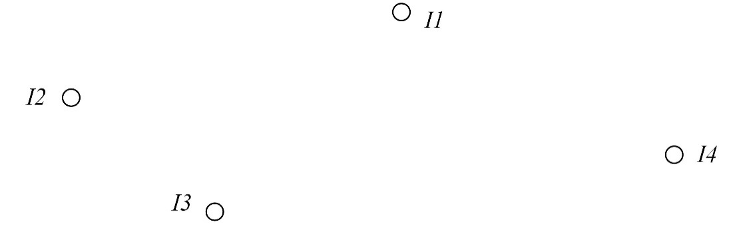

**Fig. 23.5.** The universe of discourse *D* = {*I1*, *I2*, *I3*, *I4*}

Let us assume 5 relations (5 tables):

|  |  |  |
| --- | --- | --- |
|  | **R** = { { (*I1*), (*I2*), (*I3*), (*I4*) },  { (*I1*) }  { (*I2*), (*I3*) }  { (*I2*, *I1*), (*I3*, *I1*) }  { (*I2*, *I3*) } } |  |

Let us provide names (i.e. textual symbols) to the relations:

|  |  |  |
| --- | --- | --- |
|  | **R** = { *Person*, *Manager*, *Researcher*, *reports-to*, *cooperates-with* }, where  *Person* = { (*I1*), (*I2*), (*I3*), (*I4*) } – unary relation  *Manager* = { (*I1*) } – unary relation  *Researcher* = { (*I2*), (*I3*) } – unary relation  *reports-t*o = { (*I2*, *I1*), (*I3*, *I1*) } – binary relation  *cooperates-with* = { (*I2*, *I3*) } } – binary relation |  |

These 5 relations can be represented graphically by 5 tables (Fig. 23.6):

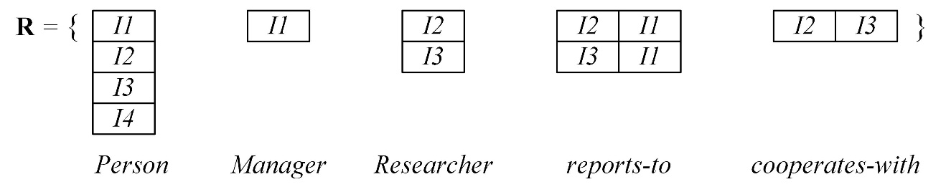

**Fig. 23.6.** 5 Representing 5 relations can graphically by 5 tables

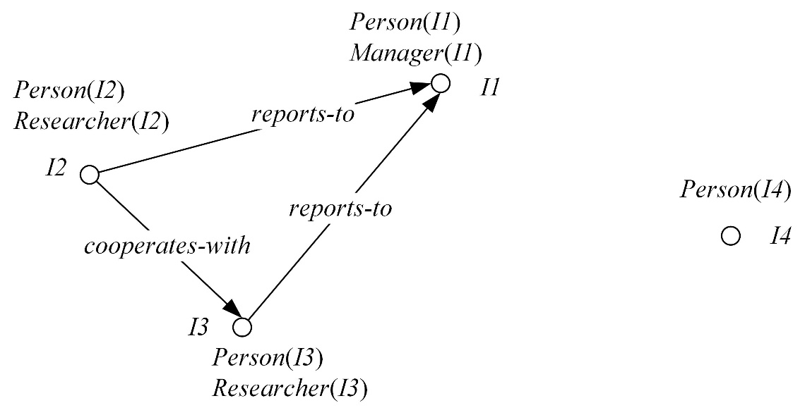

**Fig. 23.7.** An extensional relational structure from Example 23.2. It corresponds to a specific state of the world. This is a tiny part of a specific world with persons, managers, researchers, and their relationships in the running example of human resources in a large software company. Adapted from (Guarino et al. 2009, fig. 1)

**Example 23.3** (Guarino et al. 2009, example 2.2) Let us consider the following alteration of Example 23.2. An extensional relational structure (*D’*, **R’**) is supplemented with the edge (*I1*, *I4*):

* *D’* = *D*
* **R’** = { *Person*, *Manager*, *Researcher*, *reports-to’*, *cooperates-with* }, where *reports-to’* = *reports-to* ∪ {(*I1*, *I4*)}

Hence (*D’*,**R’**) ≠ (*D*,**R**), although *reports-to’* is supplemented with one line (Fig. 36.7).

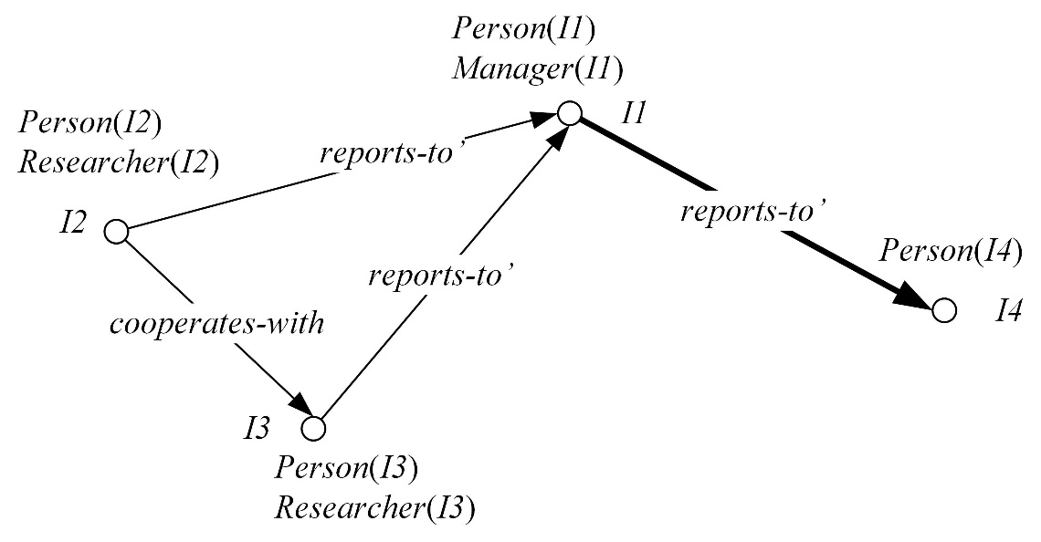

**Fig. 23.8.** The extensional relational structure (*D’*, **R’**) in Example 23.6. The relation *reports-to’* is supplemented with the edge (*I1*, *I4*). This corresponds to another state of the world

**Definition 23.4 (World** *W***).** A world is a totally ordered set of world states:

*W* = {*w*1, *w*2, *w*3 …} □

A contrast of total ordering can be illustrated with a partially ordered set. Consider a set *W* = {*w*1, *w*2, *w*3 , *w*4} with relations {*w*1<*w*2, *w*1<*w*3, *w*2<*w*4, *w*3<*w*4} (Fig. 23.9). There is no relation between *w*2 and *w*3 – neither *w*2<*w*3 nor *w*2>*w*3 – which are called *non-comparable*.

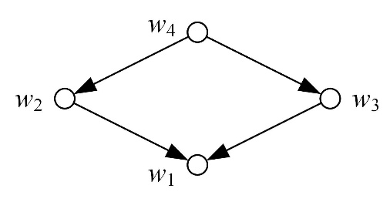

**Fig. 23.9.** A partially ordered set *W* = {*w*1, *w*2, *w*3 , *w*4}

**Definition 23.5 (Intensional relation, or conceptual relation** *ρ*(*n*)**).** An intensional relation (or conceptual relation) *ρ*(*n*) of arity *n* on (*D*, *W*) is a total function *W* → *powerset*(*Dn*) from the set *W* into the set of all *n*-ary extensional relations on *D*. In other words, *ρ*(*n*): *wi* → *ρ*(*n*)(*wi*), i.e. *ρ*(*n*) maps a world’s state *wi* into *ρ*(*n*)(*wi*), a subset of the Cartesian product *Dn* (*wi*) – a set of tuples from *Dn*, in other words, an extensional relational structure. (Guarino et al. 2009, definition 2.3) □

Here *powerset*(*A*) denotes a set of subsets of *A*. Also denoted 2*A*. For instance, suppose *A* = {*a*, *b*}. Then *powerset*(*A*) = 2*A* = { {}, {*a*}, {*b*}, {*a*, *b*} }.

**Definition 23.6 (Intensional relational structure** **C** = (*D*, *W,* R), **or conceptualization)** An intensional relational structure (or a conceptualization) is a triple **C** = (*D*, *W,* R) with

* *D* a universe of discourse
* *W*a world, i.e. a set of world’s states
* R a set of intensional relations on the domain space (*D*, *W*)

(Guarino et al. 2009, definition 2.3) □

**Example 23.7** (Guarino et al. 2009, example 2.3) Coming back to Examples 23.2 and 23.3, we can see them as describing two different world’s states compatible with the following intensional relational structure **C**= (*D*, *W,* R) (Fig. 23.10):

* *D* = {*I1*, *I2*, *I3*, *I4*}
* *W*= {*w*1, *w*2, *w*3 …}
* R = {*Person*(1), *Manager*(1), *Researcher*(1), *reports-to*(2), *cooperates-with*(2)}
* ∀*i*=*1*,*2*,*3*… *Person*(1)(*wi*) = {(*I1*), (*I2*), (*I3*), (*I4*)}
* ∀*i*=*1*,*2*,*3*… *Manager*(1)(*wi*) = {(*I1*)}
* ∀*i*=*1*,*2*,*3*… *Researcher*(1)(*wi*) = {(*I2*), (*I3*)}
* ∀*i*=*1*,*2*,*3*… *reports-to*(2)(*w*2*i–*1) = {(*I2*, *I1*), (*I3*, *I1*)} – 2 edges in odd states
* ∀ *i*=*1*,*2*,*3*… *reports-to*(2)(*w*2*i*) = {(*I2*, *I1*), (*I3*, *I1*), (*I1*, *I4*)} – 3 edges in even states
* ∀ *i*=*1*,*2*,*3*… *cooperates-with*(2)(*wi*) = {(*I2*, *I3*)}

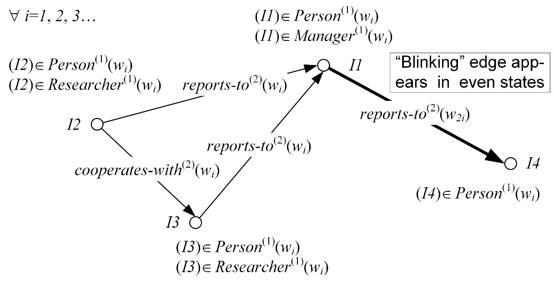

**Fig. 23.10.** The intensional relational structure in Example 23.7. The intensional relations *Person*(1), *Manager*(1), *Researcher*(1) and *cooperates-with*(2) do not change, but *reports-to*(2) changes – the edge (*I1*, *I4*) blinks

## What is a proper formal, explicit specification?

In practical applications, as well as in human communication, we need to use a language to refer to the elements of a conceptualization: for instance, to express the fact that *I2* cooperates with *I3*, we have to introduce a specific symbol (formally, a predicate symbol, say '*cooperates-with*', which, in the user’s intention, is intended to represent a certain conceptual relation. We say in this case that our language (let us call it **L**) *commits* to a conceptualization. Suppose now that **L** is a first-order logical language, whose non-logical symbols (i.e., its vocabulary) is V. The vocabulary is divided into two sets: 1) *constant symbols*, e.g, '*I1*', '*I2*', '*I3*', '*I4*', and 2) *predicate symbols*, e.g., '*Person*', '*Manager*', '*Researcher*', '*reports-to*', '*cooperates-with*':

**V** = *constant symbols* ∪ *predicate symbols*

A first-order language has the following difference from higher-order languages: predicate arguments can be formed of variables and expressions, but not of predicate names. In other words, a table field cannot be a table’s name. Examples of correct first-order sentences are '*reports-t*o'('*I2*', '*I1*') = '*true*' and ∀*x*,*y* '*reports-to*'(*x*,*y*) **⇒** '*Person*'(*x*) & '*Person*'(*y*), but not '*reports-t*o'('*Person*', '*Person*').

**Definition 23.8 (Extensional first-order structure** *M* = (*S*, *I* ) **).** Let us assume

* **L** a first-order logical language with vocabulary **V**
* *S* = (*D*, **R**) an extensional relational structure

An **extensional first-order structure** (also called model for **L**) is a tuple *M* = (*S*, *I* ), where *I* (called **extensional interpretation function**) is a total function *I*: **V →***D*∪ **R** that maps each vocabulary symbol of **V** to either an element of *D* or an extensional relation belonging to the set **R**. In other words, *I* maps constant symbols to *D* and predicate symbols to **R**, where *S*= (*D*, **R**). (Guarino et al. 2009, definition 3.1) □

**Definition 23.9 (Intensional first-order structure K**= (**C**, I), also called **ontological commitment).** Let us assume

* **L** a first-order logical language with vocabulary **V**
* **C** = (*D*, *W*,R) an intensional relational structure (conceptualization)

An **intensional first-order structure** (also called ontological commitment) for **L** is a tuple **K**= (**C**, I), where kur I (called **intensional interpretation function**) is a total function I :**V →***D* ∪ R , that maps each vocabulary symbol of **V** to either an element of *D* or an intensional relation belonging to the set R. In other words, I maps constant symbols to *D* and predicate symbols to R, where **C** = (*D*, *W*,R). (Guarino et al. 2009, definition 3.2) □

**Example 23.10** (Guarino et al. 2009, example 3.1) Let us come back to the extensional relational structure in our Example 23.2. An intensional first-order structure is as follows:

|  |  |  |
| --- | --- | --- |
|  | **V** = {'*I1*', '*I2*', '*I3*', '*I4*'} ∪  {'*Person*', '*Manager*', '*Researcher*', '*reports-to*', '*cooperates-with*'}  I : '*I1*' **→** *I1*, '*I2*' **→** *I2*, '*I3*' **→** *I3*, '*I4*' **→** *I4*,  '*Person*' **→** *Person*(1) , '*Manager*' **→** *Manager*(1), '*Researcher*' **→** *Researcher*(1),  '*reports-to*' **→** *reports-to*(2), '*cooperates-with*'**→** *cooperates-with*(2) |  |

**Definition 23.11 (Intended models** **IK**(**L**) **).** Let us assume

* **C** = (*D*, *W,* R) an intensional relational structure (conceptualization)
* **L** a first-order logical language with vocabulary **V**
* **K**= (**C**, I) an intensional first-order structure (ontological commitment)

A model *M* = (*S*, *I*), with *S* = (*D*, **R**), is called an **intended model** of **L** according to **K** iff

1. For all constant symbols *c*∈**V** we have *I*(*c*) = I(*c*)
2. There exists a world *w*∈*W* such that, for each predicate symbol *v*∈**V** there exists an intensional relation *ρ*(*n*)∈R such that I(*v*) = *ρ*(*n*) and *I*(*v*) = *ρ*(*n*)(*w*)

The set **IK**(**L**) of all models of **L** that are compatible with **K** is called the **set of intended models** of **L** according to **K**. (See Guarino et al. 2009, definition 3.3) □

In Example 23.7, for instance, we have for *w*1 (Fig. 23.11):

|  |  |  |
| --- | --- | --- |
|  | *I*('*Person*') = { (*I1*), (*I2*), (*I3*), (*I4*) } = *Person*(1) (*w*1)  *I*('*reports-to*') = { (*I2*, *I1*), (*I3*, *I1*) } = *reports-to*(2) (*w*1)  etc. |  |

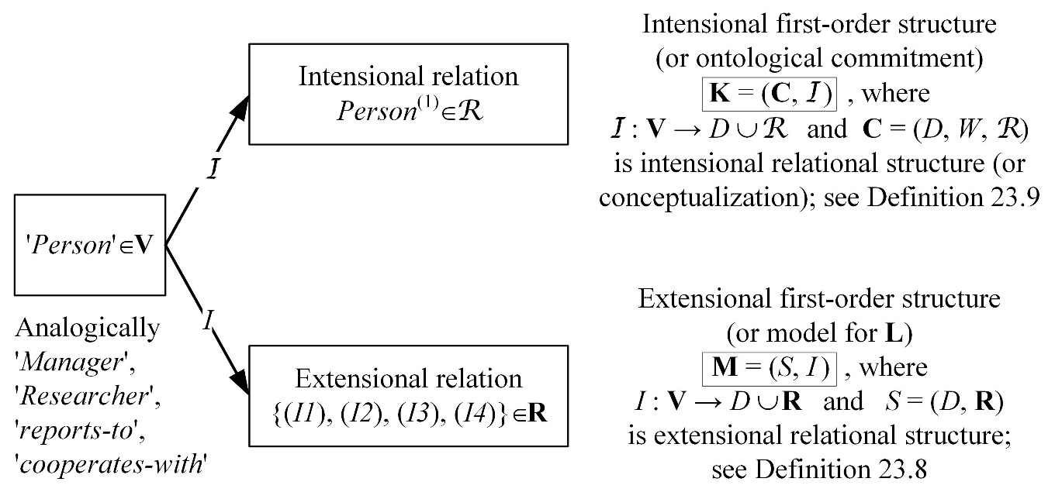

**Fig. 23.11.** The predicate symbol '*Person*' has both an extensional interpretation (through the usual notion of model, or extensional first-order structure) and an intensional interpretation (through the notion of ontological commitment, or intensional first-order structure). Adapted from (Guarino et al. 2009, Fig. 3)

**Definition 23.12 (Ontology OK).** Let us assume

* **C** = (*D*, *W,* R) an intensional relational structure (conceptualization)
* **L** a first-order logical language with vocabulary **V**
* **K**= (**C**, I) an intensional first-order structure (ontological commitment)

An ontology **OK** for **C** with vocabulary **V** and ontological commitment **K** is a logical theory consisting of a set of formulas of **L**, designed so that the set of its models approximates as well as possible the set of intended models **IK**(**L**) of **L** according to **K**.

(Guarino et al. 2009, definition 3.4) □

**Example 23.13.** In the following we build an ontology **OK** consisting of a set of logical formulae. Through *O*1 to *O*5 we specify our human resources domain (see Examples 23.2 and 23.7) with increasing precision. (Guarino et al. 2009, example 3.2)

* Taxonomic information. We start our formalization by specifying that the concepts *Researcher* and *Manager* are sub-concepts of *Person*:

|  |  |  |
| --- | --- | --- |
|  | *O*1 = { '*Researcher*'(*x*) **⇒** '*Person*'(*x*),  '*Manager*'(*x*) **⇒** '*Person*'(*x*) } |  |

* Domains and ranges. We continue by adding formulae to *O*1 which specify the domains and ranges of the binary relations:

|  |  |  |
| --- | --- | --- |
|  | *O*2=*O*1 ∪ { '*cooperates-with*'(*x*, *y*) **⇒** '*Person*'(*x*) & '*Person*'(*y*)  '*reports-to*'(*x*, *y*) **⇒** '*Person*'(*x*) & '*Person*'(*y*) } |  |

* Symmetry. *cooperates-with* can be considered a symmetric relation:

|  |  |  |
| --- | --- | --- |
|  | *O*3 = *O*2 ∪ { '*cooperates-with*'(*x*,*y*) **⇔** '*cooperates-with*'(*y*, *x*) } |  |

* Transitivity. Although arguable, we specify *reports-to* as a transitive relation:

|  |  |  |
| --- | --- | --- |
|  | *O*4 = *O*3 ∪ { '*reports-to*'(*x*, *z*) **⇐** '*reports-to*'(*x*, *y*) & '*reports-to*'(*y*, *z*) } |  |

* Disjointness. There is no *Person* who is both a *Researcher* and a *Manager*:

|  |  |  |
| --- | --- | --- |
|  | *O*5 = *O*4 ∪ { '*Manager*'(*x*) **⇒ ¬**'*Researcher*'(*x*) } |  |

The more formulae an ontology contains, the more constraints are concerned. Therefore, **IK**(**L**) contains less intended models (Fig. 23.12). In other words, if *D*' ⊂ *D* and R' ⊂ R then **M**D'(**L**) ⊃ **M**D(**L**).

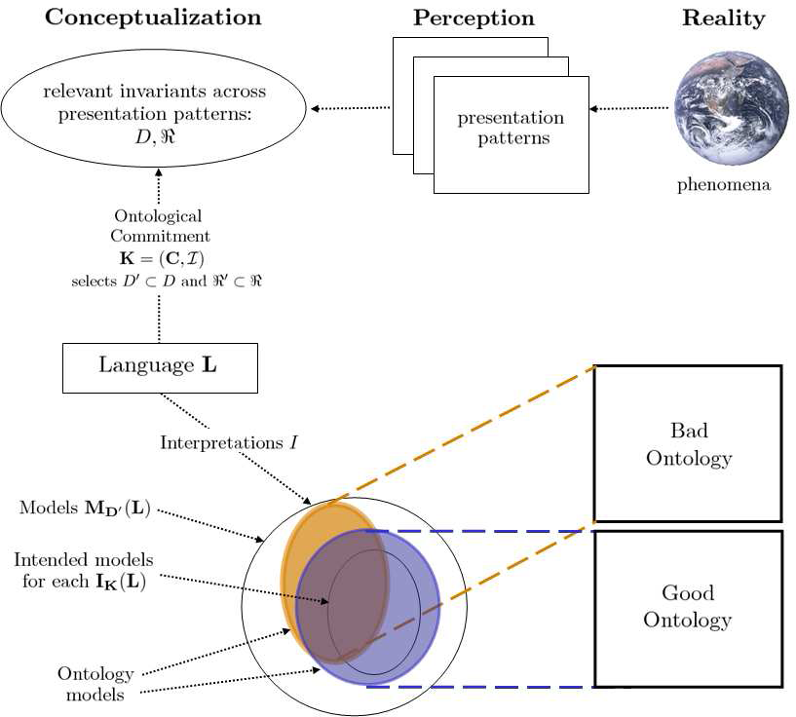

**Fig. 23.12.** The relationships between the phenomena occurring in reality, their perception (at different times), their abstract conceptualization, the language used to talk about such conceptualization, its intended models, and an (Guarino et al. 2009, fig. 2)

“At one extreme, we have rather informal approaches for the language **L** that may allow the definitions of terms only, with little or no specification of the meaning of the term. At the other end of the spectrum, we have formal approaches, i.e., logical languages that allow specifying rigorously formalized logical theories… Within this rightmost category one typically encounters the trade-off between expressiveness and efficiency when choosing the language **L**. On the one end, we find higher-order logic, full first-order logic, or modal logic. They are very expressive, but do often not allow for sound and complete reasoning and if they do, reasoning sometimes remains untractable. At the other end, we find less stringent subsets of first-order logic, which typically feature decidable and more efficient reasoners. They can be split in two major paradigms. First, languages from the family of *description logics (DL)*… e.g., OWL-DL”, see <https://www.w3.org/2001/sw/wiki/OWL> for the Web Ontology Language (OWL). “The second major paradigm comes from the tradition of *logic programming (LP)*… with one prominent representor being F-Logic” (Guarino et al. 2009, p. 12–13).

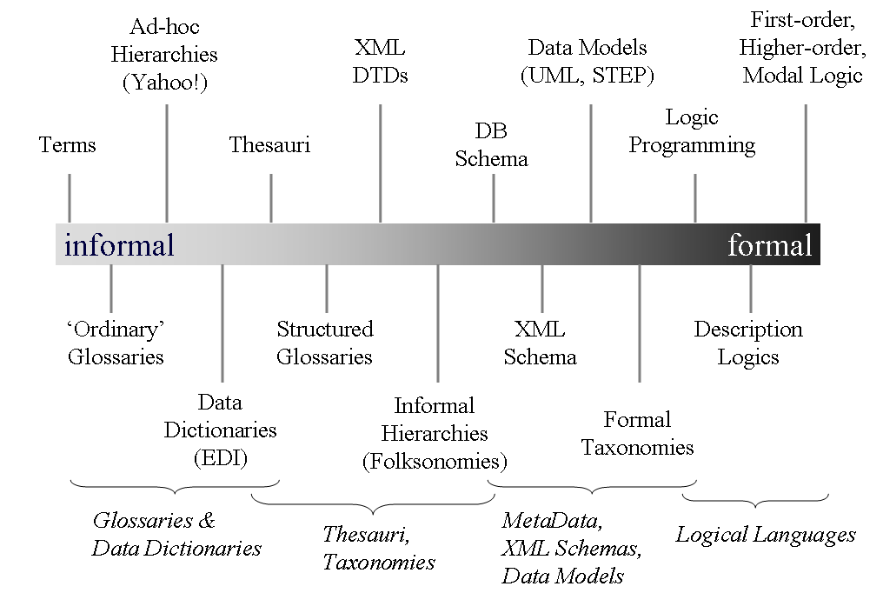

**Fig. 23.13.** Different approaches to the language **L**. Typically, logical languages are eligible for the formal, explicit specification, and, thus, ontologies (Guarino et al. 2009, Fig. 4)

Reference and meaning is shown in Fig. 23.14.

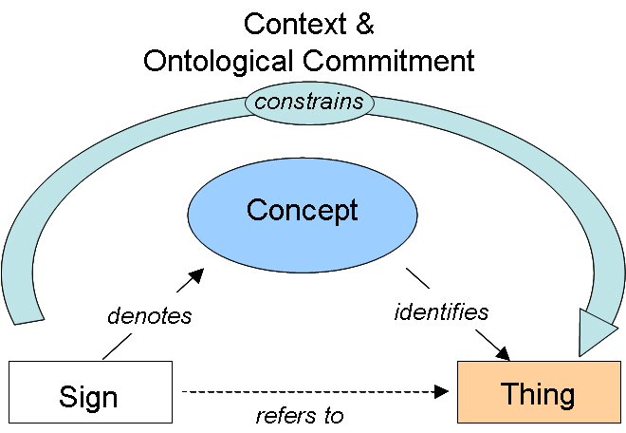

**Fig. 23.14.** Semiotic triangle (Guarino et al. 2009, fig. 6)

Distinct models of a specification

Following are examples of distinct models which satisfy the same set of formulas in logic.

**Example 23.11** (Loeckx et al. 1996, example 2.6, p. 29). Consider a language **L** whose alphabet **V** consists of one constant symbol '*0*' and one functional symbol '*Succ*'. The latter is the name of arity *1* (one argument) operation '*Succ*': \_ → \_. Both are syntactic objects (i.e. names); no semantics is assigned to them yet.

**V** = {'0'} ∪ {'Succ'}

An example of a term in **L** is '*Succ*'('*Succ*'(*x*)). A set of ground terms (terms without free variables) of **L** is

{'0', 'Succ'('0'), 'Succ'('Succ'('0')), 'Succ'('Succ'('Succ'('0'))),…}

The notion of a term is defined inductively. Constant symbols and variables are terms. If '*f*' is an operation of arity *k*, *k ≥ 1*, and *t1*,…,*tk* are terms then '*f*'(*t1,…, tk*) is a term. A term can be represented as a tree. Branches occur at the vertices of operations of arity *2* or greater.

Let an ontology be an empty set of formulas *O* = ∅. Three models of **L** are described below.

**Model *Nat*.** The “classical” model is a set of natural numbers *D* = *Nat* = {*0*, *1*, *2*, *3*,…}. Here the successor function is interpreted as adding *1* to its argument:

I*Nat* ('*Succ*') (*n*) = *n*+ *1*

The interpretation I*Nat* maps terms (syntactic objects) to semantic objects – natural numbers:

|  |  |
| --- | --- |
| I*Nat* : | '*0*' → *0*, '*Succ*'('*0*') → *1*, '*Succ*'('*Succ*'('*0*')) → *2*, '*Succ*'('*Succ*'('*Succ*'('*0*'))) → *3*,…  '*Succ*' → \_ + *1* |

**Model *Bool*.** Next model is a Boolean set *D* = *Bool* = {*true*, *false*}. The constant '*0*' is interpreted as *false*. The successor function is interpreted as “flipping” the argument:

I*Bool* ('*Succ*') (*x*) = $\left\{\begin{aligned}false if x=true \\ true if x=false\end{aligned}\right.$

The interpretation function I*Bool* maps:

|  |  |
| --- | --- |
| I*Bool* : | '*0*' → *false*, '*Succ*'('*0*') → *true*, '*Succ*'('*Succ*'('*0*')) → *false*, |
|  | '*Succ*'('*Succ*'('*Succ*'('*0*'))) → *true*,… |

**Model *C*.** Next model is a set of one element, *D* = *DC* = {#}. The constant '*0*' is interpreted as #. The successor function maps # to #:

I*C* ('*Succ*') (#) = #

The interpretation function I*C* maps:

I*C* : '*0*' → #, '*Succ*'('*0*') → #, '*Succ*'('*Succ*'('*0*')) → #, '*Succ*'('*Succ*'('*Succ*'('*0*'))) → #,…

**Example 23.12** (Loeckx et al. 1996, example 5.24 iv, p. 87). ). Consider a language **L** whose alphabet **V** consists of one constant symbol '*0*' and one functional symbol '*+*':

**V** = {'*0*'} ∪ {'*+*'}

Let an ontology *O* consist of four formulas:

|  |  |  |  |
| --- | --- | --- | --- |
|  | *O* = {  } | *x* '*+*' *(y* '*+*' *z)* = *(x* '*+*' y*)* '*+*' *z*,  *x* '*+*' '*0*' = *x*,  '*0*''*+*' *x* = *x*,  ∀*x* ∃*y* ( *x* '*+*' *y* = '*0*' & *y* '*+*' *x* = '*0*' ) } | (23.1) |

The first formula expresses a property known as associativity. The second and third formula are about the neutral element '*0*' for addition operation '*+*'. The forth formula is about the inverse element *y*. All formulas in an ontology serve as axioms that specify a model.

Any group (an algebraic structure in abstract algebra) is a model for the ontology (23.1). Below we distinguish between infinite groups and finite groups.

**Model *Z*.** The “classical” model is a set of integer numbers *D* = *Z* = {…, *–3*, *–2*, *–1*, *0*, *1*, *2*, *3*,…}. Here the addition operation '*+*' is interpreted as addition of integers:

IZ ('+' ) (n,m) = n + m

The existence of the inverse element *y* in the fourth formula in (23.1) can be replaced with a Skolem term operation '*Inv*'(*x*). This replacement is called Skolemization. The interpretation I*Z* maps '*Inv*' terms to invocations of an arity *1* function *minus* (and denoted –) for integers:

IZ ('Inv' ) (n) = –n

Integer numbers satisfy all four formulas in the ontology *O* (23.1) above. For all *x*, *y* ∈ *Z* it is true that *x +* (*y +z*) = (*x* +*y*) +*z, x* +*0* =*x*, *0* + *x* = *x*, and the inverse element of *x* is –*x*, where – ( –*x*) = *x*.

**Model *Zn*.** A model is set of integers *D* = *Zn* = {*0*, *1*, *2*,…, *n*–*1*}. They form a finite group called remainder group. Here the addition operation '*+*' is interpreted as addition modulo *n*:

IZn ('+') (l,m) = l + m modulo n (or simply l ⊕n m)

In the case *n*=*3* we have *Z3* = {*0*, *1*, *2*} and

*0*+ *0 modulo* *3* = *0* (or *0*⊕*3* *0*= *0*)

*0*+ *1 modulo* *3* = *1* (or *0*⊕*3* *1*= *1*)

*0*+ *2 modulo* *3* =*2* (or *0*⊕*3* *2*= *2*)

*1*+ *2 modulo* *3* =*0* (or *1*⊕*3* *2*= *0*)

*2*+ *2 modulo* *3* =*1* (or *2*⊕*3* *2*= *1*)

In the case *n*=*2* we have *Z2* = {*0*, *1*} and write *0*⊕ *0*= *0*, *0*⊕ *1*= *1*, *1*⊕ *1*= *0*.

In modular arithmetic, two integers are added and then the sum is divided by a positive integer called the *modulus*. The result of modular addition is the remainder of that division. For any modulus, *n*, the set of integers from *0* to *n* − *1* forms a group under modular addition: the inverse of any element *a* is *n* − *a*, and *0* is the identity element. This is familiar from the addition of hours on the face of a clock: if the hour hand is on *9* and is advanced *4* hours, it ends up on *1*. This is expressed by saying that *9* + *4* equals *1* “modulo 12” or, in symbols, *9* + *4* ≡ *1* *modulo* *12*. The group of integers modulo *n* is written *Zn*; see <https://en.wikipedia.org/wiki/Group_(mathematics)>.

**Example 23.13** (Loeckx et al. 1996, example 5.24 iv, p. 87). Consider a language **L** whose alphabet **V** consists of one constant symbol '*0*' and two functional symbols, '*+*' and '*Succ*':

**V** = {'*0*'} ∪ {'*+*', '*Succ*'}

Let an ontology consist of two formulas:

|  |  |  |
| --- | --- | --- |
|  | *O* = { *x* '*+*' '*0*' = *x*,  '*Succ*'(*x* '*+*' *y*)  =  *x* '*+*' '*Succ*'(*y*)} | (23.2) |

The first formula is about the neutral element '*0*' for addition operation '*+*'. The second formula is about a flowdown of '*Succ*'.

A model is constituted by natural numbers *D* = {*0*, *1*, *2*, *3*,…}. Here the successor function is interpreted as adding *1* to its argument. Arithmetical addition, +, is the second function on *D*. The interpretation function I maps:

|  |  |
| --- | --- |
| I : | '*0*' → *0*, '*Succ*'('*0*') → *1*, '*Succ*'('*Succ*'('*0*')) → *2*, '*Succ*'('*Succ*'('*Succ*'('*0*'))) → *3*,…  '*+*' → +,  '*Succ*' → \_ + *1* |

The meaning of the last line, '*Succ*' **→** \_ + *1*, is as follows. The functional symbol '*Succ*' is mapped to arity *1* (one argument) function which adds *1* to its argument. Natural numbers satisfy both formulae in the ontology *O* (23.2): for all *x*, *y* ∈ *D* it is true that *x + 0 = x* and *(x + y) + 1*= *x + (y +1)*.

Next model is constituted by even numbers, *D* = {*0*, *2*, *4*, *6*,…}. Here the successor operation '*Succ*' is interpreted as adding *2* to its argument. The interpretation function I maps:

|  |  |
| --- | --- |
| I : | '*0*' → *0*, '*Succ*'('*0*') → *2*, '*Succ*'('*Succ*'('*0*')) → *4*, '*Succ*'('*Succ*'('*Succ*'('*0*'))) → *6*,…  '*+*' → +,  '*Succ*' → \_ + *2* |

The last line above, '*Succ*' → \_ + *2*, means that the functional symbol '*Succ*' is mapped to arity *1* function which adds *2* to its argument. The set of even numbers is isomorphic to the set of natural numbers. Therefore even numbers are not considered as a model.

# Examination questions

1. Artificial intelligence production system, a formalisation, PRODUCTION algorithm, examples. The concept of artificial intelligence (according to your reading).

2. BACKTRACK and BACKTRACK1 search algorithms. The concept of backtracking. Is an infinite loop possible? Examples. The concept of heuristic.

3. Depth-first search and breadth-first search in a labyrinth (write programs).

4. Prefix and postfix traversal of a tree. Binary trees and general trees. Write procedures for general trees: 1) enter a general tree, 2) prefix order traversal, and 3) postfix order traversal. For example, the strings ABC.DE...F.GHI.J.K.L or A(B(CD(E))FG(H(IJKL))) represent the tree:

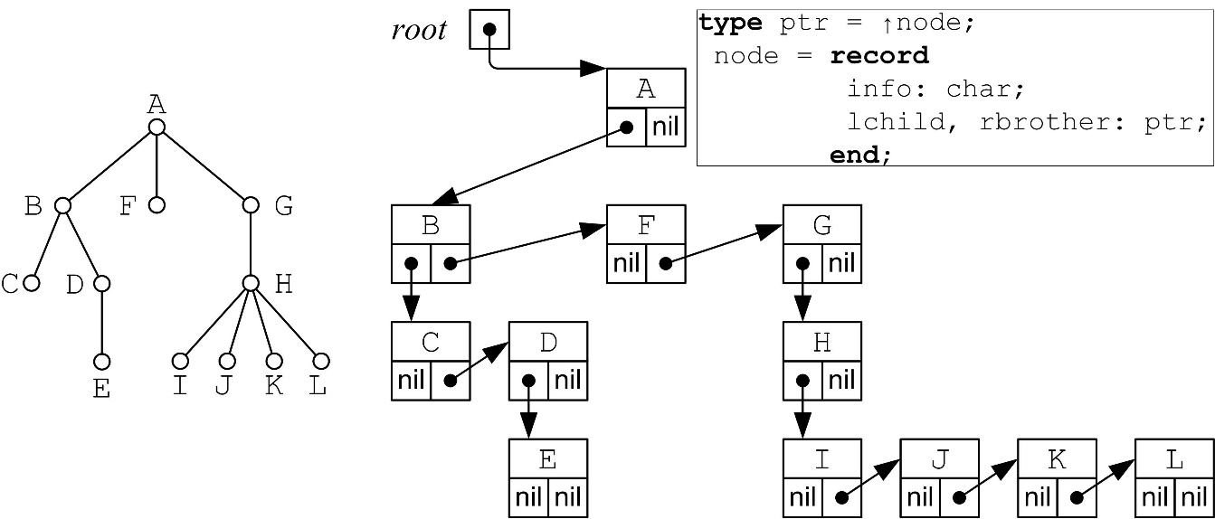

5. Depth-first search and breadth-first search in a tree. The shortest path problem for non-weighted graphs. Write an algorithm.

6. The shortest path problem for weighted graphs. Write an algorithm.

7. Depth-first search in a graph. The concepts of solver and planner.

8. Procedure GRAPHSEARCH. Uniform search, heuristic search. A difference between BACKTRACK1 and GRAPHSEARH-DEPTH-FIRST. A counterexample.

9. A\* search algorithm.

10. Forward chaining and backward chaining. Semantic graphs, program synthesis, complexity of inference.

11. The resolution rule. Inference examples. Forward chaining and backward chaining strategies in theorem proving.

12. Expert systems as artificial intelligence systems. An architecture. An example.

13. Internet shopping specification (according to Russell and Norvig).

14. The Turing test and the philosophy of artificial intelligence (according to your reading).

15. The infeasibility of achieving several goals. The punishment problem as an example.

16. Extensional relational structure, world, intensional relation, intensional relational structure, extensional first-order structure (a model for a language), intensional first-order structure (ontological commitment), intended models, and ontology.

17. Distinct models of a specification.

# References

**Main list**

1. Brachman, Ronald; Hector Levesque, Hector (2004) *Knowledge representation and reasoning*. The Morgan Kaufmann Series in Artificial Intelligence. VU MIF: 004.8/Br-04.
2. Luger, George (2009) *Artificial intelligence:* *structures and strategies for complex problem solving* (6th ed.). Addison-Wesley. <http://www.cs.unm.edu/~luger/>. VU MIF: 004.8/Lu-59.
3. Michael Negnevitsky (2011) *Artificial intelligence: a guide to intelligent systems* (3rd ed.). Addison-Wesley, 2011. VU MIF: 004.8/Ne-44.
4. Russell, Stuart; Norvig, Peter (2010) *Artificial intelligence: a modern approach* (3rd ed.). Prentice Hall. <http://aima.cs.berkeley.edu>. VU MIF: 004.8/Ru-151.

**Supplementary list**

1. Antoniou, G.; Groth, P.; van Harmelen, F.; Hoekstra, R. (2012) *A semantic web primer* (3rd ed.). The MIT Press. VU MIF 004.8/An-154.
2. Nilsson, Nils (2010) *The quest for artificial intelligence: a history of ideas and achievements*. Cambridge University Press. VU MIF: 004.8/Ni-133.
3. Nilsson, Nils (1998) *Artificial intelligence: a new synthesis*. Morgan Kaufmann Publishers. VU MIF: 004.8/Ni-133.
4. Nilsson, Nils (1982) *Principles of artificial intelligence*. Springer, Berlin Heidelberg.
5. Sowa, John F. (2000) *Knowledge representation: logical philosophical, and computational foundations*. Brooks/Cole, Pacific Grove.

**Other references**

1. Bench-Capon, T. J. M.; Prakken, H. (2006) Justifying actions by accruing arguments. In: *Computational Models of Argument – Proceedings of COMMA 2006*, IOS Press, pp. 247–258. IOS Press. <http://www.cs.uu.nl/groups/IS/archive/henry/action.pdf>, slides <http://www.cs.uu.nl/deon2006/tbc+hp.pdf>.
2. E. D. Falkenberg, W. Hesse, P. Lindgreen, B. E. Nilsson, J. L. H. Oei, C. Rolland, R. K. Stamper, F. J. M. Van Assche, A. A. Verrijn-Stuart, K. Voss (1998) *A framework of information system concepts, The FRISCO Report (Web edition)*, IFIP, the Netherlands. <http://www.mathematik.uni-marburg.de/~hesse/papers/fri-full.pdf>.
3. Guarino, N.; Oberle, D.; Staab, S. (2009) What is an Ontology? In: *Handbook on Ontologies*, S. Staab, R. Studer (eds.) pp. 1–17, Springer. <http://iaoa.org/isc2012/docs/Guarino2009_What_is_an_Ontology.pdf>.
4. Hesse, W.; A. Verrijn-Stuart, A. (2001) Towards a theory of information systems: the FRISCO approach. In: H. Jaakkola et al. (eds*.) Information Modelling and Knowledge Bases XII*, p. 81–91. IOS Press, Amsterdam.
5. Loeckx, Jacques; Ehrich, Hans-Dieter; Wolf, Markus (1996) Specification of abstract data types. Wiley-Teubner, Chichester.
6. Sawyer, Brian; Foster, Dennis (1986) *Programming expert systems in Pascal*. John Wiley, New York.
7. Thayse, André; Gribomont, Pascal; Louis, Georges et al. (1988) *Approche logique de l'intelligence artificielle*. Dunot, Paris.
8. Turing, Alan M. (1950) Computing machinery and intelligence. *Mind*, 1950, vol. 59. no. 236, pp. 433–460. <http://mind.oxfordjournals.org/content/LIX/236/433>.

1. V. Čyras. Intelektualios sistemos. e-Book. ISBN 978-9955-33-561-0. <<http://www.mif.vu.lt/~cyras/AI/konspektas-intelektualios-sistemos.pdf>>. [↑](#footnote-ref-1)
2. See generally Marvin L. Minsky (1968) Introduction, in: Semantic Information Processing, M. L. Minsky (ed.), MIT Press, Cambridge (Massachusetts). See also <https://www.britannica.com/biography/Marvin-Lee-Minsky>. [↑](#footnote-ref-2)
3. The name of a person could also be assigned via relations, e.g., *firstname*(*I4*, '*Daniel*') and *lastname*(*I4*, '*Oberle*'). [↑](#footnote-ref-3)